6.14 Small Group · Group 1 — Homework
Lesson 6-14-group1 • Standard 6.AT.7
Name: ______________________ Period: ______ Date: ____________

Today's Goals
Content: With my small group, I can use the distributive property to expand and factor expressions — one step at a time, with support.
Language: I can talk through each step out loud using a sentence frame and the lesson's key words.

Key Words
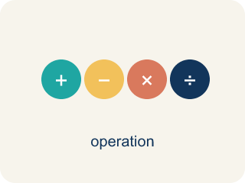
The Distributive Property (La propiedad distributiva) — Multiply a factor by every term inside parentheses.
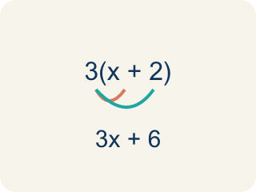
Distributive Property (Propiedad distributiva) — Multiplying a number by everything inside the parentheses: a(b + c) = ab + ac.
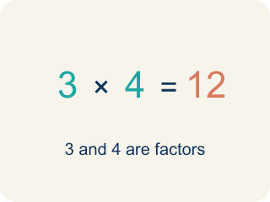
Factor (Factor) — A factor of a whole number divides it evenly, with no remainder. For example, 3 is a factor of 12 because 12 ÷ 3 = 4.

Expand (Desarrollar) — To multiply out the parentheses in an expression.
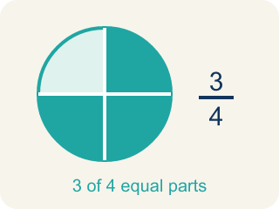
Equivalent (Equivalente) — Expressions that always have the same value.
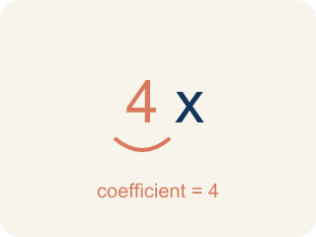
Coefficient (Coeficiente) — The number in front of a letter, like the 3 in 3x.
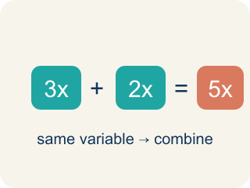
Like terms (Términos semejantes) — Terms with the same letter raised to the same power, like 2x and 5x.

Practice
Show your work. Use the blank space under each problem.
1. Expand 6(n + 3) using the distributive property.
A. 6n + 18
B. 6n + 3
C. n + 18
D. 6n + 9
______________________________________________________________________
2. Expand 4(5 − 2) using the distributive property.
A. 12
B. 20 − 2
C. 9
D. 22
______________________________________________________________________
3. Light Cue 2: Expand 5(2 + n) to set two spotlight banks.
A. 10 + 5n
B. 10 + n
C. 7 + 5n
D. 10 + 5
______________________________________________________________________
4. Light Cue 3: Expand 4(a + 2) for the back-row beam.
A. 4a + 8
B. 4a + 2
C. a + 8
D. 4a + 6
______________________________________________________________________
5. Level 2 Extension — The Spotlight Only Hit One Term
Step 1 (Light cue): 3(x + 4)
Step 2 (Distribute): 3 × x + 4
Step 3 (Simplify): 3x + 4
Which step has the mistake? Explain and fix it:
______________________________________________________________________
______________________________________________________________________
______________________________________________________________________
6. Find the Distributive Error
Step 1 (Expression): 5(2x + 4)
Step 2 (Distribute): 5 × 2x + 4
Step 3 (Simplify): 10x + 4
Which step has the mistake? Explain and fix it:
______________________________________________________________________
______________________________________________________________________
______________________________________________________________________
7. Use the distributive property to explain why 6 × 98 can be calculated as 6 × 100 − 6 × 2 = 588. Then create your own example of using the distributive property to make multiplication easier.
Sentence starter: 6 × 98 = 6(100 − 2) = 6 × ___ − 6 × ___ = ___ − ___ = ___. My example: ___ × ___ = ___(___ ± ___) = ___.
______________________________________________________________________
______________________________________________________________________
______________________________________________________________________
______________________________________________________________________
8. Use the distributive property to expand each expression.
Factored Form | Expanded Form
2(x + 5)
4(3 + 7)
______________________________________________________________________

Answer Key (Teacher)
1. A. 6n + 18
6(n + 3) = 6 × n + 6 × 3 = 6n + 18.
Watch for: The most common mistake in The Distributive Property is multiplying the outside factor by only the FIRST term inside the parentheses and forgetting the second — for example, writing 3(x + 4) = 3x + 4 instead of 3x + 12. Before you submit, check: did the outside number reach BOTH terms inside the parentheses?
2. A. 12
4(5 − 2) = 4 × 5 − 4 × 2 = 20 − 8 = 12.
Watch for: The most common mistake in The Distributive Property is multiplying the outside factor by only the FIRST term inside the parentheses and forgetting the second — for example, writing 3(x + 4) = 3x + 4 instead of 3x + 12. Before you submit, check: did the outside number reach BOTH terms inside the parentheses?
3. A. 10 + 5n
Distribute the 5 to each term: 5 × 2 + 5 × n = 10 + 5n.
Watch for: The most common mistake in The Distributive Property is multiplying the outside factor by only the FIRST term inside the parentheses and forgetting the second — for example, writing 3(x + 4) = 3x + 4 instead of 3x + 12. Before you submit, check: did the outside number reach BOTH terms inside the parentheses?
4. A. 4a + 8
Distribute the 4 to each term: 4 × a + 4 × 2 = 4a + 8.
Watch for: The most common mistake in The Distributive Property is multiplying the outside factor by only the FIRST term inside the parentheses and forgetting the second — for example, writing 3(x + 4) = 3x + 4 instead of 3x + 12. Before you submit, check: did the outside number reach BOTH terms inside the parentheses?
5. Level 2 Extension — The Spotlight Only Hit One Term
The mistake is in Step 2.
Correct work: 3(x + 4) = 3 × x + 3 × 4 = 3x + 12. The factor 3 is like a spotlight that must shine on EVERY term inside the parentheses, not just the first one. Picture the area model: a 3-by-x panel (3x) plus a 3-by-4 panel (12).
Watch for: The 3 shone on the x but skipped the 4. Distributing to every term gives 3(x + 4) = 3 × x + 3 × 4 = 3x + 12. An area model shows why: a 3-by-x panel is 3x and a 3-by-4 panel is 12, and the whole rectangle is both panels together.
6. Find the Distributive Error
The mistake is in Step 2.
Correct work: 5(2x + 4) = 5 × 2x + 5 × 4 = 10x + 20. You must distribute the 5 to BOTH terms inside the parentheses, not just the first one.
Watch for: The 5 multiplied only the first term inside. Distributing to both gives 5(2x + 4) = 5 × 2x + 5 × 4 = 10x + 20. Testing with x = 1 confirms it: the original 5(2 + 4) = 30 and 10(1) + 20 = 30, while the student's 10x + 4 would give only 14.
7. Open response — answers will vary.
Look for key words: distributive, factor, expand, mental math, equivalent, multiply.
8. Use the distributive property to expand each expression.
2(x + 5) — Expanded Form: 2x + 10
4(3 + 7) — Expanded Form: 12 + 28 = 40

