6.14 Small Group · Group 2 — Homework
Lesson 6-14-group2 • Standard 6.AT.7
Name: ______________________ Period: ______ Date: ____________

Today's Goals
Content: I can use the distributive property to expand and factor expressions, explain why the method works, and use it on a problem I have not seen before.
Language: I can justify my answer to a skeptic and connect it to a second strategy or representation.

Key Words
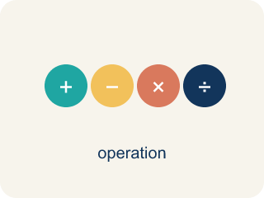
The Distributive Property (La propiedad distributiva) — Multiply a factor by every term inside parentheses.
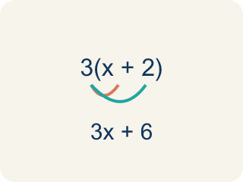
Distributive Property (Propiedad distributiva) — Multiplying a number by everything inside the parentheses: a(b + c) = ab + ac.
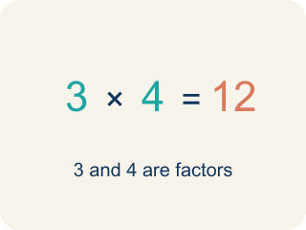
Factor (Factor) — A factor of a whole number divides it evenly, with no remainder. For example, 3 is a factor of 12 because 12 ÷ 3 = 4.

Expand (Desarrollar) — To multiply out the parentheses in an expression.
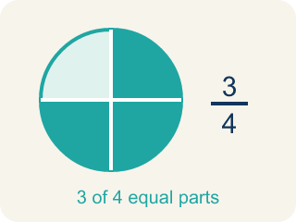
Equivalent (Equivalente) — Expressions that always have the same value.
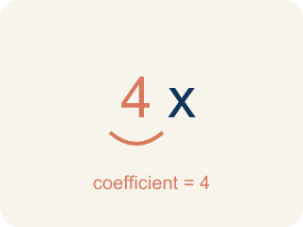
Coefficient (Coeficiente) — The number in front of a letter, like the 3 in 3x.
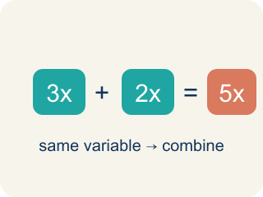
Like terms (Términos semejantes) — Terms with the same letter raised to the same power, like 2x and 5x.

Practice
Show your work. Use the blank space under each problem.
1. Spot the Common Mistake
Step 1 (Expression): 5(3x + 2)
Step 2 (Distribute): 5 × 3x + 2
Step 3 (Simplify): 15x + 2
Which step has the mistake? Explain and fix it:
______________________________________________________________________
______________________________________________________________________
______________________________________________________________________
2. Find the Distributive Error
Step 1 (Expression): 5(2x + 4)
Step 2 (Distribute): 5 × 2x + 4
Step 3 (Simplify): 10x + 4
Which step has the mistake? Explain and fix it:
______________________________________________________________________
______________________________________________________________________
______________________________________________________________________
3. Use the distributive property to explain why 6 × 98 can be calculated as 6 × 100 − 6 × 2 = 588. Then create your own example of using the distributive property to make multiplication easier.
Sentence starter: 6 × 98 = 6(100 − 2) = 6 × ___ − 6 × ___ = ___ − ___ = ___. My example: ___ × ___ = ___(___ ± ___) = ___.
______________________________________________________________________
______________________________________________________________________
______________________________________________________________________
______________________________________________________________________
4. Light Cue 1: Expand 3(x + 4) for the stage-light controller.
A. 3x + 12
B. 3x + 4
C. x + 12
D. 3x + 7
______________________________________________________________________

Answer Key (Teacher)
1. Spot the Common Mistake
The mistake is in Step 2.
Correct work: 5(3x + 2) = 5 × 3x + 5 × 2 = 15x + 10. The student distributed the 5 to the 3x (getting 15x) but left the 2 unchanged. The factor must multiply every term inside, so 5 × 2 = 10, not 2.
Watch for: The 5 was distributed to the 3x, correctly giving 15x, but the 2 was copied down untouched. Both terms inside must be multiplied: 5(3x + 2) = 5 × 3x + 5 × 2 = 15x + 10, not 15x + 2.
2. Find the Distributive Error
The mistake is in Step 2.
Correct work: 5(2x + 4) = 5 × 2x + 5 × 4 = 10x + 20. You must distribute the 5 to BOTH terms inside the parentheses, not just the first one.
Watch for: The 5 multiplied only the first term inside. Distributing to both gives 5(2x + 4) = 5 × 2x + 5 × 4 = 10x + 20. Testing with x = 1 confirms it: the original 5(2 + 4) = 30 and 10(1) + 20 = 30, while the student's 10x + 4 would give only 14.
3. Open response — answers will vary.
Look for key words: distributive, factor, expand, mental math, equivalent, multiply.
4. A. 3x + 12
Distribute the 3 to each term: 3 × x + 3 × 4 = 3x + 12.
Watch for: The most common mistake in The Distributive Property is multiplying the outside factor by only the FIRST term inside the parentheses and forgetting the second — for example, writing 3(x + 4) = 3x + 4 instead of 3x + 12. Before you submit, check: did the outside number reach BOTH terms inside the parentheses?

