The Distributive Property — Homework
Lesson 6-14 • Standard 6.AT.7
Name: ______________________ Period: ______ Date: ____________

Today's Goals
Content: I can use the distributive property to expand and factor expressions.
Language: I can explain my steps using the words distributive property, factor, expand, and equivalent.

Key Words
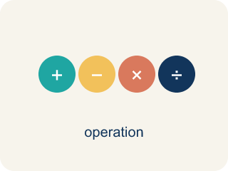
The Distributive Property (La propiedad distributiva) — Multiply a factor by every term inside parentheses.
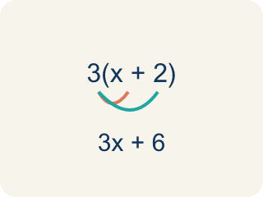
Distributive Property (Propiedad distributiva) — Multiplying a number by everything inside the parentheses: a(b + c) = ab + ac.
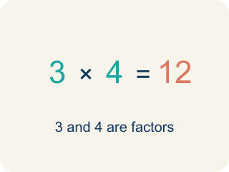
Factor (Factor) — A factor of a whole number divides it evenly, with no remainder. For example, 3 is a factor of 12 because 12 ÷ 3 = 4.

Expand (Desarrollar) — To multiply out the parentheses in an expression.
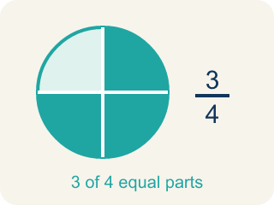
Equivalent (Equivalente) — Expressions that always have the same value.
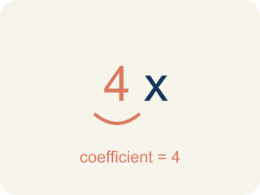
Coefficient (Coeficiente) — The number in front of a letter, like the 3 in 3x.
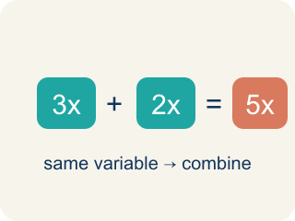
Like terms (Términos semejantes) — Terms with the same letter raised to the same power, like 2x and 5x.

Practice
Show your work. Use the blank space under each problem.
1. Expand 6(n + 3) using the distributive property.
A. 6n + 18
B. 6n + 3
C. n + 18
D. 6n + 9
______________________________________________________________________
2. Expand 4(5 − 2) using the distributive property.
A. 12
B. 20 − 2
C. 9
D. 22
______________________________________________________________________
3. Use the distributive property to expand each expression.
Factored Form | Expanded Form
3(2x + 5)
7(a − 4)
2(3m + 8)
5(6 − y)
______________________________________________________________________
4. Match each factored form to its expanded form.
Item | Answer choices
____ 2(x + 9) | F. 8x − 24
____ 5(3n − 2) | E. 12m + 6
____ 4(a + 6) | D. 21 − 3y
____ 3(7 − y) | C. 4a + 24
____ 6(2m + 1) | B. 15n − 10
____ 8(x − 3) | A. 2x + 18
______________________________________________________________________
5. Expand each expression, then sort by whether the expanded form has a constant greater than 15 or not.
Groups: Constant > 15 | Constant ≤ 15
• 3(x + 7) = 3x + 21 → __________________
• 2(n + 5) = 2n + 10 → __________________
• 5(a + 4) = 5a + 20 → __________________
• 4(y − 2) = 4y − 8 → __________________
• 6(m + 3) = 6m + 18 → __________________
• 2(3x + 1) = 6x + 2 → __________________
______________________________________________________________________
6. Spot the Common Mistake
Step 1 (Expression): 5(3x + 2)
Step 2 (Distribute): 5 × 3x + 2
Step 3 (Simplify): 15x + 2
Which step has the mistake? Explain and fix it:
______________________________________________________________________
______________________________________________________________________
______________________________________________________________________
7. Light Cue 1: Expand 3(x + 4) for the stage-light controller.
A. 3x + 12
B. 3x + 4
C. x + 12
D. 3x + 7
______________________________________________________________________
8. Light Cue 2: Expand 5(2 + n) to set two spotlight banks.
A. 10 + 5n
B. 10 + n
C. 7 + 5n
D. 10 + 5
______________________________________________________________________
9. Light Cue 3: Expand 4(a + 2) for the back-row beam.
A. 4a + 8
B. 4a + 2
C. a + 8
D. 4a + 6
______________________________________________________________________
10. Match each a(b + c) light cue to its ab + ac expanded form.
Item | Answer choices
____ 2(b + c) | D. 5p + 5
____ 6(x + 2) | C. 3m + 15
____ 3(m + 5) | B. 6x + 12
____ 5(p + 1) | A. 2b + 2c
______________________________________________________________________

Answer Key (Teacher)
1. A. 6n + 18
6(n + 3) = 6 × n + 6 × 3 = 6n + 18.
Watch for: The most common mistake in The Distributive Property is multiplying the outside factor by only the FIRST term inside the parentheses and forgetting the second — for example, writing 3(x + 4) = 3x + 4 instead of 3x + 12. Before you submit, check: did the outside number reach BOTH terms inside the parentheses?
2. A. 12
4(5 − 2) = 4 × 5 − 4 × 2 = 20 − 8 = 12.
Watch for: The most common mistake in The Distributive Property is multiplying the outside factor by only the FIRST term inside the parentheses and forgetting the second — for example, writing 3(x + 4) = 3x + 4 instead of 3x + 12. Before you submit, check: did the outside number reach BOTH terms inside the parentheses?
3. Use the distributive property to expand each expression.
3(2x + 5) — Expanded Form: 6x + 15
7(a − 4) — Expanded Form: 7a − 28
2(3m + 8) — Expanded Form: 6m + 16
5(6 − y) — Expanded Form: 30 − 5y

4. Matches:
2(x + 9) → 2x + 18
5(3n − 2) → 15n − 10
4(a + 6) → 4a + 24
3(7 − y) → 21 − 3y
6(2m + 1) → 12m + 6
8(x − 3) → 8x − 24

5. Correct groups:
3(x + 7) = 3x + 21 → Constant > 15
2(n + 5) = 2n + 10 → Constant ≤ 15
5(a + 4) = 5a + 20 → Constant > 15
4(y − 2) = 4y − 8 → Constant ≤ 15
6(m + 3) = 6m + 18 → Constant > 15
2(3x + 1) = 6x + 2 → Constant ≤ 15

6. Spot the Common Mistake
The mistake is in Step 2.
Correct work: 5(3x + 2) = 5 × 3x + 5 × 2 = 15x + 10. The student distributed the 5 to the 3x (getting 15x) but left the 2 unchanged. The factor must multiply every term inside, so 5 × 2 = 10, not 2.
Watch for: The 5 was distributed to the 3x, correctly giving 15x, but the 2 was copied down untouched. Both terms inside must be multiplied: 5(3x + 2) = 5 × 3x + 5 × 2 = 15x + 10, not 15x + 2.
7. A. 3x + 12
Distribute the 3 to each term: 3 × x + 3 × 4 = 3x + 12.
Watch for: The most common mistake in The Distributive Property is multiplying the outside factor by only the FIRST term inside the parentheses and forgetting the second — for example, writing 3(x + 4) = 3x + 4 instead of 3x + 12. Before you submit, check: did the outside number reach BOTH terms inside the parentheses?
8. A. 10 + 5n
Distribute the 5 to each term: 5 × 2 + 5 × n = 10 + 5n.
Watch for: The most common mistake in The Distributive Property is multiplying the outside factor by only the FIRST term inside the parentheses and forgetting the second — for example, writing 3(x + 4) = 3x + 4 instead of 3x + 12. Before you submit, check: did the outside number reach BOTH terms inside the parentheses?
9. A. 4a + 8
Distribute the 4 to each term: 4 × a + 4 × 2 = 4a + 8.
Watch for: The most common mistake in The Distributive Property is multiplying the outside factor by only the FIRST term inside the parentheses and forgetting the second — for example, writing 3(x + 4) = 3x + 4 instead of 3x + 12. Before you submit, check: did the outside number reach BOTH terms inside the parentheses?
10. Matches:
2(b + c) → 2b + 2c
6(x + 2) → 6x + 12
3(m + 5) → 3m + 15
5(p + 1) → 5p + 5

