6.4–6.15 Catch-Up — Homework
Lesson 6-15-catchup • Standard 6.AT.7
Name: ______________________ Period: ______ Date: ____________

Today's Goals
Content: I can show I am caught up on Lessons 6.4–6.15 by using each lesson's big idea in mixed practice.
Language: I can explain which lesson's big idea I used and how, using key vocabulary from Lessons 6.4–6.15.

Key Words
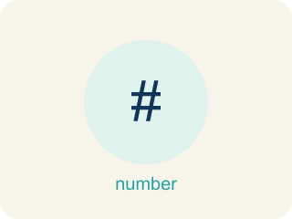
Evaluate Expressions (Evaluar expresiones) — Find the value of an expression by substituting numbers and following the order of operations.
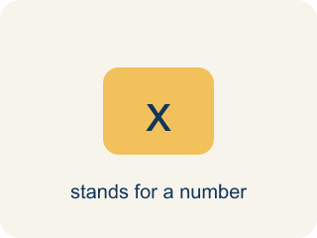
Variable (Variable) — A letter that stands for a number that is unknown or can change.

Write Algebraic Expressions (Escribir expresiones algebraicas) — Translate words or a situation into numbers, variables, and operation symbols.

Equivalent Expressions (Expresiones equivalentes) — Expressions that look different but have the same value for every allowed variable value.
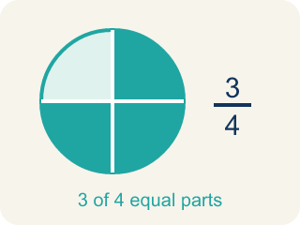
Equivalent (Equivalente) — Expressions that always have the same value.
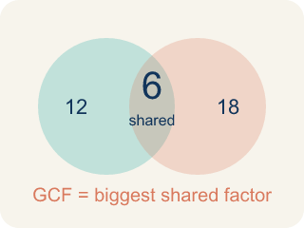
Greatest Common Factor (Máximo común divisor) — The greatest whole number that divides two or more numbers with no remainder.
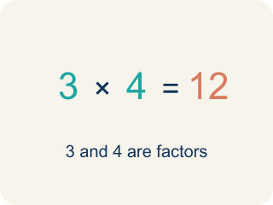
Factor (Factor) — A factor of a whole number divides it evenly, with no remainder. For example, 3 is a factor of 12 because 12 ÷ 3 = 4.
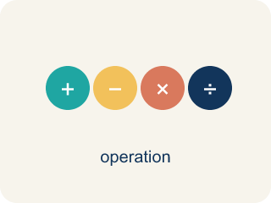
Properties of Operations (Propiedades de las operaciones) — Rules that let you reorder or regroup numbers without changing an expression's value.
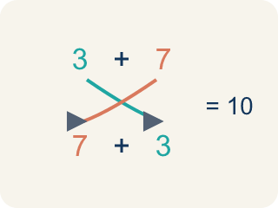
Commutative Property (Propiedad conmutativa) — You can change the order and get the same answer.

Divide Whole Numbers by Fractions (Dividir números enteros entre fracciones) — Find how many fractional groups fit in a whole number by multiplying by the reciprocal.
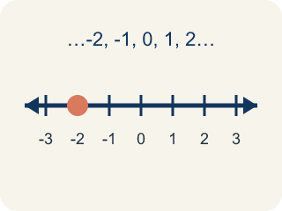
Whole Number (Número entero) — A counting number with no fraction or decimal, like 0, 1, 2, 3.

Divide Mixed Numbers (Dividir números mixtos) — Change mixed numbers to improper fractions, then multiply by the reciprocal.
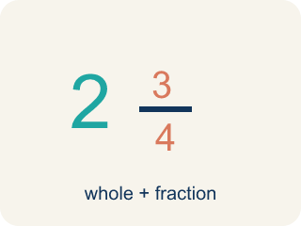
Mixed Number (Número mixto) — A whole number plus a fraction, like 2 1/3.

Fraction Division Problem Solving (Resolución de problemas de división de fracciones) — Use fraction division to find an unknown number of groups or the size of each group.
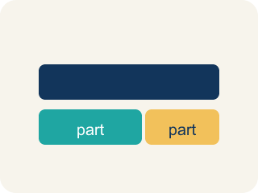
Model (Modelo) — A picture or math way to show a problem so you can solve it.
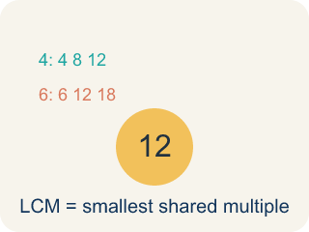
Least Common Multiple (Mínimo común múltiplo) — The least positive number that is a multiple of two or more numbers.
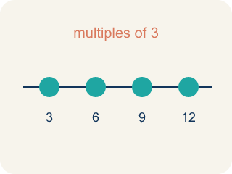
Multiple (Múltiplo) — What you get when you multiply a number by 1, 2, 3, and so on.
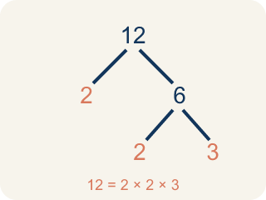
Prime Factorization (Factorización prima) — Writing a whole number as a product of only prime numbers.
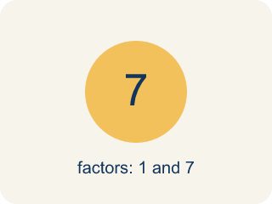
Prime number (Número primo) — A number bigger than 1 that you can only divide by 1 and itself.

The Distributive Property (La propiedad distributiva) — Multiply a factor by every term inside parentheses.
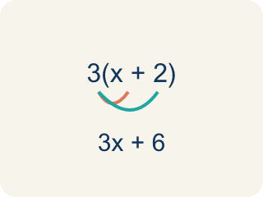
Distributive Property (Propiedad distributiva) — Multiplying a number by everything inside the parentheses: a(b + c) = ab + ac.

Simplify Algebraic Expressions (Simplificar expresiones algebraicas) — Rewrite an expression in a shorter equivalent form by combining like terms and using properties.
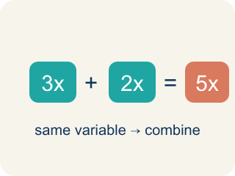
Like Terms (Términos semejantes) — Terms with the same letter raised to the same power, like 2x and 5x.
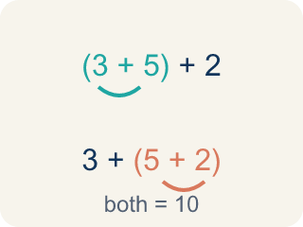
Associative Property (Propiedad asociativa) — You can change the grouping and get the same answer.

Simplify (Simplificar) — To write an expression in a shorter, simpler way.
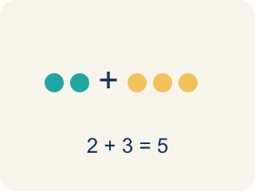
Combine (Combinar) — To add or subtract terms with the same letter into one.

Practice
Show your work. Use the blank space under each problem.
1. (Lesson 6.4) Evaluate 3x + 7 when x = 4.
A. 19
B. 34
C. 12
D. 14
______________________________________________________________________
2. (Lesson 6.4) Evaluate 20 − 2n when n = 6.
A. 8
B. 14
C. 32
D. 12
______________________________________________________________________
3. (Lesson 6.4) Spot the Common Mistake
Step 1 (Expression): Evaluate 5n − 3 when n = 6
Step 2 (Substitute): 5(6) − 3
Step 3 (Subtract first): 5 × (6 − 3) = 5 × 3 = 15
Which step has the mistake? Explain and fix it:
______________________________________________________________________
______________________________________________________________________
______________________________________________________________________
4. (Lesson 6.4) Evaluate each expression for the given value of the variable.
Expression | Variable Value | Substitution | Result
5n − 3 | n = 6 | 5(6) − 3
n² + 4 | n = 3 | 3² + 4
2(n + 8) | n = 5 | 2(5 + 8)
40 − 3n | n = 7 | 40 − 3(7)
______________________________________________________________________
5. (Lesson 6.5) Spot the Common Mistake
Step 1 (Phrase): 8 divided by a number m
Step 2 (Student's expression): m ÷ 8
Step 3 (Reasoning): I saw 'divided by' so I wrote the variable first and then 8.
Which step has the mistake? Explain and fix it:
______________________________________________________________________
______________________________________________________________________
______________________________________________________________________
6. (Lesson 6.5) Match each word phrase to its correct algebraic expression.
Groups: Correctly Matched
• twice a number k → 2k → __________________
• a number b divided by 5 → b ÷ 5 → __________________
• the sum of a number d and 15 → d + 15 → __________________
• 10 decreased by a number r → 10 − r → __________________
• 4 more than triple a number c → 3c + 4 → __________________
• half of a number h → h ÷ 2 → __________________
______________________________________________________________________
7. (Lesson 6.6) Spot the Combining Mistake
Step 1 (Expression): 7x + 3 + 2x
Step 2 (Combine): Combine every number you see: 7x + 2x + 3 = 9x + 3, then add the 9 and 3 too
Step 3 (Result): 7x + 3 + 2x = 12x
Which step has the mistake? Explain and fix it:
______________________________________________________________________
______________________________________________________________________
______________________________________________________________________
8. (Lesson 6.6) Match each expression with its simplified form.
Groups: Correctly Matched
• 8y + 2y → 10y → __________________
• 3(a + 6) → 3a + 18 → __________________
• 5n + 4 + 2n → 7n + 4 → __________________
• 9p − 3p → 6p → __________________
• 4(2x − 1) → 8x − 4 → __________________
• 6t + t → 7t → __________________
______________________________________________________________________
9. (Lesson 6.7) A teacher has 36 pencils and 48 erasers. She wants to make identical supply bags with no items left over. What is the greatest number of bags she can make?
A. 12 bags
B. 6 bags
C. 4 bags
D. 36 bags
______________________________________________________________________
10. (Lesson 6.7) Spot the Common Mistake — GCF or LCM?
Step 1 (The problem): Find the GCF of 8 and 20.
Step 2 (List factors of 8): 1, 2, 4, 8
Step 3 (List factors of 20): 1, 2, 4, 5, 10, 20
Step 4 (Choose the answer): Jordan multiplies 8 × 20 = 160 and says the GCF of 8 and 20 is 160.
Which step has the mistake? Explain and fix it:
______________________________________________________________________
______________________________________________________________________
______________________________________________________________________

Answer Key (Teacher)
1. A. 19
3(4) + 7 = 12 + 7 = 19.
Watch for: A common mistake in Simplify Algebraic Expressions is sweeping a constant into the variable terms — for example, simplifying 6x + 4 + 2x as 12x by adding all three numbers (6 + 4 + 2 = 12) instead of recognizing that 4 has no variable and cannot combine with 6x and 2x. The correct simplified expression is 8x + 4 (combine 6x + 2x = 8x, and let the 4 stay on its own). Before you submit, check that every term you combined has the exact same variable part.
2. A. 8
20 − 2(6) = 20 − 12 = 8.
Watch for: A common mistake in Simplify Algebraic Expressions is sweeping a constant into the variable terms — for example, simplifying 6x + 4 + 2x as 12x by adding all three numbers (6 + 4 + 2 = 12) instead of recognizing that 4 has no variable and cannot combine with 6x and 2x. The correct simplified expression is 8x + 4 (combine 6x + 2x = 8x, and let the 4 stay on its own). Before you submit, check that every term you combined has the exact same variable part.
3. (Lesson 6.4) Spot the Common Mistake
The mistake is in Step 3.
Correct work: 5(6) − 3 = 30 − 3 = 27. Follow the order of operations: multiply 5 × 6 = 30 FIRST, then subtract 3. There are no parentheses around 6 − 3, so you cannot subtract before multiplying.
Watch for: The step subtracted before multiplying, which would only be allowed if parentheses grouped 6 − 3. In 5(6) − 3 the multiplication comes first: 30 − 3 = 27. Inventing that grouping turned the problem into 5(6 − 3) and produced 15 instead.
4. (Lesson 6.4) Evaluate each expression for the given value of the variable.
5n − 3 — Result: 27
n² + 4 — Result: 13
2(n + 8) — Result: 26
40 − 3n — Result: 19

5. (Lesson 6.5) Spot the Common Mistake
The mistake is in Step 2.
Correct work: '8 divided by a number m' means start with 8 and divide it by m: 8 ÷ m. Division is not commutative, so order matters — m ÷ 8 means something different (a number m divided by 8).
Watch for: The expression step wrote the variable first, but "8 divided by a number m" starts with the 8 and splits it. Division is not commutative, so the correct translation is 8 ÷ m — with m = 2, 8 ÷ 2 = 4 while 2 ÷ 8 = 0.25.
6. Correct groups:
twice a number k → 2k → Correctly Matched
a number b divided by 5 → b ÷ 5 → Correctly Matched
the sum of a number d and 15 → d + 15 → Correctly Matched
10 decreased by a number r → 10 − r → Correctly Matched
4 more than triple a number c → 3c + 4 → Correctly Matched
half of a number h → h ÷ 2 → Correctly Matched

7. (Lesson 6.6) Spot the Combining Mistake
The mistake is in Step 2.
Correct work: Only LIKE terms combine. 7x and 2x are like terms (7x + 2x = 9x), but the 3 is a constant and cannot be added to the 9x. The simplified form is 9x + 3. Check x = 2: 7(2) + 3 + 2(2) = 21 and 9(2) + 3 = 21, but 12(2) = 24 — so 12x is wrong.
Watch for: 7x and 2x are like terms, so 7x + 2x = 9x is fine — but the step keeps going and adds the 9 to the 3. A constant like 3 has no variable, so it cannot join 9x in one term. The simplified form is 9x + 3. Check with x = 2: 7(2) + 3 + 2(2) = 21 and 9(2) + 3 = 21, but 12(2) = 24.
8. Correct groups:
8y + 2y → 10y → Correctly Matched
3(a + 6) → 3a + 18 → Correctly Matched
5n + 4 + 2n → 7n + 4 → Correctly Matched
9p − 3p → 6p → Correctly Matched
4(2x − 1) → 8x − 4 → Correctly Matched
6t + t → 7t → Correctly Matched

9. A. 12 bags
GCF(36, 48) = 12. She can make 12 bags, each with 3 pencils and 4 erasers.
Watch for: A common mistake in Simplify Algebraic Expressions is sweeping a constant into the variable terms — for example, simplifying 6x + 4 + 2x as 12x by adding all three numbers (6 + 4 + 2 = 12) instead of recognizing that 4 has no variable and cannot combine with 6x and 2x. The correct simplified expression is 8x + 4 (combine 6x + 2x = 8x, and let the 4 stay on its own). Before you submit, check that every term you combined has the exact same variable part.
10. (Lesson 6.7) Spot the Common Mistake — GCF or LCM?
The mistake is in Step 4.
Correct work: Multiplying the two numbers does not give the GCF. The GCF is the largest factor the numbers SHARE. The common factors of 8 and 20 are 1, 2, and 4, so the GCF is 4 — and a factor can never be larger than the numbers themselves.
Watch for: Jordan multiplied 8 × 20 to get 160, but multiplying two numbers produces a common multiple, not a common factor. A factor of 8 can never be larger than 8 itself. The factors 8 and 20 share are 1, 2, and 4, so GCF(8, 20) = 4.

