6.15 Small Group · Group 1 — Homework
Lesson 6-15-group1 • Standard 6.AT.7
Name: ______________________ Period: ______ Date: ____________

Today's Goals
Content: With my small group, I can simplify algebraic expressions by combining like terms — one step at a time, with support.
Language: I can talk through each step out loud using a sentence frame and the lesson's key words.

Key Words
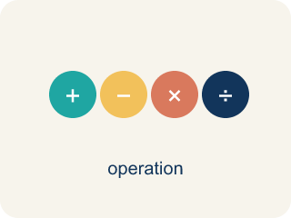
Simplify Algebraic Expressions (Simplificar expresiones algebraicas) — Rewrite an expression in a shorter equivalent form by combining like terms and using properties.
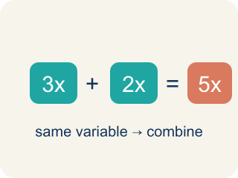
Like Terms (Términos semejantes) — Terms with the same letter raised to the same power, like 2x and 5x.
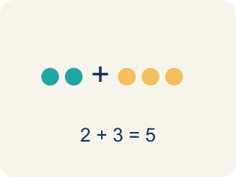
Combine (Combinar) — To add or subtract terms with the same letter into one.
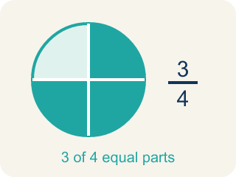
Simplify (Simplificar) — To write an expression in its shortest form.
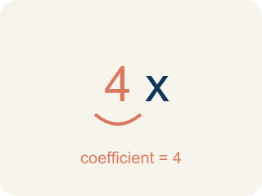
Coefficient (Coeficiente) — The number in front of a letter, like the 3 in 3x.
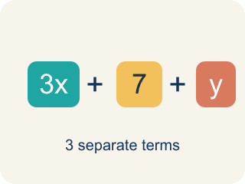
Term (Término) — A single number, variable, or product of them, separated by + or − signs.
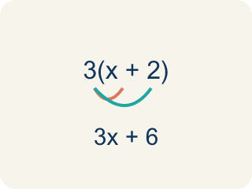
Distributive property (Propiedad distributiva) — Multiplying a number by everything inside the parentheses: a(b + c) = ab + ac.

Practice
Show your work. Use the blank space under each problem.
1. Simplify 7x + 3x.
A. 10x
B. 10x²
C. 21x
D. 73x
______________________________________________________________________
2. Simplify 9n + 4 + 2n.
A. 11n + 4
B. 15n
C. 11n² + 4
D. 92n + 4
______________________________________________________________________
3. The board shows 3x + 5x on one channel. Simplify it.
A. 8x
B. 15x
C. 8x²
D. 35x
______________________________________________________________________
4. Simplify the track: 4a + 2 + a.
A. 5a + 2
B. 7a
C. 5a²+ 2
D. 6a
______________________________________________________________________
5. Clean up this channel: 7y − 3y.
A. 4y
B. 10y
C. 4
D. 21y
______________________________________________________________________
6. Simplify the mix: 6m + 4 + 3m.
A. 9m + 4
B. 13m
C. 9m + 4m
D. 10m
______________________________________________________________________
7. Level 2 Extension — Crossed Channels on the Board
Step 1 (Track): 3x + 5
Step 2 (Combine): Add the 3 and the 5
Step 3 (Simplify): 8x
Which step has the mistake? Explain and fix it:
______________________________________________________________________
______________________________________________________________________
______________________________________________________________________
8. Find the Simplification Error
Step 1 (Expression): 5x + 3 + 2y + 4x
Step 2 (Combine): 5x + 2y + 4x + 3
Step 3 (Simplify): 11xy + 3
Which step has the mistake? Explain and fix it:
______________________________________________________________________
______________________________________________________________________
______________________________________________________________________

Answer Key (Teacher)
1. A. 10x
7x + 3x = 10x. Add the coefficients: 7 + 3 = 10.
Watch for: A common mistake in Simplify Algebraic Expressions is sweeping a constant into the variable terms — for example, simplifying 6x + 4 + 2x as 12x by adding all three numbers (6 + 4 + 2 = 12) instead of recognizing that 4 has no variable and cannot combine with 6x and 2x. The correct simplified expression is 8x + 4 (combine 6x + 2x = 8x, and let the 4 stay on its own). Before you submit, check that every term you combined has the exact same variable part.
2. A. 11n + 4
9n + 2n = 11n. The constant 4 has no like term, so it stays. Result: 11n + 4.
Watch for: A common mistake in Simplify Algebraic Expressions is sweeping a constant into the variable terms — for example, simplifying 6x + 4 + 2x as 12x by adding all three numbers (6 + 4 + 2 = 12) instead of recognizing that 4 has no variable and cannot combine with 6x and 2x. The correct simplified expression is 8x + 4 (combine 6x + 2x = 8x, and let the 4 stay on its own). Before you submit, check that every term you combined has the exact same variable part.
3. A. 8x
3x and 5x are like terms, so add the coefficients: 3 + 5 = 8. The variable x stays, giving 8x.
Watch for: A common mistake in Simplify Algebraic Expressions is sweeping a constant into the variable terms — for example, simplifying 6x + 4 + 2x as 12x by adding all three numbers (6 + 4 + 2 = 12) instead of recognizing that 4 has no variable and cannot combine with 6x and 2x. The correct simplified expression is 8x + 4 (combine 6x + 2x = 8x, and let the 4 stay on its own). Before you submit, check that every term you combined has the exact same variable part.
4. A. 5a + 2
4a + a = 5a (remember a means 1a). The 2 has no like term, so it stays. Result: 5a + 2.
Watch for: A common mistake in Simplify Algebraic Expressions is sweeping a constant into the variable terms — for example, simplifying 6x + 4 + 2x as 12x by adding all three numbers (6 + 4 + 2 = 12) instead of recognizing that 4 has no variable and cannot combine with 6x and 2x. The correct simplified expression is 8x + 4 (combine 6x + 2x = 8x, and let the 4 stay on its own). Before you submit, check that every term you combined has the exact same variable part.
5. A. 4y
Subtract the coefficients of the like terms: 7 − 3 = 4. Keep the variable y, giving 4y.
Watch for: A common mistake in Simplify Algebraic Expressions is sweeping a constant into the variable terms — for example, simplifying 6x + 4 + 2x as 12x by adding all three numbers (6 + 4 + 2 = 12) instead of recognizing that 4 has no variable and cannot combine with 6x and 2x. The correct simplified expression is 8x + 4 (combine 6x + 2x = 8x, and let the 4 stay on its own). Before you submit, check that every term you combined has the exact same variable part.
6. A. 9m + 4
6m + 3m = 9m. The constant 4 has no like term, so it stays. Result: 9m + 4.
Watch for: A common mistake in Simplify Algebraic Expressions is sweeping a constant into the variable terms — for example, simplifying 6x + 4 + 2x as 12x by adding all three numbers (6 + 4 + 2 = 12) instead of recognizing that 4 has no variable and cannot combine with 6x and 2x. The correct simplified expression is 8x + 4 (combine 6x + 2x = 8x, and let the 4 stay on its own). Before you submit, check that every term you combined has the exact same variable part.
7. Level 2 Extension — Crossed Channels on the Board
The mistake is in Step 3.
Correct work: 3x and 5 are NOT like terms — 3x has the variable x and 5 is a constant with no variable. They cannot be combined. The expression 3x + 5 is already in simplest form. Writing 8x is wrong because it changes the value (at x = 2, 3x + 5 = 11 but 8x = 16).
Watch for: The Combine step added the 3 and the 5, but 3x has the variable x while 5 has none, so they are not like terms. Nothing can be combined here — 3x + 5 is already in simplest form, and writing 8x changes the value (at x = 2 it gives 16 instead of 11).
8. Find the Simplification Error
The mistake is in Step 3.
Correct work: 5x + 4x = 9x (like terms). 2y stays separate (no other y-term). The constant 3 stays. Correct answer: 9x + 2y + 3. You cannot combine x-terms and y-terms into xy.
Watch for: The Simplify step merged the x-terms and the y-term into 11xy, but terms with different variables can never be combined. Only 5x + 4x = 9x are like terms; 2y and the constant 3 each stand alone, so the expression simplifies to 9x + 2y + 3.

