6.15 Small Group · Group 2 — Homework
Lesson 6-15-group2 • Standard 6.AT.7
Name: ______________________ Period: ______ Date: ____________

Today's Goals
Content: I can simplify algebraic expressions by combining like terms, explain why the method works, and use it on a problem I have not seen before.
Language: I can justify my answer to a skeptic and connect it to a second strategy or representation.

Key Words
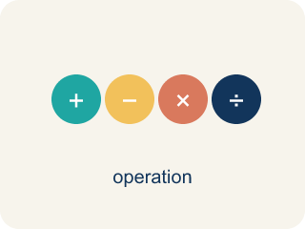
Simplify Algebraic Expressions (Simplificar expresiones algebraicas) — Rewrite an expression in a shorter equivalent form by combining like terms and using properties.
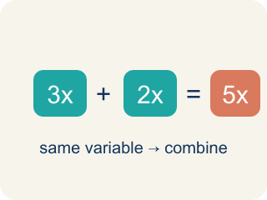
Like Terms (Términos semejantes) — Terms with the same letter raised to the same power, like 2x and 5x.
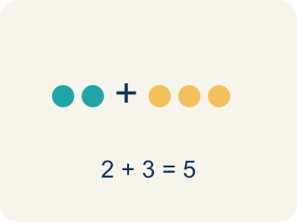
Combine (Combinar) — To add or subtract terms with the same letter into one.
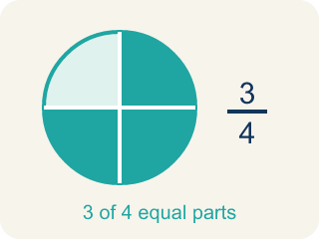
Simplify (Simplificar) — To write an expression in its shortest form.
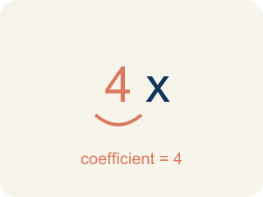
Coefficient (Coeficiente) — The number in front of a letter, like the 3 in 3x.
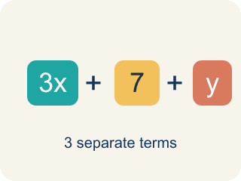
Term (Término) — A single number, variable, or product of them, separated by + or − signs.
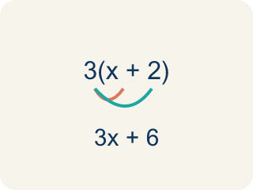
Distributive property (Propiedad distributiva) — Multiplying a number by everything inside the parentheses: a(b + c) = ab + ac.

Practice
Show your work. Use the blank space under each problem.
1. Spot the Mistake — Swept-Up Constant
Step 1 (Expression): 6x + 4 + 2x
Step 2 (Combine): Add everything: 6 + 4 + 2 = 12
Step 3 (Simplify): 12x
Which step has the mistake? Explain and fix it:
______________________________________________________________________
______________________________________________________________________
______________________________________________________________________
2. Find the Simplification Error
Step 1 (Expression): 5x + 3 + 2y + 4x
Step 2 (Combine): 5x + 2y + 4x + 3
Step 3 (Simplify): 11xy + 3
Which step has the mistake? Explain and fix it:
______________________________________________________________________
______________________________________________________________________
______________________________________________________________________
3. Three students simplified 4x + 3 + 2x + 5 + x differently. Student A got 7x + 8. Student B got 7x² + 8. Student C got 6x + 9. Who is correct? Explain the mistakes the other two students made.
Sentence starter: Student ___ is correct because 4x + 2x + x = ___x and 3 + 5 = ___. Student ___'s error was ___. Student ___'s error was ___.
______________________________________________________________________
______________________________________________________________________
______________________________________________________________________
______________________________________________________________________
4. The board shows 3x + 5x on one channel. Simplify it.
A. 8x
B. 15x
C. 8x²
D. 35x
______________________________________________________________________

Answer Key (Teacher)
1. Spot the Mistake — Swept-Up Constant
The mistake is in Step 2.
Correct work: The 4 is a constant with no variable, so it cannot be combined with the x-terms. Combine only the like terms: 6x + 2x = 8x, and the 4 stays on its own. The correct simplified expression is 8x + 4. (Check: at x = 1, 6x + 4 + 2x = 6 + 4 + 2 = 12, and 8x + 4 = 12, but 12x = 12 only by accident — at x = 2 it gives 24 instead of the true 20.)
Watch for: The Combine step swept the constant 4 in with the coefficients 6 and 2, but 4 has no variable, so it is not a like term. Only 6x + 2x = 8x combine, and the 4 stays on its own, giving 8x + 4 — at x = 2 that is 20, while 12x would give 24.
2. Find the Simplification Error
The mistake is in Step 3.
Correct work: 5x + 4x = 9x (like terms). 2y stays separate (no other y-term). The constant 3 stays. Correct answer: 9x + 2y + 3. You cannot combine x-terms and y-terms into xy.
Watch for: The Simplify step merged the x-terms and the y-term into 11xy, but terms with different variables can never be combined. Only 5x + 4x = 9x are like terms; 2y and the constant 3 each stand alone, so the expression simplifies to 9x + 2y + 3.
3. Open response — answers will vary.
Look for key words: like terms, combine, coefficient, add, variable, error, simplify.
4. A. 8x
3x and 5x are like terms, so add the coefficients: 3 + 5 = 8. The variable x stays, giving 8x.
Watch for: A common mistake in Simplify Algebraic Expressions is sweeping a constant into the variable terms — for example, simplifying 6x + 4 + 2x as 12x by adding all three numbers (6 + 4 + 2 = 12) instead of recognizing that 4 has no variable and cannot combine with 6x and 2x. The correct simplified expression is 8x + 4 (combine 6x + 2x = 8x, and let the 4 stay on its own). Before you submit, check that every term you combined has the exact same variable part.

