Simplify Algebraic Expressions — Homework
Lesson 6-15 • Standard 6.AT.7
Name: ______________________ Period: ______ Date: ____________

Today's Goals
Content: I can simplify algebraic expressions by combining like terms.
Language: I can explain my steps using the words like terms, combine, simplify, and coefficient.

Key Words
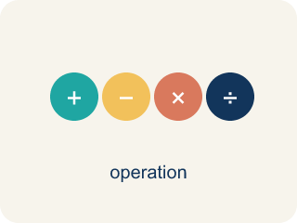
Simplify Algebraic Expressions (Simplificar expresiones algebraicas) — Rewrite an expression in a shorter equivalent form by combining like terms and using properties.
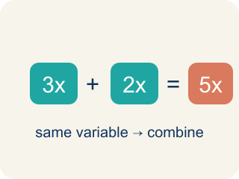
Like Terms (Términos semejantes) — Terms with the same letter raised to the same power, like 2x and 5x.
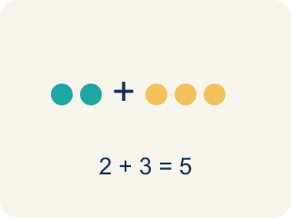
Combine (Combinar) — To add or subtract terms with the same letter into one.
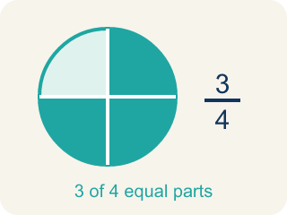
Simplify (Simplificar) — To write an expression in its shortest form.
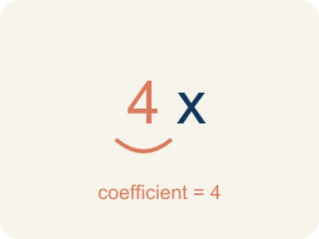
Coefficient (Coeficiente) — The number in front of a letter, like the 3 in 3x.
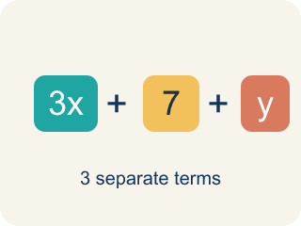
Term (Término) — A single number, variable, or product of them, separated by + or − signs.
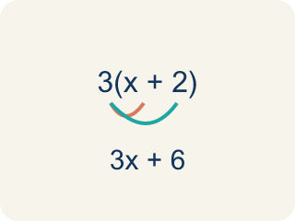
Distributive property (Propiedad distributiva) — Multiplying a number by everything inside the parentheses: a(b + c) = ab + ac.

Practice
Show your work. Use the blank space under each problem.
1. Simplify 7x + 3x.
A. 10x
B. 10x²
C. 21x
D. 73x
______________________________________________________________________
2. Simplify 9n + 4 + 2n.
A. 11n + 4
B. 15n
C. 11n² + 4
D. 92n + 4
______________________________________________________________________
3. Simplify each expression by combining like terms.
Expression | Like Terms Combined | Simplified
3a + 5a + 2 | 3a + 5a = 8a
6x + 4 + 2x + 7
10m − 3m + 5
4y + 3 + y + 9
______________________________________________________________________
4. Match each expression to its simplified form.
Item | Answer choices
____ 8x + 3x + 1 | F. 6p + 1
____ 5a − 2a + 7 | E. 7m + 10
____ 4n + n + 6 | D. 7y
____ 12y − 5y | C. 5n + 6
____ 3m + 8 + 4m + 2 | B. 3a + 7
____ 9p + 1 − 3p | A. 11x + 1
______________________________________________________________________
5. Simplify each expression, then sort by whether the simplified coefficient of the variable is greater than 6 or not.
Groups: Coefficient > 6 | Coefficient ≤ 6
• 4x + 5x = 9x → coefficient 9 → __________________
• 8n − 3n = 5n → coefficient 5 → __________________
• 3a + a + 4a = 8a → coefficient 8 → __________________
• 10m − 7m = 3m → coefficient 3 → __________________
• 2y + 5y = 7y → coefficient 7 → __________________
• 6p − p = 5p → coefficient 5 → __________________
______________________________________________________________________
6. Spot the Mistake — Swept-Up Constant
Step 1 (Expression): 6x + 4 + 2x
Step 2 (Combine): Add everything: 6 + 4 + 2 = 12
Step 3 (Simplify): 12x
Which step has the mistake? Explain and fix it:
______________________________________________________________________
______________________________________________________________________
______________________________________________________________________
7. The board shows 3x + 5x on one channel. Simplify it.
A. 8x
B. 15x
C. 8x²
D. 35x
______________________________________________________________________
8. Simplify the track: 4a + 2 + a.
A. 5a + 2
B. 7a
C. 5a²+ 2
D. 6a
______________________________________________________________________
9. Clean up this channel: 7y − 3y.
A. 4y
B. 10y
C. 4
D. 21y
______________________________________________________________________
10. Simplify the mix: 6m + 4 + 3m.
A. 9m + 4
B. 13m
C. 9m + 4m
D. 10m
______________________________________________________________________

Answer Key (Teacher)
1. A. 10x
7x + 3x = 10x. Add the coefficients: 7 + 3 = 10.
Watch for: A common mistake in Simplify Algebraic Expressions is sweeping a constant into the variable terms — for example, simplifying 6x + 4 + 2x as 12x by adding all three numbers (6 + 4 + 2 = 12) instead of recognizing that 4 has no variable and cannot combine with 6x and 2x. The correct simplified expression is 8x + 4 (combine 6x + 2x = 8x, and let the 4 stay on its own). Before you submit, check that every term you combined has the exact same variable part.
2. A. 11n + 4
9n + 2n = 11n. The constant 4 has no like term, so it stays. Result: 11n + 4.
Watch for: A common mistake in Simplify Algebraic Expressions is sweeping a constant into the variable terms — for example, simplifying 6x + 4 + 2x as 12x by adding all three numbers (6 + 4 + 2 = 12) instead of recognizing that 4 has no variable and cannot combine with 6x and 2x. The correct simplified expression is 8x + 4 (combine 6x + 2x = 8x, and let the 4 stay on its own). Before you submit, check that every term you combined has the exact same variable part.
3. Simplify each expression by combining like terms.
3a + 5a + 2 — Simplified: 8a + 2
6x + 4 + 2x + 7 — Like Terms Combined: 6x + 2x = 8x, 4 + 7 = 11
6x + 4 + 2x + 7 — Simplified: 8x + 11
10m − 3m + 5 — Like Terms Combined: 10m − 3m = 7m
10m − 3m + 5 — Simplified: 7m + 5
4y + 3 + y + 9 — Like Terms Combined: 4y + y = 5y, 3 + 9 = 12
4y + 3 + y + 9 — Simplified: 5y + 12

4. Matches:
8x + 3x + 1 → 11x + 1
5a − 2a + 7 → 3a + 7
4n + n + 6 → 5n + 6
12y − 5y → 7y
3m + 8 + 4m + 2 → 7m + 10
9p + 1 − 3p → 6p + 1

5. Correct groups:
4x + 5x = 9x → coefficient 9 → Coefficient > 6
8n − 3n = 5n → coefficient 5 → Coefficient ≤ 6
3a + a + 4a = 8a → coefficient 8 → Coefficient > 6
10m − 7m = 3m → coefficient 3 → Coefficient ≤ 6
2y + 5y = 7y → coefficient 7 → Coefficient > 6
6p − p = 5p → coefficient 5 → Coefficient ≤ 6

6. Spot the Mistake — Swept-Up Constant
The mistake is in Step 2.
Correct work: The 4 is a constant with no variable, so it cannot be combined with the x-terms. Combine only the like terms: 6x + 2x = 8x, and the 4 stays on its own. The correct simplified expression is 8x + 4. (Check: at x = 1, 6x + 4 + 2x = 6 + 4 + 2 = 12, and 8x + 4 = 12, but 12x = 12 only by accident — at x = 2 it gives 24 instead of the true 20.)
Watch for: The Combine step swept the constant 4 in with the coefficients 6 and 2, but 4 has no variable, so it is not a like term. Only 6x + 2x = 8x combine, and the 4 stays on its own, giving 8x + 4 — at x = 2 that is 20, while 12x would give 24.
7. A. 8x
3x and 5x are like terms, so add the coefficients: 3 + 5 = 8. The variable x stays, giving 8x.
Watch for: A common mistake in Simplify Algebraic Expressions is sweeping a constant into the variable terms — for example, simplifying 6x + 4 + 2x as 12x by adding all three numbers (6 + 4 + 2 = 12) instead of recognizing that 4 has no variable and cannot combine with 6x and 2x. The correct simplified expression is 8x + 4 (combine 6x + 2x = 8x, and let the 4 stay on its own). Before you submit, check that every term you combined has the exact same variable part.
8. A. 5a + 2
4a + a = 5a (remember a means 1a). The 2 has no like term, so it stays. Result: 5a + 2.
Watch for: A common mistake in Simplify Algebraic Expressions is sweeping a constant into the variable terms — for example, simplifying 6x + 4 + 2x as 12x by adding all three numbers (6 + 4 + 2 = 12) instead of recognizing that 4 has no variable and cannot combine with 6x and 2x. The correct simplified expression is 8x + 4 (combine 6x + 2x = 8x, and let the 4 stay on its own). Before you submit, check that every term you combined has the exact same variable part.
9. A. 4y
Subtract the coefficients of the like terms: 7 − 3 = 4. Keep the variable y, giving 4y.
Watch for: A common mistake in Simplify Algebraic Expressions is sweeping a constant into the variable terms — for example, simplifying 6x + 4 + 2x as 12x by adding all three numbers (6 + 4 + 2 = 12) instead of recognizing that 4 has no variable and cannot combine with 6x and 2x. The correct simplified expression is 8x + 4 (combine 6x + 2x = 8x, and let the 4 stay on its own). Before you submit, check that every term you combined has the exact same variable part.
10. A. 9m + 4
6m + 3m = 9m. The constant 4 has no like term, so it stays. Result: 9m + 4.
Watch for: A common mistake in Simplify Algebraic Expressions is sweeping a constant into the variable terms — for example, simplifying 6x + 4 + 2x as 12x by adding all three numbers (6 + 4 + 2 = 12) instead of recognizing that 4 has no variable and cannot combine with 6x and 2x. The correct simplified expression is 8x + 4 (combine 6x + 2x = 8x, and let the 4 stay on its own). Before you submit, check that every term you combined has the exact same variable part.

