2.1–2.3 Catch-Up — Homework
Lesson 6-2-catchup • Standard 6.NOS.1
Name: ______________________ Period: ______ Date: ____________

Today's Goals
Content: I can show I am caught up on Lessons 2.1–2.3 by using each lesson's big idea in mixed practice.
Language: I can explain which lesson's big idea I used and how, using key vocabulary from Lessons 2.1–2.3.

Key Words
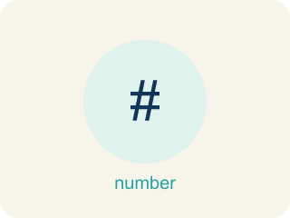
Division of Fractions (División de fracciones) — Finding how many groups of one fraction fit inside another amount.
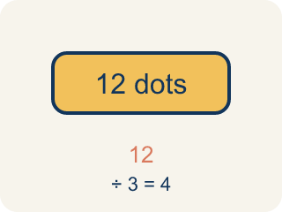
Dividend (Dividendo) — The number you are splitting up in a division problem.
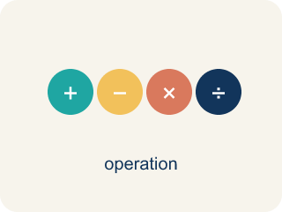
Divide Whole Numbers by Fractions (Dividir números enteros entre fracciones) — Find how many fractional groups fit in a whole number by multiplying by the reciprocal.
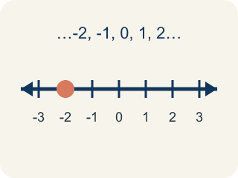
Whole Number (Número entero) — A counting number with no fraction or decimal, like 0, 1, 2, 3.

Divide Fractions (Dividir fracciones) — Multiply the first fraction by the reciprocal of the second fraction.
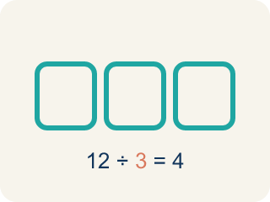
Divisor (Divisor) — The number you split by in a division problem.
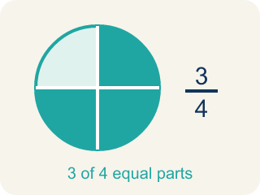
Fraction (Fracción) — A number that shows part of a whole, like 3/4.

Practice
Show your work. Use the blank space under each problem.
1. (Lesson 2.1) What does 3 ÷ 1/4 mean?
A. How many 1/4-size pieces fit into 3
B. 3 groups of 1/4
C. 3 minus 1/4
D. 1/4 of 3
______________________________________________________________________
2. (Lesson 2.1) Which expression means 'how many 1/3-size pieces are in 2'?
A. 2 ÷ 1/3
B. 2 × 1/3
C. 1/3 ÷ 2
D. 2 + 1/3
______________________________________________________________________
3. (Lesson 2.1) A shelf is 5 feet long. Books are each 1/4 foot wide. How many books fit on the shelf? Which expression represents this?
A. 5 ÷ 1/4 = 20 books
B. 5 × 1/4 = 1 1/4 books
C. 1/4 ÷ 5 = 1/20 book
D. 5 + 1/4 = 5 1/4 books
______________________________________________________________________
4. (Lesson 2.1) Spot the Common Mistake
Step 1 (Problem): How many 1/5-cup scoops fill a 6-cup container? Find 6 ÷ 1/5.
Step 2 (Student writes): I will flip the first number instead of the divisor: 6 ÷ 1/5 = 1/6 × 5 = 5/6 scoop.
Step 3 (Student's answer): 5/6 of a scoop
Which step has the mistake? Explain and fix it:
______________________________________________________________________
______________________________________________________________________
______________________________________________________________________
5. (Lesson 2.2) What is 6 ÷ 2/3?
A. 9
B. 4
C. 12
D. 2/18
______________________________________________________________________
6. (Lesson 2.2) Spot the Common Mistake
Step 1 (Problem): 8 ÷ 3/4
Step 2 (Keep, Change, Flip): Flipped the wrong number — wrote 1/8 × 3/4 instead of 8 × 4/3
Step 3 (Multiply): 1/8 × 3/4 = 3/32
Which step has the mistake? Explain and fix it:
______________________________________________________________________
______________________________________________________________________
______________________________________________________________________
7. (Lesson 2.3) A recipe needs 2/3 cup of sugar. You only have a 1/6-cup scoop. How many scoops do you need?
A. 4 scoops
B. 3 scoops
C. 6 scoops
D. 2 scoops
______________________________________________________________________
8. (Lesson 2.3) Spot the Common Mistake
Step 1 (Problem): 2/3 ÷ 1/2
Step 2 (Change ÷ to × (but forgot to flip)): 2/3 × 1/2
Step 3 (Multiply): 2/6
Step 4 (Simplify): 1/3
Which step has the mistake? Explain and fix it:
______________________________________________________________________
______________________________________________________________________
______________________________________________________________________
9. (Lesson 2.1) Agent Cole has 8 feet of evidence rope and cuts it into 1/3-foot pieces for tagging. What does 8 ÷ 1/3 mean?
A. How many 1/3-foot pieces fit into 8 feet
B. 1/3 of the 8 feet of rope
C. 8 feet shortened by 1/3 of a foot
D. 8 pieces that are each 1/3 foot long
______________________________________________________________________
10. (Lesson 2.2) Detective Park has 4 cups of flour. Each batch of evidence-cookies needs 1/2 cup. How many batches can he make?
A. 8
B. 2
C. 4
D. 6
______________________________________________________________________

Answer Key (Teacher)
1. A. How many 1/4-size pieces fit into 3
3 ÷ 1/4 asks: how many 1/4-size pieces fit into 3? The answer is 12, because each whole has 4 fourths, and 3 × 4 = 12.
Watch for: A common mistake in Divide Fractions is flipping the wrong fraction: students flip the dividend (the first fraction) instead of the divisor (the second fraction). For example, solving 3/4 ÷ 5/8 by flipping 3/4 to 4/3 and keeping 5/8 gives 4/3 × 5/8 = 20/24 = 5/6 — but only the divisor gets flipped. Keep 3/4, change ÷ to ×, and flip only the divisor 5/8 to its reciprocal 8/5: 3/4 × 8/5 = 24/20 = 6/5. Before you submit, check that the fraction you kept (the dividend) is still facing the same way it started.
2. A. 2 ÷ 1/3
Finding how many 1/3-size pieces fit into 2 is represented by 2 ÷ 1/3. The answer is 6.
Watch for: A common mistake in Divide Fractions is flipping the wrong fraction: students flip the dividend (the first fraction) instead of the divisor (the second fraction). For example, solving 3/4 ÷ 5/8 by flipping 3/4 to 4/3 and keeping 5/8 gives 4/3 × 5/8 = 20/24 = 5/6 — but only the divisor gets flipped. Keep 3/4, change ÷ to ×, and flip only the divisor 5/8 to its reciprocal 8/5: 3/4 × 8/5 = 24/20 = 6/5. Before you submit, check that the fraction you kept (the dividend) is still facing the same way it started.
3. A. 5 ÷ 1/4 = 20 books
You are finding how many 1/4-foot pieces fit into 5 feet, which is 5 ÷ 1/4 = 5 × 4 = 20 books.
Watch for: A common mistake in Divide Fractions is flipping the wrong fraction: students flip the dividend (the first fraction) instead of the divisor (the second fraction). For example, solving 3/4 ÷ 5/8 by flipping 3/4 to 4/3 and keeping 5/8 gives 4/3 × 5/8 = 20/24 = 5/6 — but only the divisor gets flipped. Keep 3/4, change ÷ to ×, and flip only the divisor 5/8 to its reciprocal 8/5: 3/4 × 8/5 = 24/20 = 6/5. Before you submit, check that the fraction you kept (the dividend) is still facing the same way it started.
4. (Lesson 2.1) Spot the Common Mistake
The mistake is in Step 2.
Correct work: To divide, multiply by the reciprocal of the DIVISOR (1/5), not the dividend. The reciprocal of 1/5 is 5, so 6 ÷ 1/5 = 6 × 5 = 30 scoops.
Watch for: In the "Student writes" step the reciprocal was taken of the dividend 6 instead of the divisor 1/5. Only the divisor gets flipped: the reciprocal of 1/5 is 5, so 6 ÷ 1/5 = 6 × 5 = 30 scoops. That matches the story too — each cup holds 5 one-fifth scoops, and there are 6 cups.
5. A. 9
6 ÷ 2/3 = 6 × 3/2 = 18/2 = 9. Keep 6, change ÷ to ×, flip 2/3 to 3/2.
Watch for: A common mistake in Divide Fractions is flipping the wrong fraction: students flip the dividend (the first fraction) instead of the divisor (the second fraction). For example, solving 3/4 ÷ 5/8 by flipping 3/4 to 4/3 and keeping 5/8 gives 4/3 × 5/8 = 20/24 = 5/6 — but only the divisor gets flipped. Keep 3/4, change ÷ to ×, and flip only the divisor 5/8 to its reciprocal 8/5: 3/4 × 8/5 = 24/20 = 6/5. Before you submit, check that the fraction you kept (the dividend) is still facing the same way it started.
6. (Lesson 2.2) Spot the Common Mistake
The mistake is in Step 2.
Correct work: Keep the dividend 8 the same and flip only the divisor: 8 × 4/3 = 32/3 = 10 2/3. The mistake was flipping the whole number 8 into 1/8 instead of flipping the divisor 3/4 into 4/3.
Watch for: Only the divisor gets flipped. The Keep, Change, Flip step turned the dividend 8 into 1/8 and left 3/4 alone, which is backwards; the correct rewrite is 8 × 4/3 = 32/3 = 10 2/3. Since 3/4 is less than 1, more than 8 of those pieces fit into 8 wholes, so a tiny answer like 3/32 cannot be right.
7. A. 4 scoops
2/3 ÷ 1/6 = 2/3 × 6/1 = 12/3 = 4 scoops.
Watch for: A common mistake in Divide Fractions is flipping the wrong fraction: students flip the dividend (the first fraction) instead of the divisor (the second fraction). For example, solving 3/4 ÷ 5/8 by flipping 3/4 to 4/3 and keeping 5/8 gives 4/3 × 5/8 = 20/24 = 5/6 — but only the divisor gets flipped. Keep 3/4, change ÷ to ×, and flip only the divisor 5/8 to its reciprocal 8/5: 3/4 × 8/5 = 24/20 = 6/5. Before you submit, check that the fraction you kept (the dividend) is still facing the same way it started.
8. (Lesson 2.3) Spot the Common Mistake
The mistake is in Step 2.
Correct work: The student changed ÷ to × but forgot to flip the divisor. Keep 2/3, change ÷ to ×, and flip the divisor 1/2 to its reciprocal 2/1: 2/3 × 2/1 = 4/3 = 1 1/3. The correct quotient is 4/3 (1 1/3), not 1/3.
Watch for: The step that changed ÷ to × left the divisor as 1/2 instead of flipping it, so the problem turned into multiplication of the original fractions. Keep, Change, Flip turns the divisor into 2/1, giving 2/3 × 2/1 = 4/3 = 1 1/3. That size makes sense, because 1/2 is smaller than 2/3, so more than one copy fits.
9. A. How many 1/3-foot pieces fit into 8 feet
Dividing by 1/3 asks how many 1/3-foot pieces fit into 8 feet. Each foot holds 3 thirds, so 8 × 3 = 24 pieces.
Watch for: A common mistake in Divide Fractions is flipping the wrong fraction: students flip the dividend (the first fraction) instead of the divisor (the second fraction). For example, solving 3/4 ÷ 5/8 by flipping 3/4 to 4/3 and keeping 5/8 gives 4/3 × 5/8 = 20/24 = 5/6 — but only the divisor gets flipped. Keep 3/4, change ÷ to ×, and flip only the divisor 5/8 to its reciprocal 8/5: 3/4 × 8/5 = 24/20 = 6/5. Before you submit, check that the fraction you kept (the dividend) is still facing the same way it started.
10. A. 8
4 ÷ 1/2 = 4 × 2/1 = 8 batches. Each cup makes 2 half-cup batches.
Watch for: A common mistake in Divide Fractions is flipping the wrong fraction: students flip the dividend (the first fraction) instead of the divisor (the second fraction). For example, solving 3/4 ÷ 5/8 by flipping 3/4 to 4/3 and keeping 5/8 gives 4/3 × 5/8 = 20/24 = 5/6 — but only the divisor gets flipped. Keep 3/4, change ÷ to ×, and flip only the divisor 5/8 to its reciprocal 8/5: 3/4 × 8/5 = 24/20 = 6/5. Before you submit, check that the fraction you kept (the dividend) is still facing the same way it started.

