6.2 Small Group · Group 1 — Homework
Lesson 6-2-group1 • Standard 6.NOS.1
Name: ______________________ Period: ______ Date: ____________

Today's Goals
Content: With my small group, I can divide a fraction by a fraction by multiplying by the reciprocal and simplifying — one step at a time, with support.
Language: I can talk through each step out loud using a sentence frame and the lesson's key words.

Key Words
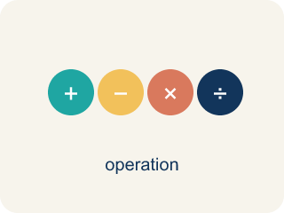
Divide Fractions (Dividir fracciones) — Multiply the first fraction by the reciprocal of the second fraction.
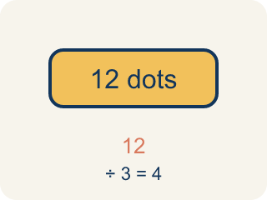
Dividend (Dividendo) — The number you are splitting up in a division problem.
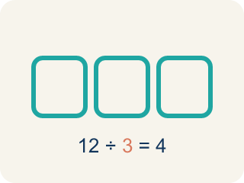
Divisor (Divisor) — The number you split by in a division problem.
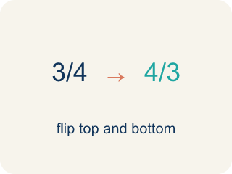
Reciprocal (Recíproco) — A fraction turned upside down.
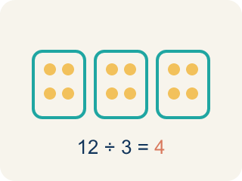
Quotient (Cociente) — The answer when you divide.
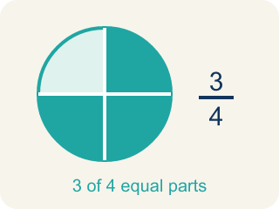
Simplify (Simplificar) — To make a fraction smaller using the same parts, like 2/4 = 1/2.

Practice
Show your work. Use the blank space under each problem.
1. What is the reciprocal of 3/5?
A. 5/3
B. 3/5
C. 5/5
D. 1/3
______________________________________________________________________
2. What is 1/2 ÷ 1/4?
A. 2
B. 1/8
C. 4
D. 1/2
______________________________________________________________________
3. What is (3/4) ÷ (1/2)?
A. 3/2
B. 3/8
C. 1/2
D. 2/3
______________________________________________________________________
4. What is (2/3) ÷ (4/9)?
A. 3/2
B. 8/27
C. 2/3
D. 9/4
______________________________________________________________________
5. What is (5/6) ÷ (5/12)?
A. 2
B. 1/2
C. 25/72
D. 12/5
______________________________________________________________________
6. What is (7/8) ÷ (1/4)?
A. 7/2
B. 7/32
C. 1/2
D. 4/7
______________________________________________________________________
7. Lock 1 — Crack the code: What is (1/2) ÷ (1/4) in simplest form?
A. 2
B. 1/8
C. 4
D. 1/2
______________________________________________________________________
8. Lock 2 — The vault dial reads a fraction problem: What is (2/3) ÷ (1/6) in simplest form?
A. 4
B. 1/9
C. 2/18
D. 9/2
______________________________________________________________________

Answer Key (Teacher)
1. A. 5/3
To find the reciprocal, flip the fraction. The reciprocal of 3/5 is 5/3.
Watch for: A common mistake in Divide Fractions is flipping the wrong fraction: students flip the dividend (the first fraction) instead of the divisor (the second fraction). For example, solving 3/4 ÷ 5/8 by flipping 3/4 to 4/3 and keeping 5/8 gives 4/3 × 5/8 = 20/24 = 5/6 — but only the divisor gets flipped. Keep 3/4, change ÷ to ×, and flip only the divisor 5/8 to its reciprocal 8/5: 3/4 × 8/5 = 24/20 = 6/5. Before you submit, check that the fraction you kept (the dividend) is still facing the same way it started.
2. A. 2
1/2 ÷ 1/4 = 1/2 × 4/1 = 4/2 = 2. Two 1/4-size pieces fit into 1/2.
Watch for: A common mistake in Divide Fractions is flipping the wrong fraction: students flip the dividend (the first fraction) instead of the divisor (the second fraction). For example, solving 3/4 ÷ 5/8 by flipping 3/4 to 4/3 and keeping 5/8 gives 4/3 × 5/8 = 20/24 = 5/6 — but only the divisor gets flipped. Keep 3/4, change ÷ to ×, and flip only the divisor 5/8 to its reciprocal 8/5: 3/4 × 8/5 = 24/20 = 6/5. Before you submit, check that the fraction you kept (the dividend) is still facing the same way it started.
3. A. 3/2
(3/4) ÷ (1/2) = (3/4) × (2/1) = 6/4 = 3/2.
Watch for: A common mistake in Divide Fractions is flipping the wrong fraction: students flip the dividend (the first fraction) instead of the divisor (the second fraction). For example, solving 3/4 ÷ 5/8 by flipping 3/4 to 4/3 and keeping 5/8 gives 4/3 × 5/8 = 20/24 = 5/6 — but only the divisor gets flipped. Keep 3/4, change ÷ to ×, and flip only the divisor 5/8 to its reciprocal 8/5: 3/4 × 8/5 = 24/20 = 6/5. Before you submit, check that the fraction you kept (the dividend) is still facing the same way it started.
4. A. 3/2
(2/3) × (9/4) = 18/12 = 3/2.
Watch for: A common mistake in Divide Fractions is flipping the wrong fraction: students flip the dividend (the first fraction) instead of the divisor (the second fraction). For example, solving 3/4 ÷ 5/8 by flipping 3/4 to 4/3 and keeping 5/8 gives 4/3 × 5/8 = 20/24 = 5/6 — but only the divisor gets flipped. Keep 3/4, change ÷ to ×, and flip only the divisor 5/8 to its reciprocal 8/5: 3/4 × 8/5 = 24/20 = 6/5. Before you submit, check that the fraction you kept (the dividend) is still facing the same way it started.
5. A. 2
(5/6) × (12/5) = 60/30 = 2.
Watch for: A common mistake in Divide Fractions is flipping the wrong fraction: students flip the dividend (the first fraction) instead of the divisor (the second fraction). For example, solving 3/4 ÷ 5/8 by flipping 3/4 to 4/3 and keeping 5/8 gives 4/3 × 5/8 = 20/24 = 5/6 — but only the divisor gets flipped. Keep 3/4, change ÷ to ×, and flip only the divisor 5/8 to its reciprocal 8/5: 3/4 × 8/5 = 24/20 = 6/5. Before you submit, check that the fraction you kept (the dividend) is still facing the same way it started.
6. A. 7/2
(7/8) × (4/1) = 28/8 = 7/2.
Watch for: A common mistake in Divide Fractions is flipping the wrong fraction: students flip the dividend (the first fraction) instead of the divisor (the second fraction). For example, solving 3/4 ÷ 5/8 by flipping 3/4 to 4/3 and keeping 5/8 gives 4/3 × 5/8 = 20/24 = 5/6 — but only the divisor gets flipped. Keep 3/4, change ÷ to ×, and flip only the divisor 5/8 to its reciprocal 8/5: 3/4 × 8/5 = 24/20 = 6/5. Before you submit, check that the fraction you kept (the dividend) is still facing the same way it started.
7. A. 2
(1/2) ÷ (1/4) = (1/2) × (4/1) = 4/2 = 2. Two 1/4-size pieces fit into 1/2, so the lock opens on 2.
Watch for: A common mistake in Divide Fractions is flipping the wrong fraction: students flip the dividend (the first fraction) instead of the divisor (the second fraction). For example, solving 3/4 ÷ 5/8 by flipping 3/4 to 4/3 and keeping 5/8 gives 4/3 × 5/8 = 20/24 = 5/6 — but only the divisor gets flipped. Keep 3/4, change ÷ to ×, and flip only the divisor 5/8 to its reciprocal 8/5: 3/4 × 8/5 = 24/20 = 6/5. Before you submit, check that the fraction you kept (the dividend) is still facing the same way it started.
8. A. 4
(2/3) ÷ (1/6) = (2/3) × (6/1) = 12/3 = 4. The dial unlocks at 4.
Watch for: A common mistake in Divide Fractions is flipping the wrong fraction: students flip the dividend (the first fraction) instead of the divisor (the second fraction). For example, solving 3/4 ÷ 5/8 by flipping 3/4 to 4/3 and keeping 5/8 gives 4/3 × 5/8 = 20/24 = 5/6 — but only the divisor gets flipped. Keep 3/4, change ÷ to ×, and flip only the divisor 5/8 to its reciprocal 8/5: 3/4 × 8/5 = 24/20 = 6/5. Before you submit, check that the fraction you kept (the dividend) is still facing the same way it started.

