6.2 Small Group · Group 2 — Homework
Lesson 6-2-group2 • Standard 6.NOS.1
Name: ______________________ Period: ______ Date: ____________

Today's Goals
Content: I can divide a fraction by a fraction by multiplying by the reciprocal and simplifying, explain why the method works, and use it on a problem I have not seen before.
Language: I can justify my answer to a skeptic and connect it to a second strategy or representation.

Key Words
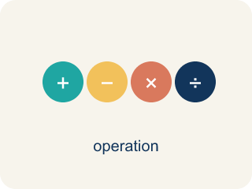
Divide Fractions (Dividir fracciones) — Multiply the first fraction by the reciprocal of the second fraction.
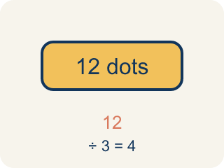
Dividend (Dividendo) — The number you are splitting up in a division problem.
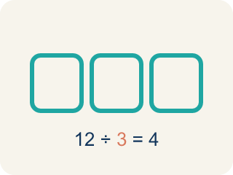
Divisor (Divisor) — The number you split by in a division problem.
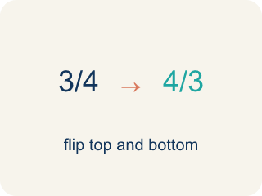
Reciprocal (Recíproco) — A fraction turned upside down.
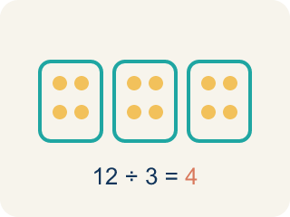
Quotient (Cociente) — The answer when you divide.
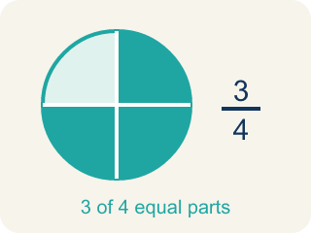
Simplify (Simplificar) — To make a fraction smaller using the same parts, like 2/4 = 1/2.

Practice
Show your work. Use the blank space under each problem.
1. A recipe needs 2/3 cup of sugar. You only have a 1/6-cup scoop. How many scoops do you need?
A. 4 scoops
B. 3 scoops
C. 6 scoops
D. 2 scoops
______________________________________________________________________
2. Spot the Common Mistake
Step 1 (Problem): 2/3 ÷ 1/2
Step 2 (Change ÷ to × (but forgot to flip)): 2/3 × 1/2
Step 3 (Multiply): 2/6
Step 4 (Simplify): 1/3
Which step has the mistake? Explain and fix it:
______________________________________________________________________
______________________________________________________________________
______________________________________________________________________
3. Find the Division Error
Step 1 (Problem): 2/5 ÷ 3/4
Step 2 (Keep, Change, Flip): 2/5 × 3/4
Step 3 (Multiply): 6/20
Step 4 (Simplify): 3/10
Which step has the mistake? Explain and fix it:
______________________________________________________________________
______________________________________________________________________
______________________________________________________________________
4. Is 3/4 ÷ 1/2 the same as 1/2 ÷ 3/4? Solve both and explain why or why not. What does this tell you about the order in division?
Sentence starter: 3/4 ÷ 1/2 = ___ and 1/2 ÷ 3/4 = ___. These are ___ because ___. This shows that division is ___.
______________________________________________________________________
______________________________________________________________________
______________________________________________________________________
______________________________________________________________________

Answer Key (Teacher)
1. A. 4 scoops
2/3 ÷ 1/6 = 2/3 × 6/1 = 12/3 = 4 scoops.
Watch for: A common mistake in Divide Fractions is flipping the wrong fraction: students flip the dividend (the first fraction) instead of the divisor (the second fraction). For example, solving 3/4 ÷ 5/8 by flipping 3/4 to 4/3 and keeping 5/8 gives 4/3 × 5/8 = 20/24 = 5/6 — but only the divisor gets flipped. Keep 3/4, change ÷ to ×, and flip only the divisor 5/8 to its reciprocal 8/5: 3/4 × 8/5 = 24/20 = 6/5. Before you submit, check that the fraction you kept (the dividend) is still facing the same way it started.
2. Spot the Common Mistake
The mistake is in Step 2.
Correct work: The student changed ÷ to × but forgot to flip the divisor. Keep 2/3, change ÷ to ×, and flip the divisor 1/2 to its reciprocal 2/1: 2/3 × 2/1 = 4/3 = 1 1/3. The correct quotient is 4/3 (1 1/3), not 1/3.
Watch for: The step that changed ÷ to × left the divisor as 1/2 instead of flipping it, so the problem turned into multiplication of the original fractions. Keep, Change, Flip turns the divisor into 2/1, giving 2/3 × 2/1 = 4/3 = 1 1/3. That size makes sense, because 1/2 is smaller than 2/3, so more than one copy fits.
3. Find the Division Error
The mistake is in Step 2.
Correct work: The student forgot to flip. 2/5 × 4/3 (flip the divisor 3/4 to get 4/3). Then 2/5 × 4/3 = 8/15.
Watch for: The Keep, Change, Flip step swapped the operation but left the divisor as 3/4, so no fraction was actually flipped. The reciprocal of 3/4 is 4/3, so the problem is 2/5 × 4/3 = 8/15, not 3/10.
4. Open response — answers will vary.
Look for key words: not the same, 1 1/2, 2/3, order matters, not commutative.

