6.3 Small Group · Group 1 — Homework
Lesson 6-3-group1 • Standard 6.AT.5
Name: ______________________ Period: ______ Date: ____________

Today's Goals
Content: With my small group, I can write and evaluate numbers in exponent form using a base and a power — one step at a time, with support.
Language: I can talk through each step out loud using a sentence frame and the lesson's key words.

Key Words
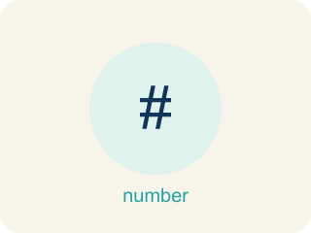
Powers and Exponents (Potencias y exponentes) — A power uses a base and an exponent to show repeated multiplication.
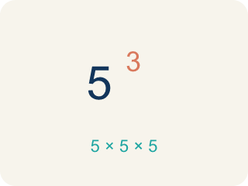
Exponent (Exponente) — A small number that tells how many times to multiply a number by itself.
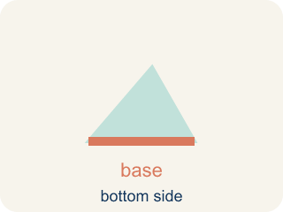
Base (Base) — The number that gets multiplied by itself.

Power (Potencia) — A number written with a base and an exponent, like 2³.
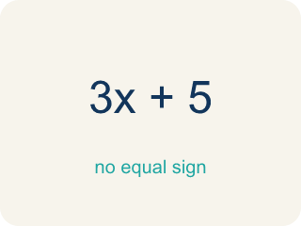
Evaluate (Evaluar) — To find the value by putting numbers in for the letters.

Practice
Show your work. Use the blank space under each problem.
1. What is the value of 4³?
A. 64
B. 12
C. 43
D. 7
______________________________________________________________________
2. What is the value of 6²?
A. 36
B. 12
C. 62
D. 8
______________________________________________________________________
3. A synth pattern repeats 7 × 7 × 7. How do you write that as a power?
A. 7³
B. 3⁷
C. 7 × 3
D. 21³
______________________________________________________________________
4. The bass line doubles for 2⁶ counts. What is the value of 2⁶?
A. 64
B. 12
C. 32
D. 36
______________________________________________________________________
5. Level 2 Extension — Spot the Beat-Builder Bug
Step 1 (Track says): Play 3⁴ beats
Step 2 (Producer's thinking): 3 × 4
Step 3 (Calculate): = 12
Which step has the mistake? Explain and fix it:
______________________________________________________________________
______________________________________________________________________
______________________________________________________________________
6. Find the Exponent Error
Step 1 (Expression): 2³
Step 2 (Student's thinking): 2 × 3
Step 3 (Calculate): = 6
Which step has the mistake? Explain and fix it:
______________________________________________________________________
______________________________________________________________________
______________________________________________________________________
7. A bacteria colony doubles every hour. Starting with 1 bacterium, write a power expression for the number after 6 hours. Explain why exponential growth is so much faster than adding the same number each hour.
Sentence starter: After 6 hours there are ___ bacteria because 2⁶ = ___. If it grew by adding 2 each hour instead, there would only be ___ bacteria. Exponential growth is faster because ___.
______________________________________________________________________
______________________________________________________________________
______________________________________________________________________
______________________________________________________________________
8. Write each power as repeated multiplication, then find the value.
Power | Repeated Multiplication | Value
3² | 3 × 3
2⁴ | 2 × 2 × 2 × 2
______________________________________________________________________

Answer Key (Teacher)
1. A. 64
4³ = 4 × 4 × 4 = 64.
Watch for: A common mistake in Powers and Exponents is multiplying the base by the exponent instead of using the base as a repeated factor — for example, thinking 2³ = 2 × 3 = 6 instead of 2³ = 2 × 2 × 2 = 8. Before you submit, rewrite the power as repeated multiplication first, then multiply step by step.
2. A. 36
6² = 6 × 6 = 36.
Watch for: A common mistake in Powers and Exponents is multiplying the base by the exponent instead of using the base as a repeated factor — for example, thinking 2³ = 2 × 3 = 6 instead of 2³ = 2 × 2 × 2 = 8. Before you submit, rewrite the power as repeated multiplication first, then multiply step by step.
3. A. 7³
The base 7 is used as a factor 3 times, so the power is 7³. 7³ = 7 × 7 × 7 = 343.
Watch for: A common mistake in Powers and Exponents is multiplying the base by the exponent instead of using the base as a repeated factor — for example, thinking 2³ = 2 × 3 = 6 instead of 2³ = 2 × 2 × 2 = 8. Before you submit, rewrite the power as repeated multiplication first, then multiply step by step.
4. A. 64
2⁶ = 2 × 2 × 2 × 2 × 2 × 2 = 64. The exponent 6 counts how many times 2 is a factor.
Watch for: A common mistake in Powers and Exponents is multiplying the base by the exponent instead of using the base as a repeated factor — for example, thinking 2³ = 2 × 3 = 6 instead of 2³ = 2 × 2 × 2 = 8. Before you submit, rewrite the power as repeated multiplication first, then multiply step by step.
5. Level 2 Extension — Spot the Beat-Builder Bug
The mistake is in Step 2.
Correct work: 3⁴ does NOT mean 3 × 4. The exponent 4 tells you to use the base 3 as a factor 4 times: 3 × 3 × 3 × 3 = 81. So the track plays 81 beats, not 12.
Watch for: The "Producer's thinking" step reads 3⁴ as 3 × 4, which multiplies by the exponent instead of counting factors. The 4 means the base 3 is used four times: 3 × 3 = 9, 9 × 3 = 27, 27 × 3 = 81. The track plays 81 beats, not 12.
6. Find the Exponent Error
The mistake is in Step 2.
Correct work: 2³ means 2 × 2 × 2, NOT 2 × 3. The exponent tells us to multiply the base by itself 3 times: 2 × 2 × 2 = 8.
Watch for: The "Student's thinking" step reads 2³ as 2 × 3, which is multiplication by the exponent rather than repeated multiplication of the base. Written correctly, 2³ = 2 × 2 × 2, so 2 × 2 = 4 and 4 × 2 = 8. The value is 8, not 6.
7. Open response — answers will vary.
Look for key words: power, base, exponent, doubles, repeated multiplication, exponential, growth.
8. Write each power as repeated multiplication, then find the value.
3² — Value: 9
2⁴ — Value: 16

