6.3 Small Group · Group 2 — Homework
Lesson 6-3-group2 • Standard 6.AT.5
Name: ______________________ Period: ______ Date: ____________

Today's Goals
Content: I can write and evaluate numbers in exponent form using a base and a power, explain what each part stands for, and build one for a situation I have not seen before.
Language: I can justify my answer to a skeptic and connect it to a second strategy or representation.

Key Words
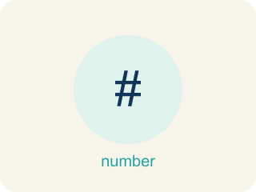
Powers and Exponents (Potencias y exponentes) — A power uses a base and an exponent to show repeated multiplication.
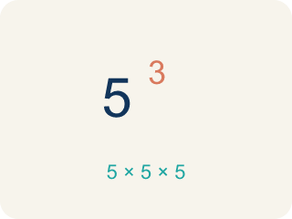
Exponent (Exponente) — A small number that tells how many times to multiply a number by itself.
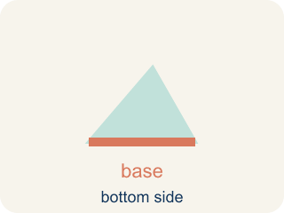
Base (Base) — The number that gets multiplied by itself.

Power (Potencia) — A number written with a base and an exponent, like 2³.
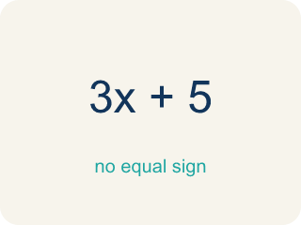
Evaluate (Evaluar) — To find the value by putting numbers in for the letters.

Practice
Show your work. Use the blank space under each problem.
1. Spot the Common Mistake
Step 1 (Expression): 2⁴
Step 2 (Student's thinking): 2 × 4
Step 3 (Calculate): = 8
Which step has the mistake? Explain and fix it:
______________________________________________________________________
______________________________________________________________________
______________________________________________________________________
2. Find the Exponent Error
Step 1 (Expression): 2³
Step 2 (Student's thinking): 2 × 3
Step 3 (Calculate): = 6
Which step has the mistake? Explain and fix it:
______________________________________________________________________
______________________________________________________________________
______________________________________________________________________
3. A bacteria colony doubles every hour. Starting with 1 bacterium, write a power expression for the number after 6 hours. Explain why exponential growth is so much faster than adding the same number each hour.
Sentence starter: After 6 hours there are ___ bacteria because 2⁶ = ___. If it grew by adding 2 each hour instead, there would only be ___ bacteria. Exponential growth is faster because ___.
______________________________________________________________________
______________________________________________________________________
______________________________________________________________________
______________________________________________________________________
4. The drum loop plays 3⁴ beats. What is the value of 3⁴?
A. 81
B. 12
C. 7
D. 27
______________________________________________________________________

Answer Key (Teacher)
1. Spot the Common Mistake
The mistake is in Step 2.
Correct work: 2⁴ does NOT mean 2 × 4. The exponent 4 tells you to use the base 2 as a factor 4 times: 2 × 2 × 2 × 2 = 16. So 2⁴ = 16, not 8.
Watch for: The "Student's thinking" step turns 2⁴ into 2 × 4. The exponent 4 is a count, not a factor: it says to use the base 2 four times, giving 2 × 2 × 2 × 2. Doubling step by step gives 2, 4, 8, 16, so 2⁴ = 16, not 8.
2. Find the Exponent Error
The mistake is in Step 2.
Correct work: 2³ means 2 × 2 × 2, NOT 2 × 3. The exponent tells us to multiply the base by itself 3 times: 2 × 2 × 2 = 8.
Watch for: The "Student's thinking" step reads 2³ as 2 × 3, which is multiplication by the exponent rather than repeated multiplication of the base. Written correctly, 2³ = 2 × 2 × 2, so 2 × 2 = 4 and 4 × 2 = 8. The value is 8, not 6.
3. Open response — answers will vary.
Look for key words: power, base, exponent, doubles, repeated multiplication, exponential, growth.
4. A. 81
3⁴ means use 3 as a factor 4 times: 3 × 3 × 3 × 3 = 81. It is NOT 3 × 4 = 12.
Watch for: A common mistake in Powers and Exponents is multiplying the base by the exponent instead of using the base as a repeated factor — for example, thinking 2³ = 2 × 3 = 6 instead of 2³ = 2 × 2 × 2 = 8. Before you submit, rewrite the power as repeated multiplication first, then multiply step by step.

