6.4 Small Group · Group 1 — Homework
Lesson 6-4-group1 • Standard 6.AT.6c
Name: ______________________ Period: ______ Date: ____________

Today's Goals
Content: With my small group, I can evaluate algebraic expressions by substituting values for the variables — one step at a time, with support.
Language: I can talk through each step out loud using a sentence frame and the lesson's key words.

Key Words
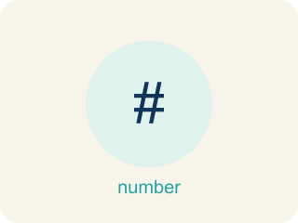
Evaluate Expressions (Evaluar expresiones) — Find the value of an expression by substituting numbers and following the order of operations.
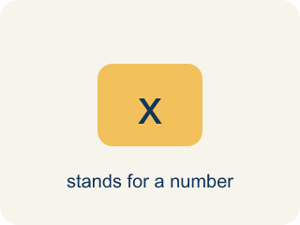
Variable (Variable) — A letter that stands for a number that is unknown or can change.
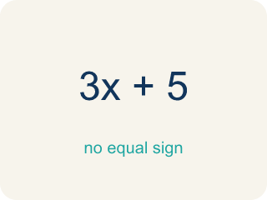
Expression (Expresión) — A math phrase with numbers and letters, but no equal sign.

Evaluate (Evaluar) — To find the value by putting numbers in for the letters.
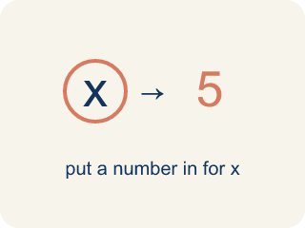
Substitute (Sustituir) — To put a number in place of a letter.
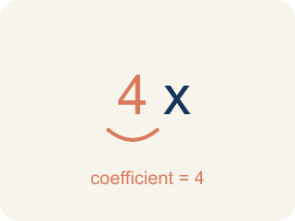
Coefficient (Coeficiente) — The number in front of a letter, like the 3 in 3x.
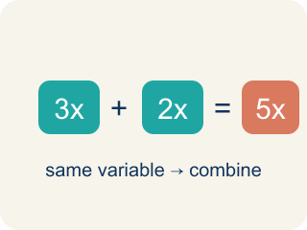
Like terms (Términos semejantes) — Terms with the same letter raised to the same power, like 2x and 5x.

Practice
Show your work. Use the blank space under each problem.
1. Evaluate 3x + 7 when x = 4.
A. 19
B. 34
C. 12
D. 14
______________________________________________________________________
2. Evaluate 20 − 2n when n = 6.
A. 8
B. 14
C. 32
D. 12
______________________________________________________________________
3. Track 2 — The volume mix is 2(n + 3), where n is the number of monitors. Evaluate 2(n + 3) when n = 5.
A. 16
B. 13
C. 20
D. 26
______________________________________________________________________
4. Track 3 — The speaker power is x², where x is the gain setting. Evaluate x² when x = 6.
A. 36
B. 12
C. 18
D. 30
______________________________________________________________________
5. Level 2 Extension — Fix the DJ's Order-of-Operations Mistake
Step 1 (Expression): Mix the track 3x + 5 when x = 4
Step 2 (Substitute): 3(4) + 5
Step 3 (Add first): 3 × (4 + 5) = 3 × 9 = 27
Step 4 (Result): The track mixes down to 27
Which step has the mistake? Explain and fix it:
______________________________________________________________________
______________________________________________________________________
______________________________________________________________________
6. Find the Evaluation Error
Step 1 (Expression): 4x² + 3 when x = 2
Step 2 (Substitute): 4(2)² + 3
Step 3 (Apply exponent): (4 × 2)² + 3 = 8² + 3
Step 4 (Calculate): 64 + 3 = 67
Which step has the mistake? Explain and fix it:
______________________________________________________________________
______________________________________________________________________
______________________________________________________________________
7. A gym membership costs $25 per month plus a $40 signup fee. Write an expression using m for months, then evaluate it for 6 months and 12 months. Explain what each part of the expression represents.
Sentence starter: The expression is ___. For 6 months: ___ = ___. For 12 months: ___ = ___. The ___ represents the ___ and the ___ represents the ___.
______________________________________________________________________
______________________________________________________________________
______________________________________________________________________
______________________________________________________________________
8. Substitute the value of x into each expression and evaluate.
Expression | Value of x | Result
3x + 2 | x = 5
10 − x | x = 4
______________________________________________________________________

Answer Key (Teacher)
1. A. 19
3(4) + 7 = 12 + 7 = 19.
Watch for: A common mistake in Evaluate Expressions is treating a coefficient like an addend instead of a factor — for example, evaluating 3x + 7 when x = 4 as 3 + 4 + 7 = 14 instead of the correct 3(4) + 7 = 12 + 7 = 19. A number written right next to a variable always means multiply, never add. Before you submit, ask: "Did I multiply the coefficient by the value I substituted, or did I accidentally add it?"
2. A. 8
20 − 2(6) = 20 − 12 = 8.
Watch for: A common mistake in Evaluate Expressions is treating a coefficient like an addend instead of a factor — for example, evaluating 3x + 7 when x = 4 as 3 + 4 + 7 = 14 instead of the correct 3(4) + 7 = 12 + 7 = 19. A number written right next to a variable always means multiply, never add. Before you submit, ask: "Did I multiply the coefficient by the value I substituted, or did I accidentally add it?"
3. A. 16
Substitute n = 5: 2(5 + 3). Do the parentheses first: 5 + 3 = 8. Then multiply: 2 × 8 = 16.
Watch for: A common mistake in Evaluate Expressions is treating a coefficient like an addend instead of a factor — for example, evaluating 3x + 7 when x = 4 as 3 + 4 + 7 = 14 instead of the correct 3(4) + 7 = 12 + 7 = 19. A number written right next to a variable always means multiply, never add. Before you submit, ask: "Did I multiply the coefficient by the value I substituted, or did I accidentally add it?"
4. A. 36
x² means x times itself. Substitute x = 6: 6² = 6 × 6 = 36.
Watch for: A common mistake in Evaluate Expressions is treating a coefficient like an addend instead of a factor — for example, evaluating 3x + 7 when x = 4 as 3 + 4 + 7 = 14 instead of the correct 3(4) + 7 = 12 + 7 = 19. A number written right next to a variable always means multiply, never add. Before you submit, ask: "Did I multiply the coefficient by the value I substituted, or did I accidentally add it?"
5. Level 2 Extension — Fix the DJ's Order-of-Operations Mistake
The mistake is in Step 3.
Correct work: 3(4) + 5 = 12 + 5 = 17. Follow the order of operations: multiply 3 × 4 = 12 FIRST, then add 5. There are no parentheses around 4 + 5, so you cannot add before multiplying.
Watch for: The step added 4 + 5 before multiplying, but nothing groups them — in 3(4) + 5 only the 4 is attached to the 3. Multiply first to get 12, then add 5 for 17. The written work would be correct only for 3(4 + 5), which is a different expression.
6. Find the Evaluation Error
The mistake is in Step 3.
Correct work: 4(2²) + 3 = 4(4) + 3 = 16 + 3 = 19. Square the 2 first, THEN multiply by 4.
Watch for: The exponent in 4x² belongs only to x, not to 4x, so the work cannot be rewritten as (4 × 2)². Square first: 2² = 4, then multiply by 4 to get 16, then add 3 for 19. Treating it as 8² inflated the answer all the way to 67.
7. Open response — answers will vary.
Look for key words: expression, variable, evaluate, substitute, coefficient, constant, cost.
8. Substitute the value of x into each expression and evaluate.
3x + 2 — Result: 17
10 − x — Result: 6

