6.4 Small Group · Group 2 — Homework
Lesson 6-4-group2 • Standard 6.AT.6c
Name: ______________________ Period: ______ Date: ____________

Today's Goals
Content: I can evaluate algebraic expressions by substituting values for the variables, explain why the method works, and use it on a problem I have not seen before.
Language: I can justify my answer to a skeptic and connect it to a second strategy or representation.

Key Words
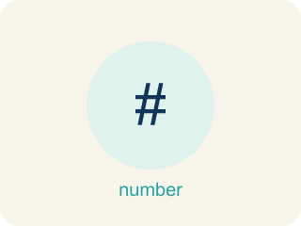
Evaluate Expressions (Evaluar expresiones) — Find the value of an expression by substituting numbers and following the order of operations.
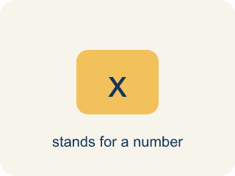
Variable (Variable) — A letter that stands for a number that is unknown or can change.
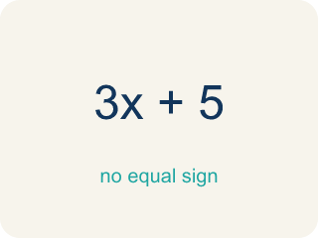
Expression (Expresión) — A math phrase with numbers and letters, but no equal sign.

Evaluate (Evaluar) — To find the value by putting numbers in for the letters.
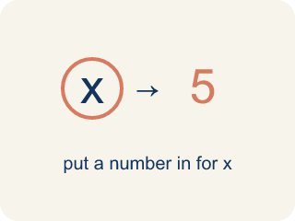
Substitute (Sustituir) — To put a number in place of a letter.
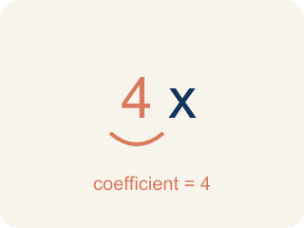
Coefficient (Coeficiente) — The number in front of a letter, like the 3 in 3x.
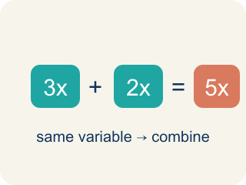
Like terms (Términos semejantes) — Terms with the same letter raised to the same power, like 2x and 5x.

Practice
Show your work. Use the blank space under each problem.
1. Spot the Common Mistake
Step 1 (Expression): Evaluate 5n − 3 when n = 6
Step 2 (Substitute): 5(6) − 3
Step 3 (Subtract first): 5 × (6 − 3) = 5 × 3 = 15
Which step has the mistake? Explain and fix it:
______________________________________________________________________
______________________________________________________________________
______________________________________________________________________
2. Find the Evaluation Error
Step 1 (Expression): 4x² + 3 when x = 2
Step 2 (Substitute): 4(2)² + 3
Step 3 (Apply exponent): (4 × 2)² + 3 = 8² + 3
Step 4 (Calculate): 64 + 3 = 67
Which step has the mistake? Explain and fix it:
______________________________________________________________________
______________________________________________________________________
______________________________________________________________________
3. A gym membership costs $25 per month plus a $40 signup fee. Write an expression using m for months, then evaluate it for 6 months and 12 months. Explain what each part of the expression represents.
Sentence starter: The expression is ___. For 6 months: ___ = ___. For 12 months: ___ = ___. The ___ represents the ___ and the ___ represents the ___.
______________________________________________________________________
______________________________________________________________________
______________________________________________________________________
______________________________________________________________________
4. Track 1 — The beat formula is 3x + 5, where x is the number of bass drops. Evaluate 3x + 5 when x = 4.
A. 17
B. 27
C. 12
D. 21
______________________________________________________________________

Answer Key (Teacher)
1. Spot the Common Mistake
The mistake is in Step 3.
Correct work: 5(6) − 3 = 30 − 3 = 27. Follow the order of operations: multiply 5 × 6 = 30 FIRST, then subtract 3. There are no parentheses around 6 − 3, so you cannot subtract before multiplying.
Watch for: The step subtracted before multiplying, which would only be allowed if parentheses grouped 6 − 3. In 5(6) − 3 the multiplication comes first: 30 − 3 = 27. Inventing that grouping turned the problem into 5(6 − 3) and produced 15 instead.
2. Find the Evaluation Error
The mistake is in Step 3.
Correct work: 4(2²) + 3 = 4(4) + 3 = 16 + 3 = 19. Square the 2 first, THEN multiply by 4.
Watch for: The exponent in 4x² belongs only to x, not to 4x, so the work cannot be rewritten as (4 × 2)². Square first: 2² = 4, then multiply by 4 to get 16, then add 3 for 19. Treating it as 8² inflated the answer all the way to 67.
3. Open response — answers will vary.
Look for key words: expression, variable, evaluate, substitute, coefficient, constant, cost.
4. A. 17
Substitute x = 4: 3(4) + 5. Multiply first: 3 × 4 = 12. Then add: 12 + 5 = 17.
Watch for: A common mistake in Evaluate Expressions is treating a coefficient like an addend instead of a factor — for example, evaluating 3x + 7 when x = 4 as 3 + 4 + 7 = 14 instead of the correct 3(4) + 7 = 12 + 7 = 19. A number written right next to a variable always means multiply, never add. Before you submit, ask: "Did I multiply the coefficient by the value I substituted, or did I accidentally add it?"

