6.1–6.3 Catch-Up — Homework
Lesson 6-5-catchup • Standard 6.AT.6a
Name: ______________________ Period: ______ Date: ____________

Today's Goals
Content: I can show I am caught up on Lessons 6.1–6.3 by using each lesson's big idea in mixed practice.
Language: I can explain which lesson's big idea I used and how, using key vocabulary from Lessons 6.1–6.3.

Key Words
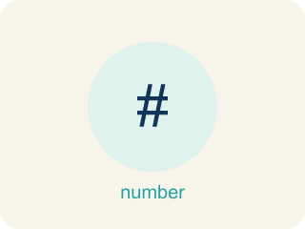
Powers and Exponents (Potencias y exponentes) — A power uses a base and an exponent to show repeated multiplication.
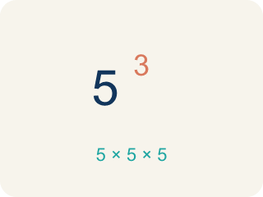
Exponent (Exponente) — A small number that tells how many times to multiply a number by itself.

Evaluate Expressions (Evaluar expresiones) — Find the value of an expression by substituting numbers and following the order of operations.
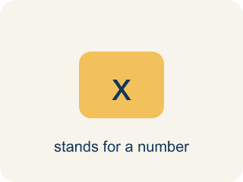
Variable (Variable) — A letter that stands for a number that is unknown or can change.

Write Algebraic Expressions (Escribir expresiones algebraicas) — Translate words or a situation into numbers, variables, and operation symbols.
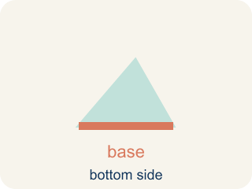
Base (Base) — The number that gets multiplied by itself.
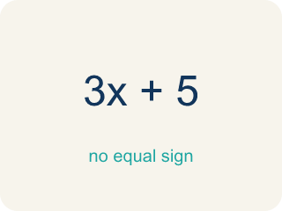
Expression (Expresión) — A math phrase with numbers and letters, but no equal sign.

Algebraic Expression (Expresión algebraica) — A math phrase that has at least one letter.

Practice
Show your work. Use the blank space under each problem.
1. (Lesson 6.1) What is the value of 4³?
A. 64
B. 12
C. 43
D. 7
______________________________________________________________________
2. (Lesson 6.1) What is the value of 6²?
A. 36
B. 12
C. 62
D. 8
______________________________________________________________________
3. (Lesson 6.1) Spot the Common Mistake
Step 1 (Expression): 2⁴
Step 2 (Student's thinking): 2 × 4
Step 3 (Calculate): = 8
Which step has the mistake? Explain and fix it:
______________________________________________________________________
______________________________________________________________________
______________________________________________________________________
4. (Lesson 6.1) Evaluate each exponential expression. Show the repeated multiplication and the final value.
Power | Repeated Multiplication | Value
4³ | 4 × 4 × 4
2⁶ | 2 × 2 × 2 × 2 × 2 × 2
5³ | 5 × 5 × 5
10⁴ | 10 × 10 × 10 × 10
______________________________________________________________________
5. (Lesson 6.2) Spot the Common Mistake
Step 1 (Expression): Evaluate 5n − 3 when n = 6
Step 2 (Substitute): 5(6) − 3
Step 3 (Subtract first): 5 × (6 − 3) = 5 × 3 = 15
Which step has the mistake? Explain and fix it:
______________________________________________________________________
______________________________________________________________________
______________________________________________________________________
6. (Lesson 6.2) Evaluate each expression for the given value of the variable.
Expression | Variable Value | Substitution | Result
5n − 3 | n = 6 | 5(6) − 3
n² + 4 | n = 3 | 3² + 4
2(n + 8) | n = 5 | 2(5 + 8)
40 − 3n | n = 7 | 40 − 3(7)
______________________________________________________________________
7. (Lesson 6.3) Spot the Common Mistake
Step 1 (Phrase): 8 divided by a number m
Step 2 (Student's expression): m ÷ 8
Step 3 (Reasoning): I saw 'divided by' so I wrote the variable first and then 8.
Which step has the mistake? Explain and fix it:
______________________________________________________________________
______________________________________________________________________
______________________________________________________________________
8. (Lesson 6.3) Match each word phrase to its correct algebraic expression.
Groups: Correctly Matched
• twice a number k → 2k → __________________
• a number b divided by 5 → b ÷ 5 → __________________
• the sum of a number d and 15 → d + 15 → __________________
• 10 decreased by a number r → 10 − r → __________________
• 4 more than triple a number c → 3c + 4 → __________________
• half of a number h → h ÷ 2 → __________________
______________________________________________________________________
9. (Lesson 6.1) The drum loop plays 3⁴ beats. What is the value of 3⁴?
A. 81
B. 12
C. 7
D. 27
______________________________________________________________________
10. (Lesson 6.2) Track 1 — The beat formula is 3x + 5, where x is the number of bass drops. Evaluate 3x + 5 when x = 4.
A. 17
B. 27
C. 12
D. 21
______________________________________________________________________

Answer Key (Teacher)
1. A. 64
4³ = 4 × 4 × 4 = 64.
Watch for: A common mistake in Write Algebraic Expressions is treating 'each' or 'per' as if it means add instead of multiply, and attaching the variable to the wrong number. For 'a $25 setup fee plus $8 per hour, h,' students often write 25 + 8 + h (adding all three numbers) or 25h + 8 (multiplying the flat fee by h) instead of the correct 8h + 25. Since $8 applies per hour, it must multiply the variable (8h), and the flat $25 fee is a constant added only once — check that the per-unit rate, not the flat fee, is the number multiplied by the variable.
2. A. 36
6² = 6 × 6 = 36.
Watch for: A common mistake in Write Algebraic Expressions is treating 'each' or 'per' as if it means add instead of multiply, and attaching the variable to the wrong number. For 'a $25 setup fee plus $8 per hour, h,' students often write 25 + 8 + h (adding all three numbers) or 25h + 8 (multiplying the flat fee by h) instead of the correct 8h + 25. Since $8 applies per hour, it must multiply the variable (8h), and the flat $25 fee is a constant added only once — check that the per-unit rate, not the flat fee, is the number multiplied by the variable.
3. (Lesson 6.1) Spot the Common Mistake
The mistake is in Step 2.
Correct work: 2⁴ does NOT mean 2 × 4. The exponent 4 tells you to use the base 2 as a factor 4 times: 2 × 2 × 2 × 2 = 16. So 2⁴ = 16, not 8.
Watch for: The "Student's thinking" step turns 2⁴ into 2 × 4. The exponent 4 is a count, not a factor: it says to use the base 2 four times, giving 2 × 2 × 2 × 2. Doubling step by step gives 2, 4, 8, 16, so 2⁴ = 16, not 8.
4. (Lesson 6.1) Evaluate each exponential expression. Show the repeated multiplication and the final value.
4³ — Value: 64
2⁶ — Value: 64
5³ — Value: 125
10⁴ — Value: 10000

5. (Lesson 6.2) Spot the Common Mistake
The mistake is in Step 3.
Correct work: 5(6) − 3 = 30 − 3 = 27. Follow the order of operations: multiply 5 × 6 = 30 FIRST, then subtract 3. There are no parentheses around 6 − 3, so you cannot subtract before multiplying.
Watch for: The step subtracted before multiplying, which would only be allowed if parentheses grouped 6 − 3. In 5(6) − 3 the multiplication comes first: 30 − 3 = 27. Inventing that grouping turned the problem into 5(6 − 3) and produced 15 instead.
6. (Lesson 6.2) Evaluate each expression for the given value of the variable.
5n − 3 — Result: 27
n² + 4 — Result: 13
2(n + 8) — Result: 26
40 − 3n — Result: 19

7. (Lesson 6.3) Spot the Common Mistake
The mistake is in Step 2.
Correct work: '8 divided by a number m' means start with 8 and divide it by m: 8 ÷ m. Division is not commutative, so order matters — m ÷ 8 means something different (a number m divided by 8).
Watch for: The expression step wrote the variable first, but "8 divided by a number m" starts with the 8 and splits it. Division is not commutative, so the correct translation is 8 ÷ m — with m = 2, 8 ÷ 2 = 4 while 2 ÷ 8 = 0.25.
8. Correct groups:
twice a number k → 2k → Correctly Matched
a number b divided by 5 → b ÷ 5 → Correctly Matched
the sum of a number d and 15 → d + 15 → Correctly Matched
10 decreased by a number r → 10 − r → Correctly Matched
4 more than triple a number c → 3c + 4 → Correctly Matched
half of a number h → h ÷ 2 → Correctly Matched

9. A. 81
3⁴ means use 3 as a factor 4 times: 3 × 3 × 3 × 3 = 81. It is NOT 3 × 4 = 12.
Watch for: A common mistake in Write Algebraic Expressions is treating 'each' or 'per' as if it means add instead of multiply, and attaching the variable to the wrong number. For 'a $25 setup fee plus $8 per hour, h,' students often write 25 + 8 + h (adding all three numbers) or 25h + 8 (multiplying the flat fee by h) instead of the correct 8h + 25. Since $8 applies per hour, it must multiply the variable (8h), and the flat $25 fee is a constant added only once — check that the per-unit rate, not the flat fee, is the number multiplied by the variable.
10. A. 17
Substitute x = 4: 3(4) + 5. Multiply first: 3 × 4 = 12. Then add: 12 + 5 = 17.
Watch for: A common mistake in Write Algebraic Expressions is treating 'each' or 'per' as if it means add instead of multiply, and attaching the variable to the wrong number. For 'a $25 setup fee plus $8 per hour, h,' students often write 25 + 8 + h (adding all three numbers) or 25h + 8 (multiplying the flat fee by h) instead of the correct 8h + 25. Since $8 applies per hour, it must multiply the variable (8h), and the flat $25 fee is a constant added only once — check that the per-unit rate, not the flat fee, is the number multiplied by the variable.

