6.5 Small Group · Group 1 — Homework
Lesson 6-5-group1 • Standard 6.AT.6a
Name: ______________________ Period: ______ Date: ____________

Today's Goals
Content: With my small group, I can write algebraic expressions from words and real-world situations — one step at a time, with support.
Language: I can talk through each step out loud using a sentence frame and the lesson's key words.

Key Words
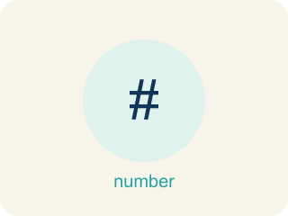
Write Algebraic Expressions (Escribir expresiones algebraicas) — Translate words or a situation into numbers, variables, and operation symbols.
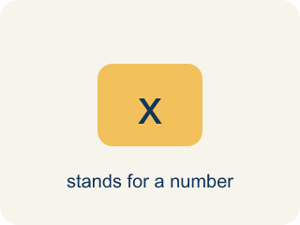
Variable (Variable) — A letter that stands for a number that is unknown or can change.
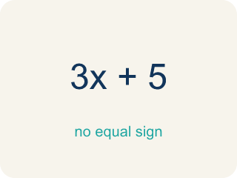
Algebraic Expression (Expresión algebraica) — A math phrase that has at least one letter.
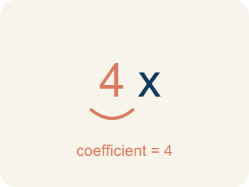
Coefficient (Coeficiente) — The number in front of a letter, like the 3 in 3x.
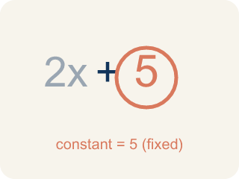
Constant (Constante) — A fixed number in an expression or equation that does not change.
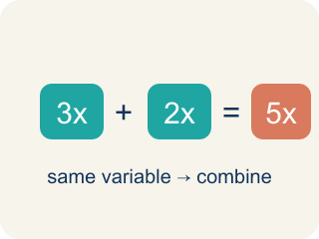
Like terms (Términos semejantes) — Terms with the same letter raised to the same power, like 2x and 5x.

Practice
Show your work. Use the blank space under each problem.
1. Which expression represents 'the product of 6 and a number n'?
A. 6n
B. 6 + n
C. n − 6
D. n ÷ 6
______________________________________________________________________
2. Which expression represents '9 less than a number y'?
A. y − 9
B. 9 − y
C. y + 9
D. 9y
______________________________________________________________________
3. Line 2: The chorus says '5 less than a number of tracks x.' Which expression matches?
A. x − 5
B. 5 − x
C. 5x
D. x + 5
______________________________________________________________________
4. Line 3: A verse says 'twice a number of speakers' (use s). Which expression matches?
A. 2s
B. s + 2
C. s − 2
D. s ÷ 2
______________________________________________________________________
5. Level 2 Extension — Remix the Translation Error
Step 1 (Lyric): 5 less than a number of streams x
Step 2 (Producer's expression): 5 − x
Step 3 (Reasoning): I see 'less than' so I subtract, and 5 comes first in the lyric.
Which step has the mistake? Explain and fix it:
______________________________________________________________________
______________________________________________________________________
______________________________________________________________________
6. Find the Translation Error
Step 1 (Phrase): 12 less than a number g
Step 2 (Student's expression): 12 − g
Step 3 (Reasoning): I see 'less than' so I subtract, and 12 comes first in the phrase.
Which step has the mistake? Explain and fix it:
______________________________________________________________________
______________________________________________________________________
______________________________________________________________________
7. Write a real-world situation that could be modeled by the expression 4n + 10. Explain what the variable n represents, what the coefficient 4 means, and what the constant 10 represents.
Sentence starter: Situation: ___. The variable n represents ___. The coefficient 4 means ___ for each ___. The constant 10 represents ___.
______________________________________________________________________
______________________________________________________________________
______________________________________________________________________
______________________________________________________________________
8. Sort each key word by the operation it represents.
Groups: Addition | Subtraction | Multiplication
• sum → __________________
• more than → __________________
• difference → __________________
• less than → __________________
• product → __________________
• times → __________________
______________________________________________________________________

Answer Key (Teacher)
1. A. 6n
'Product' means multiplication, so the product of 6 and n is 6n.
Watch for: A common mistake in Write Algebraic Expressions is treating 'each' or 'per' as if it means add instead of multiply, and attaching the variable to the wrong number. For 'a $25 setup fee plus $8 per hour, h,' students often write 25 + 8 + h (adding all three numbers) or 25h + 8 (multiplying the flat fee by h) instead of the correct 8h + 25. Since $8 applies per hour, it must multiply the variable (8h), and the flat $25 fee is a constant added only once — check that the per-unit rate, not the flat fee, is the number multiplied by the variable.
2. A. y − 9
'Less than' means subtract from the number, so it's y − 9.
Watch for: A common mistake in Write Algebraic Expressions is treating 'each' or 'per' as if it means add instead of multiply, and attaching the variable to the wrong number. For 'a $25 setup fee plus $8 per hour, h,' students often write 25 + 8 + h (adding all three numbers) or 25h + 8 (multiplying the flat fee by h) instead of the correct 8h + 25. Since $8 applies per hour, it must multiply the variable (8h), and the flat $25 fee is a constant added only once — check that the per-unit rate, not the flat fee, is the number multiplied by the variable.
3. A. x − 5
'Less than' subtracts from the number: start with x and take away 5, so x − 5.
Watch for: A common mistake in Write Algebraic Expressions is treating 'each' or 'per' as if it means add instead of multiply, and attaching the variable to the wrong number. For 'a $25 setup fee plus $8 per hour, h,' students often write 25 + 8 + h (adding all three numbers) or 25h + 8 (multiplying the flat fee by h) instead of the correct 8h + 25. Since $8 applies per hour, it must multiply the variable (8h), and the flat $25 fee is a constant added only once — check that the per-unit rate, not the flat fee, is the number multiplied by the variable.
4. A. 2s
'Twice' means two times the number, so twice s is 2s.
Watch for: A common mistake in Write Algebraic Expressions is treating 'each' or 'per' as if it means add instead of multiply, and attaching the variable to the wrong number. For 'a $25 setup fee plus $8 per hour, h,' students often write 25 + 8 + h (adding all three numbers) or 25h + 8 (multiplying the flat fee by h) instead of the correct 8h + 25. Since $8 applies per hour, it must multiply the variable (8h), and the flat $25 fee is a constant added only once — check that the per-unit rate, not the flat fee, is the number multiplied by the variable.
5. Level 2 Extension — Remix the Translation Error
The mistake is in Step 2.
Correct work: '5 less than a number of streams x' means start with x and subtract 5: x − 5. With 'less than,' the number being subtracted FROM comes after the phrase, so the order flips to x − 5.
Watch for: The expression step wrote the numbers in the order they were read, but "less than" reverses them. "5 less than a number of streams x" begins at x and takes 5 away, so the expression is x − 5 — the same way "5 less than 20" means 20 − 5.
6. Find the Translation Error
The mistake is in Step 2.
Correct work: '12 less than a number g' means start with g and subtract 12: g − 12. The phrase 'less than' reverses the order — the number being subtracted FROM comes after 'less than.'
Watch for: The expression step copied the numbers in the order they appear, but "less than" reverses them. "12 less than a number g" starts at g and takes 12 away, so it is g − 12 — the same way "5 less than 20" means 20 − 5 = 15.
7. Open response — answers will vary.
Look for key words: variable, coefficient, constant, expression, real-world, model.
8. Correct groups:
sum → Addition
more than → Addition
difference → Subtraction
less than → Subtraction
product → Multiplication
times → Multiplication

