6.5 Small Group · Group 2 — Homework
Lesson 6-5-group2 • Standard 6.AT.6a
Name: ______________________ Period: ______ Date: ____________

Today's Goals
Content: I can write algebraic expressions from words and real-world situations, explain what each part stands for, and build one for a situation I have not seen before.
Language: I can justify my answer to a skeptic and connect it to a second strategy or representation.

Key Words
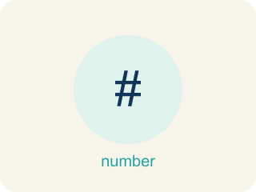
Write Algebraic Expressions (Escribir expresiones algebraicas) — Translate words or a situation into numbers, variables, and operation symbols.
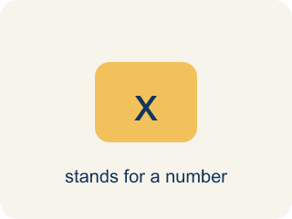
Variable (Variable) — A letter that stands for a number that is unknown or can change.
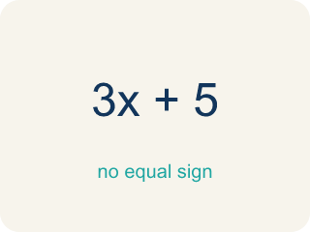
Algebraic Expression (Expresión algebraica) — A math phrase that has at least one letter.
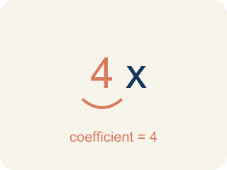
Coefficient (Coeficiente) — The number in front of a letter, like the 3 in 3x.
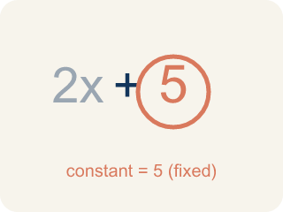
Constant (Constante) — A fixed number in an expression or equation that does not change.
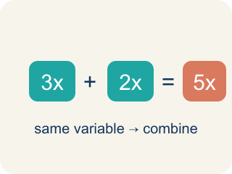
Like terms (Términos semejantes) — Terms with the same letter raised to the same power, like 2x and 5x.

Practice
Show your work. Use the blank space under each problem.
1. Spot the Common Mistake
Step 1 (Phrase): 8 divided by a number m
Step 2 (Student's expression): m ÷ 8
Step 3 (Reasoning): I saw 'divided by' so I wrote the variable first and then 8.
Which step has the mistake? Explain and fix it:
______________________________________________________________________
______________________________________________________________________
______________________________________________________________________
2. Find the Translation Error
Step 1 (Phrase): 12 less than a number g
Step 2 (Student's expression): 12 − g
Step 3 (Reasoning): I see 'less than' so I subtract, and 12 comes first in the phrase.
Which step has the mistake? Explain and fix it:
______________________________________________________________________
______________________________________________________________________
______________________________________________________________________
3. Write a real-world situation that could be modeled by the expression 4n + 10. Explain what the variable n represents, what the coefficient 4 means, and what the constant 10 represents.
Sentence starter: Situation: ___. The variable n represents ___. The coefficient 4 means ___ for each ___. The constant 10 represents ___.
______________________________________________________________________
______________________________________________________________________
______________________________________________________________________
______________________________________________________________________
4. Line 1: A lyric says '7 more than a number of beats n.' Which expression matches?
A. n + 7
B. 7n
C. n − 7
D. 7 − n
______________________________________________________________________

Answer Key (Teacher)
1. Spot the Common Mistake
The mistake is in Step 2.
Correct work: '8 divided by a number m' means start with 8 and divide it by m: 8 ÷ m. Division is not commutative, so order matters — m ÷ 8 means something different (a number m divided by 8).
Watch for: The expression step wrote the variable first, but "8 divided by a number m" starts with the 8 and splits it. Division is not commutative, so the correct translation is 8 ÷ m — with m = 2, 8 ÷ 2 = 4 while 2 ÷ 8 = 0.25.
2. Find the Translation Error
The mistake is in Step 2.
Correct work: '12 less than a number g' means start with g and subtract 12: g − 12. The phrase 'less than' reverses the order — the number being subtracted FROM comes after 'less than.'
Watch for: The expression step copied the numbers in the order they appear, but "less than" reverses them. "12 less than a number g" starts at g and takes 12 away, so it is g − 12 — the same way "5 less than 20" means 20 − 5 = 15.
3. Open response — answers will vary.
Look for key words: variable, coefficient, constant, expression, real-world, model.
4. A. n + 7
'More than' means addition, so '7 more than n' is n + 7.
Watch for: A common mistake in Write Algebraic Expressions is treating 'each' or 'per' as if it means add instead of multiply, and attaching the variable to the wrong number. For 'a $25 setup fee plus $8 per hour, h,' students often write 25 + 8 + h (adding all three numbers) or 25h + 8 (multiplying the flat fee by h) instead of the correct 8h + 25. Since $8 applies per hour, it must multiply the variable (8h), and the flat $25 fee is a constant added only once — check that the per-unit rate, not the flat fee, is the number multiplied by the variable.

