6.6 Small Group · Group 1 — Homework
Lesson 6-6-group1 • Standard 6.AT.7
Name: ______________________ Period: ______ Date: ____________

Today's Goals
Content: With my small group, I can show that two expressions are equivalent by simplifying and combining like terms — one step at a time, with support.
Language: I can talk through each step out loud using a sentence frame and the lesson's key words.

Key Words
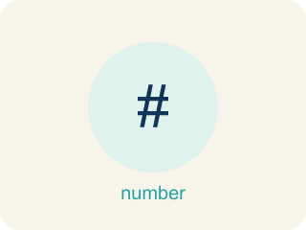
Equivalent Expressions (Expresiones equivalentes) — Expressions that look different but have the same value for every allowed variable value.
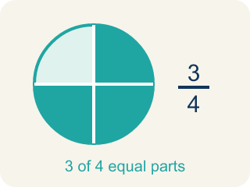
Equivalent (Equivalente) — Expressions that always have the same value.

Simplify (Simplificar) — To write an expression in a shorter, simpler way.
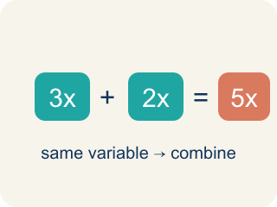
Like Terms (Términos semejantes) — Terms with the same letter raised to the same power, like 2x and 5x.
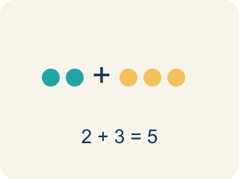
Combine (Combinar) — To add or subtract terms with the same letter into one.
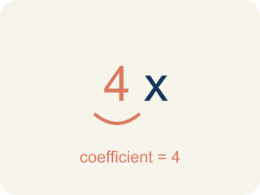
Coefficient (Coeficiente) — The number in front of a letter, like the 3 in 3x.

Practice
Show your work. Use the blank space under each problem.
1. Which expression is equivalent to 4x + 3x?
A. 7x
B. 12x
C. 7x²
D. 43x
______________________________________________________________________
2. Which expression is equivalent to 2(m + 5)?
A. 2m + 10
B. 2m + 5
C. m + 10
D. 7m
______________________________________________________________________
3. Producer A wrote 2(x + 3) for a beat's cost. Which expression is equivalent?
A. 2x + 6
B. 2x + 3
C. x + 6
D. 2x + 5
______________________________________________________________________
4. A track stacks 3x and then one more x. Which expression is equivalent to 3x + x?
A. 4x
B. 3x²
C. 4
D. 3x
______________________________________________________________________
5. Producer B flipped a formula to 5 + 2x. Which expression is equivalent?
A. 2x + 5
B. 7x
C. 10x
D. 5x + 2
______________________________________________________________________
6. Level 2 Extension — The False Remix
Step 1 (Expression): 2x + 6
Step 2 (Claim): 2x and 6 are like terms, so combine them
Step 3 (Result): 2x + 6 = 8x
Which step has the mistake? Explain and fix it:
______________________________________________________________________
______________________________________________________________________
______________________________________________________________________
7. Find the Simplification Error
Step 1 (Expression): 3x + 5 + 2x + 1
Step 2 (Combine): 3x + 2x + 5 + 1
Step 3 (Simplify): 5x² + 6
Which step has the mistake? Explain and fix it:
______________________________________________________________________
______________________________________________________________________
______________________________________________________________________
8. A student says 2x + 3 and 5x are equivalent because both equal 5 when x = 1. Is the student correct? Explain why testing one value is not enough to prove equivalence, and find a value of x where they give different results.
Sentence starter: The student is ___ because ___. When x = 1: 2(1) + 3 = ___ and 5(1) = ___. But when x = ___: 2(___) + 3 = ___ and 5(___) = ___. To prove equivalence, expressions must be equal for ___ values of x.
______________________________________________________________________
______________________________________________________________________
______________________________________________________________________
______________________________________________________________________

Answer Key (Teacher)
1. A. 7x
4x + 3x = 7x. Combine the coefficients: 4 + 3 = 7.
Watch for: A common mistake in Equivalent Expressions is adding the exponents instead of the coefficients when combining like terms — writing 3x + 2x as 5x² instead of 5x. Remember: 3x means 3 groups of x and 2x means 2 more groups of x, so you add the coefficients (3 + 2 = 5) and keep the variable's power the same (x¹, not x²).
2. A. 2m + 10
2(m + 5) = 2m + 10 using the distributive property.
Watch for: A common mistake in Equivalent Expressions is adding the exponents instead of the coefficients when combining like terms — writing 3x + 2x as 5x² instead of 5x. Remember: 3x means 3 groups of x and 2x means 2 more groups of x, so you add the coefficients (3 + 2 = 5) and keep the variable's power the same (x¹, not x²).
3. A. 2x + 6
Distribute the 2 to each term inside: 2 · x + 2 · 3 = 2x + 6. Check x = 5: 2(5 + 3) = 16 and 2(5) + 6 = 16.
Watch for: A common mistake in Equivalent Expressions is adding the exponents instead of the coefficients when combining like terms — writing 3x + 2x as 5x² instead of 5x. Remember: 3x means 3 groups of x and 2x means 2 more groups of x, so you add the coefficients (3 + 2 = 5) and keep the variable's power the same (x¹, not x²).
4. A. 4x
3x + x is 3 groups of x plus 1 more group of x = 4x. Add the coefficients: 3 + 1 = 4. Check x = 3: 3(3) + 3 = 12 and 4(3) = 12.
Watch for: A common mistake in Equivalent Expressions is adding the exponents instead of the coefficients when combining like terms — writing 3x + 2x as 5x² instead of 5x. Remember: 3x means 3 groups of x and 2x means 2 more groups of x, so you add the coefficients (3 + 2 = 5) and keep the variable's power the same (x¹, not x²).
5. A. 2x + 5
Order of addition does not change the value (commutative property): 5 + 2x = 2x + 5. Check x = 10: 5 + 2(10) = 25 and 2(10) + 5 = 25.
Watch for: A common mistake in Equivalent Expressions is adding the exponents instead of the coefficients when combining like terms — writing 3x + 2x as 5x² instead of 5x. Remember: 3x means 3 groups of x and 2x means 2 more groups of x, so you add the coefficients (3 + 2 = 5) and keep the variable's power the same (x¹, not x²).
6. Level 2 Extension — The False Remix
The mistake is in Step 2.
Correct work: 2x and 6 are NOT like terms — 2x has a variable and 6 is just a number, so they cannot be combined into one term. 2x + 6 is already simplified. You could rewrite it by factoring: 2x + 6 = 2(x + 3). Check x = 5: 2(5) + 6 = 16, but 8(5) = 40 — not equal, so 8x is wrong.
Watch for: 2x and 6 are NOT like terms — 2x carries a variable and 6 is just a number — so they cannot be merged into one term. 2x + 6 is already in simplest form; the only rewrite available is factoring: 2x + 6 = 2(x + 3). Testing x = 5 confirms it: 2(5) + 6 = 16, but 8(5) = 40.
7. Find the Simplification Error
The mistake is in Step 3.
Correct work: 3x + 2x = 5x (NOT 5x²). When you combine like terms, you add the coefficients, not multiply them. The correct answer is 5x + 6.
Watch for: Rearranging to 3x + 2x + 5 + 1 is correct. The error is in the last step: combining like terms adds the COEFFICIENTS, so 3x + 2x = 5x, not 5x². The exponent never changes when you add like terms, so the answer is 5x + 6.
8. Open response — answers will vary.
Look for key words: equivalent, substitute, all values, counterexample, not equal, test.

