6.6 Small Group · Group 2 — Homework
Lesson 6-6-group2 • Standard 6.AT.7
Name: ______________________ Period: ______ Date: ____________

Today's Goals
Content: I can show that two expressions are equivalent by simplifying and combining like terms, explain why the method works, and use it on a problem I have not seen before.
Language: I can justify my answer to a skeptic and connect it to a second strategy or representation.

Key Words
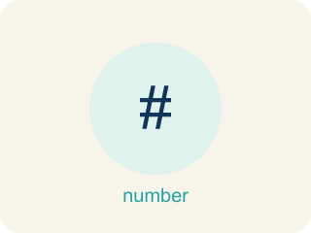
Equivalent Expressions (Expresiones equivalentes) — Expressions that look different but have the same value for every allowed variable value.
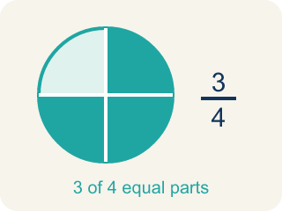
Equivalent (Equivalente) — Expressions that always have the same value.

Simplify (Simplificar) — To write an expression in a shorter, simpler way.
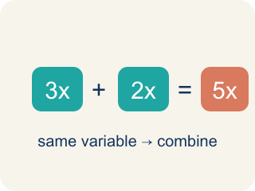
Like Terms (Términos semejantes) — Terms with the same letter raised to the same power, like 2x and 5x.
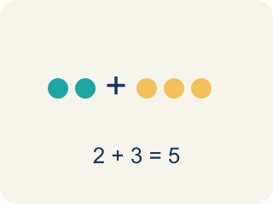
Combine (Combinar) — To add or subtract terms with the same letter into one.
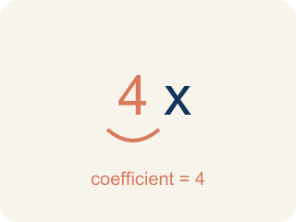
Coefficient (Coeficiente) — The number in front of a letter, like the 3 in 3x.

Practice
Show your work. Use the blank space under each problem.
1. Spot the Combining Mistake
Step 1 (Expression): 7x + 3 + 2x
Step 2 (Combine): Combine every number you see: 7x + 2x + 3 = 9x + 3, then add the 9 and 3 too
Step 3 (Result): 7x + 3 + 2x = 12x
Which step has the mistake? Explain and fix it:
______________________________________________________________________
______________________________________________________________________
______________________________________________________________________
2. Find the Simplification Error
Step 1 (Expression): 3x + 5 + 2x + 1
Step 2 (Combine): 3x + 2x + 5 + 1
Step 3 (Simplify): 5x² + 6
Which step has the mistake? Explain and fix it:
______________________________________________________________________
______________________________________________________________________
______________________________________________________________________
3. A student says 2x + 3 and 5x are equivalent because both equal 5 when x = 1. Is the student correct? Explain why testing one value is not enough to prove equivalence, and find a value of x where they give different results.
Sentence starter: The student is ___ because ___. When x = 1: 2(1) + 3 = ___ and 5(1) = ___. But when x = ___: 2(___) + 3 = ___ and 5(___) = ___. To prove equivalence, expressions must be equal for ___ values of x.
______________________________________________________________________
______________________________________________________________________
______________________________________________________________________
______________________________________________________________________
4. Producer A wrote 2(x + 3) for a beat's cost. Which expression is equivalent?
A. 2x + 6
B. 2x + 3
C. x + 6
D. 2x + 5
______________________________________________________________________

Answer Key (Teacher)
1. Spot the Combining Mistake
The mistake is in Step 2.
Correct work: Only LIKE terms combine. 7x and 2x are like terms (7x + 2x = 9x), but the 3 is a constant and cannot be added to the 9x. The simplified form is 9x + 3. Check x = 2: 7(2) + 3 + 2(2) = 21 and 9(2) + 3 = 21, but 12(2) = 24 — so 12x is wrong.
Watch for: 7x and 2x are like terms, so 7x + 2x = 9x is fine — but the step keeps going and adds the 9 to the 3. A constant like 3 has no variable, so it cannot join 9x in one term. The simplified form is 9x + 3. Check with x = 2: 7(2) + 3 + 2(2) = 21 and 9(2) + 3 = 21, but 12(2) = 24.
2. Find the Simplification Error
The mistake is in Step 3.
Correct work: 3x + 2x = 5x (NOT 5x²). When you combine like terms, you add the coefficients, not multiply them. The correct answer is 5x + 6.
Watch for: Rearranging to 3x + 2x + 5 + 1 is correct. The error is in the last step: combining like terms adds the COEFFICIENTS, so 3x + 2x = 5x, not 5x². The exponent never changes when you add like terms, so the answer is 5x + 6.
3. Open response — answers will vary.
Look for key words: equivalent, substitute, all values, counterexample, not equal, test.
4. A. 2x + 6
Distribute the 2 to each term inside: 2 · x + 2 · 3 = 2x + 6. Check x = 5: 2(5 + 3) = 16 and 2(5) + 6 = 16.
Watch for: A common mistake in Equivalent Expressions is adding the exponents instead of the coefficients when combining like terms — writing 3x + 2x as 5x² instead of 5x. Remember: 3x means 3 groups of x and 2x means 2 more groups of x, so you add the coefficients (3 + 2 = 5) and keep the variable's power the same (x¹, not x²).

