6.7 Small Group · Group 1 — Homework
Lesson 6-7-group1 • Standard 6.NOS.4
Name: ______________________ Period: ______ Date: ____________

Today's Goals
Content: With my small group, I can find the greatest common factor (GCF) of two numbers by listing or comparing their factors — one step at a time, with support.
Language: I can talk through each step out loud using a sentence frame and the lesson's key words.

Key Words
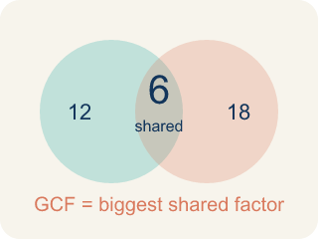
Greatest Common Factor (Máximo común divisor) — The greatest whole number that divides two or more numbers with no remainder.
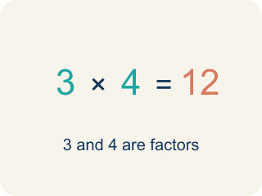
Factor (Factor) — A factor of a whole number divides it evenly, with no remainder. For example, 3 is a factor of 12 because 12 ÷ 3 = 4.

Common factor (Factor común) — A number that divides two or more numbers evenly.
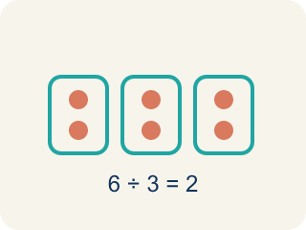
Divisible (Divisible) — A number you can divide evenly, with nothing left over.
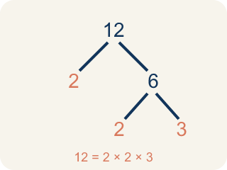
Prime factorization (Factorización prima) — Writing a number as prime numbers multiplied together. It helps you find the GCF.

Practice
Show your work. Use the blank space under each problem.
1. What is the GCF of 8 and 12?
A. 4
B. 2
C. 8
D. 24
______________________________________________________________________
2. Which pair of numbers has a GCF of 5?
A. 15 and 25
B. 10 and 12
C. 6 and 15
D. 8 and 20
______________________________________________________________________
3. Spot the Common Mistake — GCF or LCM?
Step 1 (The problem): Find the GCF of 8 and 20.
Step 2 (List factors of 8): 1, 2, 4, 8
Step 3 (List factors of 20): 1, 2, 4, 5, 10, 20
Step 4 (Choose the answer): Jordan multiplies 8 × 20 = 160 and says the GCF of 8 and 20 is 160.
Which step has the mistake? Explain and fix it:
______________________________________________________________________
______________________________________________________________________
______________________________________________________________________
4. Mission Control must split 24 oxygen tanks and 36 ration packs into identical crew pods with none left over. What is the GCF of 24 and 36?
A. 12
B. 6
C. 8
D. 72
______________________________________________________________________
5. The astronaut crew has 40 solar cells and 60 battery cells to load into matching storage bins with nothing left over. What is the GCF of 40 and 60?
A. 20
B. 10
C. 4
D. 120
______________________________________________________________________
6. Level 2 Extension — The Wrong Mission Number
Step 1 (The problem): Split 12 oxygen tanks and 18 ration packs into the most equal crew pods with none left over.
Step 2 (List factors of 12): 1, 2, 3, 4, 6, 12
Step 3 (List factors of 18): 1, 2, 3, 6, 9, 18
Step 4 (Choose the number of pods): Cadet Rio says 36 pods, because 36 is the smallest number that both 12 and 18 divide into.
Which step has the mistake? Explain and fix it:
______________________________________________________________________
______________________________________________________________________
______________________________________________________________________
7. Find Amara's Mistake
Step 1 (Find factors of 16): 1, 2, 4, 8, 16
Step 2 (Find factors of 28): 1, 2, 4, 7, 14, 28
Step 3 (List common factors): 1, 2, 4
Step 4 (Choose GCF): GCF = 2
Which step has the mistake? Explain and fix it:
______________________________________________________________________
______________________________________________________________________
______________________________________________________________________
8. A farmer has 54 apples and 36 oranges. She wants to make gift baskets where every basket has the same number of apples and the same number of oranges, with none left over. Find the greatest number of baskets and explain how you used GCF to solve this.
Sentence starter: The GCF of 54 and 36 is ___ because ___. So the farmer can make ___ baskets, each with ___ apples and ___ oranges.
______________________________________________________________________
______________________________________________________________________
______________________________________________________________________
______________________________________________________________________

Answer Key (Teacher)
1. A. 4
Factors of 8: 1, 2, 4, 8. Factors of 12: 1, 2, 3, 4, 6, 12. The largest common factor is 4.
Watch for: A common mistake in Greatest Common Factor is confusing it with the Least Common Multiple: some students list the MULTIPLES of both numbers and pick the smallest shared one (getting an answer bigger than either number, like 72 for 24 and 36) instead of listing FACTORS and picking the largest one they share (12). Remember: the GCF splits numbers INTO equal groups, so it can never be bigger than the smaller of the two numbers.
2. A. 15 and 25
15 = 3 × 5, 25 = 5 × 5. Both share the factor 5, and 5 is the largest shared factor.
Watch for: A common mistake in Greatest Common Factor is confusing it with the Least Common Multiple: some students list the MULTIPLES of both numbers and pick the smallest shared one (getting an answer bigger than either number, like 72 for 24 and 36) instead of listing FACTORS and picking the largest one they share (12). Remember: the GCF splits numbers INTO equal groups, so it can never be bigger than the smaller of the two numbers.
3. Spot the Common Mistake — GCF or LCM?
The mistake is in Step 4.
Correct work: Multiplying the two numbers does not give the GCF. The GCF is the largest factor the numbers SHARE. The common factors of 8 and 20 are 1, 2, and 4, so the GCF is 4 — and a factor can never be larger than the numbers themselves.
Watch for: Jordan multiplied 8 × 20 to get 160, but multiplying two numbers produces a common multiple, not a common factor. A factor of 8 can never be larger than 8 itself. The factors 8 and 20 share are 1, 2, and 4, so GCF(8, 20) = 4.
4. A. 12
Factors of 24: 1, 2, 3, 4, 6, 8, 12, 24. Factors of 36: 1, 2, 3, 4, 6, 9, 12, 18, 36. The greatest shared factor is 12, so 12 pods can be filled equally.
Watch for: A common mistake in Greatest Common Factor is confusing it with the Least Common Multiple: some students list the MULTIPLES of both numbers and pick the smallest shared one (getting an answer bigger than either number, like 72 for 24 and 36) instead of listing FACTORS and picking the largest one they share (12). Remember: the GCF splits numbers INTO equal groups, so it can never be bigger than the smaller of the two numbers.
5. A. 20
Factors of 40: 1, 2, 4, 5, 8, 10, 20, 40. Factors of 60: 1, 2, 3, 4, 5, 6, 10, 12, 15, 20, 30, 60. The greatest shared factor is 20, so 20 bins can be filled equally.
Watch for: A common mistake in Greatest Common Factor is confusing it with the Least Common Multiple: some students list the MULTIPLES of both numbers and pick the smallest shared one (getting an answer bigger than either number, like 72 for 24 and 36) instead of listing FACTORS and picking the largest one they share (12). Remember: the GCF splits numbers INTO equal groups, so it can never be bigger than the smaller of the two numbers.
6. Level 2 Extension — The Wrong Mission Number
The mistake is in Step 4.
Correct work: Cadet Rio found the LCM (least common multiple = 36), but making equal groups with none left over needs the GCF (greatest common factor). The common factors of 12 and 18 are 1, 2, 3, 6, and the greatest is 6. So Mission Control can fill 6 equal pods, each with 2 oxygen tanks and 3 ration packs.
Watch for: Cadet Rio found 36, which is the least common multiple of 12 and 18, not the greatest common factor. Splitting supplies into equal groups with none left over needs a number that DIVIDES both counts, so it can never be bigger than 12. The common factors are 1, 2, 3, and 6, so Mission Control fills 6 pods with 12 ÷ 6 = 2 tanks and 18 ÷ 6 = 3 packs each.
7. Find Amara's Mistake
The mistake is in Step 4.
Correct work: GCF = 4 (the greatest of the common factors, not just any common factor). Amara found the common factors correctly but chose 2 instead of the largest one, 4.
Watch for: Amara's factor lists and her list of common factors (1, 2, 4) are all correct. The error is in the last step: she chose 2, but the GCF has to be the greatest of the shared factors, which is 4. So the GCF of 16 and 28 is 4, not 2.
8. Open response — answers will vary.
Look for key words: GCF, greatest, common, factor, 18, baskets, divide, equally.

