6.7 Small Group · Group 2 — Homework
Lesson 6-7-group2 • Standard 6.NOS.4
Name: ______________________ Period: ______ Date: ____________

Today's Goals
Content: I can find the greatest common factor (GCF) of two numbers by listing or comparing their factors, explain why the method works, and use it on a problem I have not seen before.
Language: I can justify my answer to a skeptic and connect it to a second strategy or representation.

Key Words
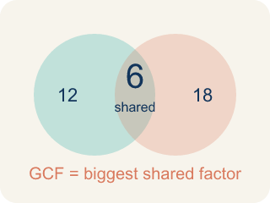
Greatest Common Factor (Máximo común divisor) — The greatest whole number that divides two or more numbers with no remainder.
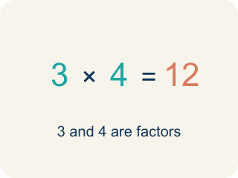
Factor (Factor) — A factor of a whole number divides it evenly, with no remainder. For example, 3 is a factor of 12 because 12 ÷ 3 = 4.

Common factor (Factor común) — A number that divides two or more numbers evenly.
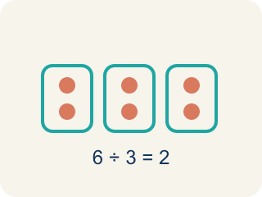
Divisible (Divisible) — A number you can divide evenly, with nothing left over.
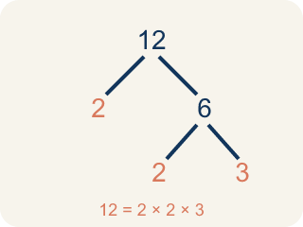
Prime factorization (Factorización prima) — Writing a number as prime numbers multiplied together. It helps you find the GCF.

Practice
Show your work. Use the blank space under each problem.
1. A teacher has 36 pencils and 48 erasers. She wants to make identical supply bags with no items left over. What is the greatest number of bags she can make?
A. 12 bags
B. 6 bags
C. 4 bags
D. 36 bags
______________________________________________________________________
2. Spot the Common Mistake — GCF or LCM?
Step 1 (The problem): Find the GCF of 8 and 20.
Step 2 (List factors of 8): 1, 2, 4, 8
Step 3 (List factors of 20): 1, 2, 4, 5, 10, 20
Step 4 (Choose the answer): Jordan multiplies 8 × 20 = 160 and says the GCF of 8 and 20 is 160.
Which step has the mistake? Explain and fix it:
______________________________________________________________________
______________________________________________________________________
______________________________________________________________________
3. Find Amara's Mistake
Step 1 (Find factors of 16): 1, 2, 4, 8, 16
Step 2 (Find factors of 28): 1, 2, 4, 7, 14, 28
Step 3 (List common factors): 1, 2, 4
Step 4 (Choose GCF): GCF = 2
Which step has the mistake? Explain and fix it:
______________________________________________________________________
______________________________________________________________________
______________________________________________________________________
4. A farmer has 54 apples and 36 oranges. She wants to make gift baskets where every basket has the same number of apples and the same number of oranges, with none left over. Find the greatest number of baskets and explain how you used GCF to solve this.
Sentence starter: The GCF of 54 and 36 is ___ because ___. So the farmer can make ___ baskets, each with ___ apples and ___ oranges.
______________________________________________________________________
______________________________________________________________________
______________________________________________________________________
______________________________________________________________________

Answer Key (Teacher)
1. A. 12 bags
GCF(36, 48) = 12. She can make 12 bags, each with 3 pencils and 4 erasers.
Watch for: A common mistake in Greatest Common Factor is confusing it with the Least Common Multiple: some students list the MULTIPLES of both numbers and pick the smallest shared one (getting an answer bigger than either number, like 72 for 24 and 36) instead of listing FACTORS and picking the largest one they share (12). Remember: the GCF splits numbers INTO equal groups, so it can never be bigger than the smaller of the two numbers.
2. Spot the Common Mistake — GCF or LCM?
The mistake is in Step 4.
Correct work: Multiplying the two numbers does not give the GCF. The GCF is the largest factor the numbers SHARE. The common factors of 8 and 20 are 1, 2, and 4, so the GCF is 4 — and a factor can never be larger than the numbers themselves.
Watch for: Jordan multiplied 8 × 20 to get 160, but multiplying two numbers produces a common multiple, not a common factor. A factor of 8 can never be larger than 8 itself. The factors 8 and 20 share are 1, 2, and 4, so GCF(8, 20) = 4.
3. Find Amara's Mistake
The mistake is in Step 4.
Correct work: GCF = 4 (the greatest of the common factors, not just any common factor). Amara found the common factors correctly but chose 2 instead of the largest one, 4.
Watch for: Amara's factor lists and her list of common factors (1, 2, 4) are all correct. The error is in the last step: she chose 2, but the GCF has to be the greatest of the shared factors, which is 4. So the GCF of 16 and 28 is 4, not 2.
4. Open response — answers will vary.
Look for key words: GCF, greatest, common, factor, 18, baskets, divide, equally.

