6.8 Small Group · Group 1 — Homework
Lesson 6-8-group1 • Standard 6.AT.7
Name: ______________________ Period: ______ Date: ____________

Today's Goals
Content: With my small group, I can use the commutative, associative, and identity properties to rewrite expressions — one step at a time, with support.
Language: I can talk through each step out loud using a sentence frame and the lesson's key words.

Key Words
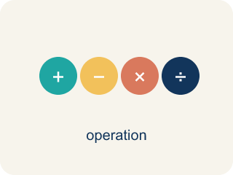
Properties of Operations (Propiedades de las operaciones) — Rules that let you reorder or regroup numbers without changing an expression's value.
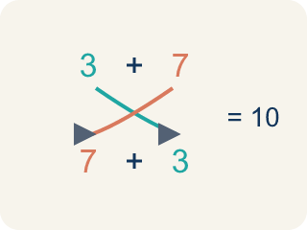
Commutative Property (Propiedad conmutativa) — You can change the order and get the same answer.
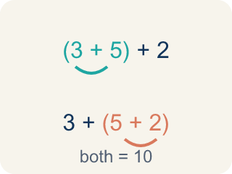
Associative Property (Propiedad asociativa) — You can change the grouping and get the same answer.
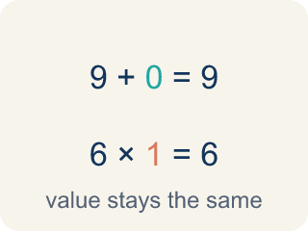
Identity Property (Propiedad de identidad) — Adding 0 or multiplying by 1 keeps the same value.
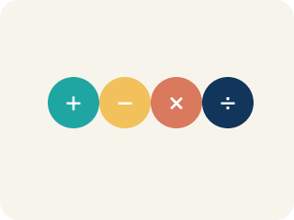
Property (Propiedad) — A rule that is always true in math.
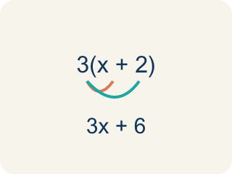
Distributive Property (Propiedad distributiva) — Multiplying a number by everything inside the parentheses: a(b + c) = ab + ac.

Practice
Show your work. Use the blank space under each problem.
1. Which property is shown? 5 + 13 = 13 + 5
A. Commutative Property
B. Associative Property
C. Identity Property
D. Distributive Property
______________________________________________________________________
2. Which property is shown? (6 × 3) × 2 = 6 × (3 × 2)
A. Associative Property
B. Commutative Property
C. Identity Property
D. Distributive Property
______________________________________________________________________
3. Track 3 plays (7 + 3) + 5 = 7 + (3 + 5). Only the parentheses moved. Which property is this?
A. Associative Property
B. Commutative Property
C. Distributive Property
D. Identity Property
______________________________________________________________________
4. Track 4 plays 1 × y = y. Which property is this?
A. Identity Property
B. Distributive Property
C. Commutative Property
D. Associative Property
______________________________________________________________________
5. Level 2 Extension — Catch the Mislabeled Track
Step 1 (Track): 3(a + b) = 3a + 3b
Step 2 (Student's label): This shows the Associative Property.
Step 3 (Reasoning): There are parentheses, so the grouping must have changed.
Which step has the mistake? Explain and fix it:
______________________________________________________________________
______________________________________________________________________
______________________________________________________________________
6. Find the Property Error
Step 1 (Statement): 15 − 8 = 8 − 15
Step 2 (Student's claim): This shows the Commutative Property of Subtraction.
Step 3 (Reasoning): I switched the order, so it must be commutative.
Which step has the mistake? Explain and fix it:
______________________________________________________________________
______________________________________________________________________
______________________________________________________________________
7. Explain why the commutative property works for addition and multiplication but NOT for subtraction and division. Give a specific number example for each operation to prove your point.
Sentence starter: Addition: ___ + ___ = ___ + ___ = ___ (works). Subtraction: ___ − ___ ≠ ___ − ___ because ___. Multiplication: ___ × ___ = ___ × ___ = ___ (works). Division: ___ ÷ ___ ≠ ___ ÷ ___ because ___.
______________________________________________________________________
______________________________________________________________________
______________________________________________________________________
______________________________________________________________________
8. Sort each equation by the property it shows.
Groups: Commutative | Associative | Identity
• 9 + 4 = 4 + 9 → __________________
• 7 × 1 = 7 → __________________
• (5 + 1) + 3 = 5 + (1 + 3) → __________________
______________________________________________________________________

Answer Key (Teacher)
1. A. Commutative Property
The order of the addends changed, so this is the Commutative Property of Addition.
Watch for: A common mistake in Properties of Operations is applying the commutative property where it does not belong, or confusing it with the associative property. Students often assume 15 − 8 = 8 − 15 (it does not: 7 ≠ −7 — commutative only works for addition and multiplication), or they see parentheses move and call it "associative" even when the numbers inside just swapped places, like (2 + 3) + 4 = (3 + 2) + 4 (that is commutative — the order inside the parentheses changed, not the grouping). Before you label a property, ask: did only the order change (commutative), did only the grouping change (associative), or was a 0 or 1 involved (identity)?
2. A. Associative Property
The grouping (parentheses) changed but the order stayed the same, so this is the Associative Property of Multiplication.
Watch for: A common mistake in Properties of Operations is applying the commutative property where it does not belong, or confusing it with the associative property. Students often assume 15 − 8 = 8 − 15 (it does not: 7 ≠ −7 — commutative only works for addition and multiplication), or they see parentheses move and call it "associative" even when the numbers inside just swapped places, like (2 + 3) + 4 = (3 + 2) + 4 (that is commutative — the order inside the parentheses changed, not the grouping). Before you label a property, ask: did only the order change (commutative), did only the grouping change (associative), or was a 0 or 1 involved (identity)?
3. A. Associative Property
The grouping (parentheses) changed but the order of the numbers stayed the same, so this is the Associative Property.
Watch for: A common mistake in Properties of Operations is applying the commutative property where it does not belong, or confusing it with the associative property. Students often assume 15 − 8 = 8 − 15 (it does not: 7 ≠ −7 — commutative only works for addition and multiplication), or they see parentheses move and call it "associative" even when the numbers inside just swapped places, like (2 + 3) + 4 = (3 + 2) + 4 (that is commutative — the order inside the parentheses changed, not the grouping). Before you label a property, ask: did only the order change (commutative), did only the grouping change (associative), or was a 0 or 1 involved (identity)?
4. A. Identity Property
Multiplying by 1 keeps the same value, so this is the Identity Property of Multiplication.
Watch for: A common mistake in Properties of Operations is applying the commutative property where it does not belong, or confusing it with the associative property. Students often assume 15 − 8 = 8 − 15 (it does not: 7 ≠ −7 — commutative only works for addition and multiplication), or they see parentheses move and call it "associative" even when the numbers inside just swapped places, like (2 + 3) + 4 = (3 + 2) + 4 (that is commutative — the order inside the parentheses changed, not the grouping). Before you label a property, ask: did only the order change (commutative), did only the grouping change (associative), or was a 0 or 1 involved (identity)?
5. Level 2 Extension — Catch the Mislabeled Track
The mistake is in Step 2.
Correct work: This track actually shows the Distributive Property, not the Associative Property. The 3 is multiplied across both terms inside the parentheses: 3 × a and 3 × b. Check with numbers a = 2, b = 6: 3(2 + 6) = 3 × 8 = 24, and 3 × 2 + 3 × 6 = 6 + 18 = 24. The Associative Property only changes grouping inside one operation, like (a + b) + c = a + (b + c). Distributive spreads a multiplier over a sum.
Watch for: Parentheses alone do not mean associative. In 3(a + b) = 3a + 3b the 3 gets multiplied by each term inside, which is the Distributive Property; testing a = 2 and b = 6 gives 3 × 8 = 24 and 6 + 18 = 24. Associative would only regroup one operation, like (a + b) + c = a + (b + c).
6. Find the Property Error
The mistake is in Step 2.
Correct work: 15 − 8 = 7, but 8 − 15 = −7. These are NOT equal. The commutative property does NOT apply to subtraction. It only works for addition and multiplication.
Watch for: The claim fails as soon as you compute: 15 − 8 = 7 but 8 − 15 = −7, so the two sides are not equal and no property is being shown. The commutative property applies only to addition and multiplication, never to subtraction or division.
7. Open response — answers will vary.
Look for key words: commutative, order, addition, subtraction, multiplication, division, not equal.
8. Correct groups:
9 + 4 = 4 + 9 → Commutative
7 × 1 = 7 → Identity
(5 + 1) + 3 = 5 + (1 + 3) → Associative

