6.8 Small Group · Group 2 — Homework
Lesson 6-8-group2 • Standard 6.AT.7
Name: ______________________ Period: ______ Date: ____________

Today's Goals
Content: I can use the commutative, associative, and identity properties to rewrite expressions, explain why the method works, and use it on a problem I have not seen before.
Language: I can justify my answer to a skeptic and connect it to a second strategy or representation.

Key Words
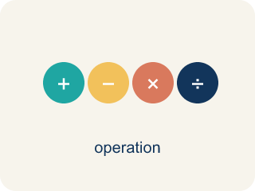
Properties of Operations (Propiedades de las operaciones) — Rules that let you reorder or regroup numbers without changing an expression's value.
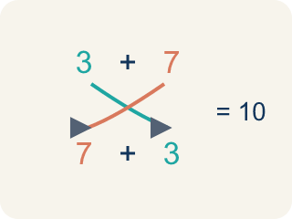
Commutative Property (Propiedad conmutativa) — You can change the order and get the same answer.
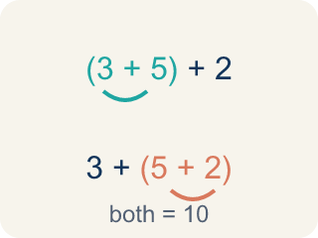
Associative Property (Propiedad asociativa) — You can change the grouping and get the same answer.
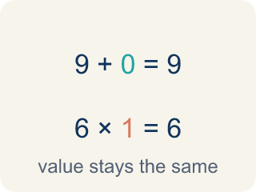
Identity Property (Propiedad de identidad) — Adding 0 or multiplying by 1 keeps the same value.
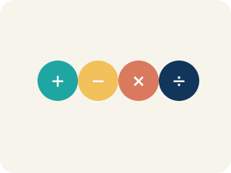
Property (Propiedad) — A rule that is always true in math.
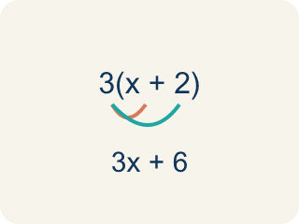
Distributive Property (Propiedad distributiva) — Multiplying a number by everything inside the parentheses: a(b + c) = ab + ac.

Practice
Show your work. Use the blank space under each problem.
1. Spot the Common Mistake
Step 1 (Statement): (2 + 3) + 4 = (3 + 2) + 4
Step 2 (Student's label): This shows the Associative Property.
Step 3 (Reasoning): There are parentheses, so the grouping must have changed.
Which step has the mistake? Explain and fix it:
______________________________________________________________________
______________________________________________________________________
______________________________________________________________________
2. Find the Property Error
Step 1 (Statement): 15 − 8 = 8 − 15
Step 2 (Student's claim): This shows the Commutative Property of Subtraction.
Step 3 (Reasoning): I switched the order, so it must be commutative.
Which step has the mistake? Explain and fix it:
______________________________________________________________________
______________________________________________________________________
______________________________________________________________________
3. Explain why the commutative property works for addition and multiplication but NOT for subtraction and division. Give a specific number example for each operation to prove your point.
Sentence starter: Addition: ___ + ___ = ___ + ___ = ___ (works). Subtraction: ___ − ___ ≠ ___ − ___ because ___. Multiplication: ___ × ___ = ___ × ___ = ___ (works). Division: ___ ÷ ___ ≠ ___ ÷ ___ because ___.
______________________________________________________________________
______________________________________________________________________
______________________________________________________________________
______________________________________________________________________
4. Track 2 on the playlist plays 5(7 + 2) = 5 × 7 + 5 × 2. Which property is this?
A. Distributive Property
B. Commutative Property
C. Associative Property
D. Identity Property
______________________________________________________________________

Answer Key (Teacher)
1. Spot the Common Mistake
The mistake is in Step 2.
Correct work: This is actually the Commutative Property, not the Associative Property. Look inside the parentheses: 2 + 3 became 3 + 2 — the ORDER of the addends switched, but the grouping (the parentheses) stayed in the exact same place around the first two numbers. The Associative Property would move the parentheses, like (2 + 3) + 4 = 2 + (3 + 4). Both sides still equal 9, but the property shown is commutative.
Watch for: The parentheses in (2 + 3) + 4 = (3 + 2) + 4 never moved — they stay around the first two numbers on both sides. What changed is the order inside them, 2 + 3 becoming 3 + 2, so this is the Commutative Property; Associative would look like (2 + 3) + 4 = 2 + (3 + 4).
2. Find the Property Error
The mistake is in Step 2.
Correct work: 15 − 8 = 7, but 8 − 15 = −7. These are NOT equal. The commutative property does NOT apply to subtraction. It only works for addition and multiplication.
Watch for: The claim fails as soon as you compute: 15 − 8 = 7 but 8 − 15 = −7, so the two sides are not equal and no property is being shown. The commutative property applies only to addition and multiplication, never to subtraction or division.
3. Open response — answers will vary.
Look for key words: commutative, order, addition, subtraction, multiplication, division, not equal.
4. A. Distributive Property
Multiplying 5 across both numbers inside the parentheses (5 × 7 and 5 × 2) shows the Distributive Property.
Watch for: A common mistake in Properties of Operations is applying the commutative property where it does not belong, or confusing it with the associative property. Students often assume 15 − 8 = 8 − 15 (it does not: 7 ≠ −7 — commutative only works for addition and multiplication), or they see parentheses move and call it "associative" even when the numbers inside just swapped places, like (2 + 3) + 4 = (3 + 2) + 4 (that is commutative — the order inside the parentheses changed, not the grouping). Before you label a property, ask: did only the order change (commutative), did only the grouping change (associative), or was a 0 or 1 involved (identity)?

