Generate Equivalent Expressions — Homework
Lesson 6-8 • Standard 6.AT.7
Name: ______________________ Period: ______ Date: ____________

Today's Goals
Content: I can use the commutative, associative, and identity properties to rewrite expressions.
Language: I can explain my reasoning using the words commutative property, associative property, and identity property.

Key Words
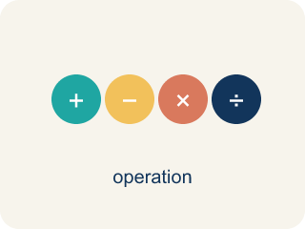
Properties of Operations (Propiedades de las operaciones) — Rules that let you reorder or regroup numbers without changing an expression's value.
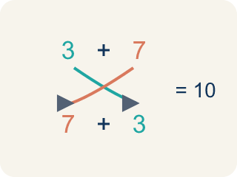
Commutative Property (Propiedad conmutativa) — You can change the order and get the same answer.
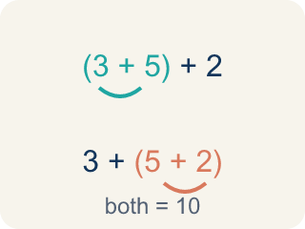
Associative Property (Propiedad asociativa) — You can change the grouping and get the same answer.
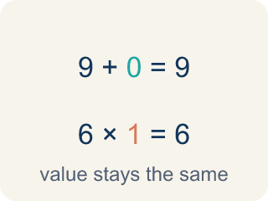
Identity Property (Propiedad de identidad) — Adding 0 or multiplying by 1 keeps the same value.
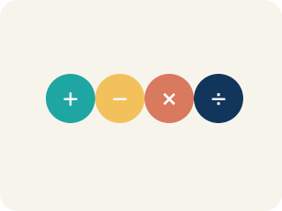
Property (Propiedad) — A rule that is always true in math.
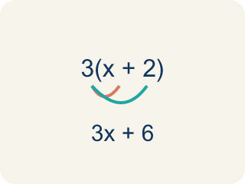
Distributive Property (Propiedad distributiva) — Multiplying a number by everything inside the parentheses: a(b + c) = ab + ac.

Practice
Show your work. Use the blank space under each problem.
1. Which property is shown? 5 + 13 = 13 + 5
A. Commutative Property
B. Associative Property
C. Identity Property
D. Distributive Property
______________________________________________________________________
2. Which property is shown? (6 × 3) × 2 = 6 × (3 × 2)
A. Associative Property
B. Commutative Property
C. Identity Property
D. Distributive Property
______________________________________________________________________
3. Match each equation with the property it demonstrates.
Groups: Commutative | Associative | Identity
• a + b = b + a → __________________
• x × 1 = x → __________________
• (m + n) + p = m + (n + p) → __________________
• c × d = d × c → __________________
• y + 0 = y → __________________
• (a × b) × c = a × (b × c) → __________________
______________________________________________________________________
4. Match each equation to its property.
Item | Answer choices
____ 7 + 9 = 9 + 7 | F. Associative (Add)
____ (2 × 5) × 3 = 2 × (5 × 3) | E. Commutative (Mult)
____ 15 × 1 = 15 | D. Identity (Add)
____ 0 + 23 = 23 | C. Identity (Mult)
____ 6 × 4 = 4 × 6 | B. Associative (Mult)
____ (8 + 3) + 7 = 8 + (3 + 7) | A. Commutative (Add)
______________________________________________________________________
5. Use properties to rewrite each expression in a way that makes mental math easier. Then calculate.
Original | Rearranged (using properties) | Value
25 × 7 × 4 | 25 × 4 × 7 = 100 × 7
19 + 36 + 1 | 19 + 1 + 36 = 20 + 36
50 × 9 × 2 | 50 × 2 × 9 = 100 × 9
______________________________________________________________________
6. Spot the Common Mistake
Step 1 (Statement): (2 + 3) + 4 = (3 + 2) + 4
Step 2 (Student's label): This shows the Associative Property.
Step 3 (Reasoning): There are parentheses, so the grouping must have changed.
Which step has the mistake? Explain and fix it:
______________________________________________________________________
______________________________________________________________________
______________________________________________________________________
7. Drag each track on the playlist into the property of operations it shows. Ask yourself: did the order change, the grouping change, or did a 0 or 1 keep the value the same?
Groups: Commutative Property | Associative Property | Distributive Property | Identity Property
• 2 + 5 = 5 + 2 → __________________
• 5 × 9 = 9 × 5 → __________________
• (2 + 6) + 4 = 2 + (6 + 4) → __________________
• (3 × 2) × 5 = 3 × (2 × 5) → __________________
• 5(7 + 2) = 5 × 7 + 5 × 2 → __________________
• 2(x + 5) = 2x + 10 → __________________
• 11 + 0 = 11 → __________________
• 6 × 1 = 6 → __________________
______________________________________________________________________
8. Track 2 on the playlist plays 5(7 + 2) = 5 × 7 + 5 × 2. Which property is this?
A. Distributive Property
B. Commutative Property
C. Associative Property
D. Identity Property
______________________________________________________________________
9. Track 3 plays (7 + 3) + 5 = 7 + (3 + 5). Only the parentheses moved. Which property is this?
A. Associative Property
B. Commutative Property
C. Distributive Property
D. Identity Property
______________________________________________________________________
10. Track 4 plays 1 × y = y. Which property is this?
A. Identity Property
B. Distributive Property
C. Commutative Property
D. Associative Property
______________________________________________________________________

Answer Key (Teacher)
1. A. Commutative Property
The order of the addends changed, so this is the Commutative Property of Addition.
Watch for: A common mistake in Properties of Operations is applying the commutative property where it does not belong, or confusing it with the associative property. Students often assume 15 − 8 = 8 − 15 (it does not: 7 ≠ −7 — commutative only works for addition and multiplication), or they see parentheses move and call it "associative" even when the numbers inside just swapped places, like (2 + 3) + 4 = (3 + 2) + 4 (that is commutative — the order inside the parentheses changed, not the grouping). Before you label a property, ask: did only the order change (commutative), did only the grouping change (associative), or was a 0 or 1 involved (identity)?
2. A. Associative Property
The grouping (parentheses) changed but the order stayed the same, so this is the Associative Property of Multiplication.
Watch for: A common mistake in Properties of Operations is applying the commutative property where it does not belong, or confusing it with the associative property. Students often assume 15 − 8 = 8 − 15 (it does not: 7 ≠ −7 — commutative only works for addition and multiplication), or they see parentheses move and call it "associative" even when the numbers inside just swapped places, like (2 + 3) + 4 = (3 + 2) + 4 (that is commutative — the order inside the parentheses changed, not the grouping). Before you label a property, ask: did only the order change (commutative), did only the grouping change (associative), or was a 0 or 1 involved (identity)?
3. Correct groups:
a + b = b + a → Commutative
x × 1 = x → Identity
(m + n) + p = m + (n + p) → Associative
c × d = d × c → Commutative
y + 0 = y → Identity
(a × b) × c = a × (b × c) → Associative

4. Matches:
7 + 9 = 9 + 7 → Commutative (Add)
(2 × 5) × 3 = 2 × (5 × 3) → Associative (Mult)
15 × 1 = 15 → Identity (Mult)
0 + 23 = 23 → Identity (Add)
6 × 4 = 4 × 6 → Commutative (Mult)
(8 + 3) + 7 = 8 + (3 + 7) → Associative (Add)

5. Use properties to rewrite each expression in a way that makes mental math easier. Then calculate.
25 × 7 × 4 — Value: 700
19 + 36 + 1 — Value: 56
50 × 9 × 2 — Value: 900

6. Spot the Common Mistake
The mistake is in Step 2.
Correct work: This is actually the Commutative Property, not the Associative Property. Look inside the parentheses: 2 + 3 became 3 + 2 — the ORDER of the addends switched, but the grouping (the parentheses) stayed in the exact same place around the first two numbers. The Associative Property would move the parentheses, like (2 + 3) + 4 = 2 + (3 + 4). Both sides still equal 9, but the property shown is commutative.
Watch for: The parentheses in (2 + 3) + 4 = (3 + 2) + 4 never moved — they stay around the first two numbers on both sides. What changed is the order inside them, 2 + 3 becoming 3 + 2, so this is the Commutative Property; Associative would look like (2 + 3) + 4 = 2 + (3 + 4).
7. Correct groups:
2 + 5 = 5 + 2 → Commutative Property
5 × 9 = 9 × 5 → Commutative Property
(2 + 6) + 4 = 2 + (6 + 4) → Associative Property
(3 × 2) × 5 = 3 × (2 × 5) → Associative Property
5(7 + 2) = 5 × 7 + 5 × 2 → Distributive Property
2(x + 5) = 2x + 10 → Distributive Property
11 + 0 = 11 → Identity Property
6 × 1 = 6 → Identity Property

8. A. Distributive Property
Multiplying 5 across both numbers inside the parentheses (5 × 7 and 5 × 2) shows the Distributive Property.
Watch for: A common mistake in Properties of Operations is applying the commutative property where it does not belong, or confusing it with the associative property. Students often assume 15 − 8 = 8 − 15 (it does not: 7 ≠ −7 — commutative only works for addition and multiplication), or they see parentheses move and call it "associative" even when the numbers inside just swapped places, like (2 + 3) + 4 = (3 + 2) + 4 (that is commutative — the order inside the parentheses changed, not the grouping). Before you label a property, ask: did only the order change (commutative), did only the grouping change (associative), or was a 0 or 1 involved (identity)?
9. A. Associative Property
The grouping (parentheses) changed but the order of the numbers stayed the same, so this is the Associative Property.
Watch for: A common mistake in Properties of Operations is applying the commutative property where it does not belong, or confusing it with the associative property. Students often assume 15 − 8 = 8 − 15 (it does not: 7 ≠ −7 — commutative only works for addition and multiplication), or they see parentheses move and call it "associative" even when the numbers inside just swapped places, like (2 + 3) + 4 = (3 + 2) + 4 (that is commutative — the order inside the parentheses changed, not the grouping). Before you label a property, ask: did only the order change (commutative), did only the grouping change (associative), or was a 0 or 1 involved (identity)?
10. A. Identity Property
Multiplying by 1 keeps the same value, so this is the Identity Property of Multiplication.
Watch for: A common mistake in Properties of Operations is applying the commutative property where it does not belong, or confusing it with the associative property. Students often assume 15 − 8 = 8 − 15 (it does not: 7 ≠ −7 — commutative only works for addition and multiplication), or they see parentheses move and call it "associative" even when the numbers inside just swapped places, like (2 + 3) + 4 = (3 + 2) + 4 (that is commutative — the order inside the parentheses changed, not the grouping). Before you label a property, ask: did only the order change (commutative), did only the grouping change (associative), or was a 0 or 1 involved (identity)?

