6.9 Small Group · Group 1 — Homework
Lesson 6-9-group1 • Standard 6.NOS.1
Name: ______________________ Period: ______ Date: ____________

Today's Goals
Content: With my small group, I can divide a whole number by a fraction by multiplying by the reciprocal — one step at a time, with support.
Language: I can talk through each step out loud using a sentence frame and the lesson's key words.

Key Words
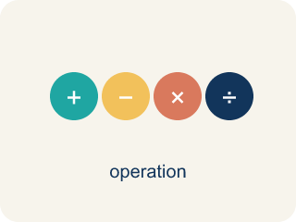
Divide Whole Numbers by Fractions (Dividir números enteros entre fracciones) — Find how many fractional groups fit in a whole number by multiplying by the reciprocal.
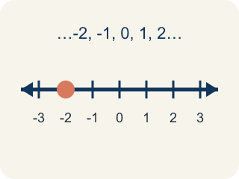
Whole Number (Número entero) — A counting number with no fraction or decimal, like 0, 1, 2, 3.
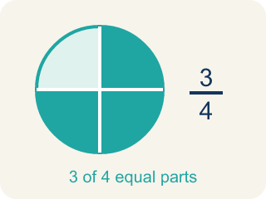
Fraction (Fracción) — A number that shows part of a whole, like 3/4.
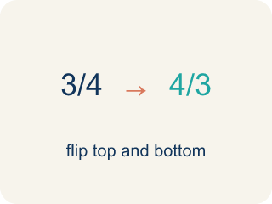
Reciprocal (Recíproco) — A fraction turned upside down.

Keep, Change, Flip (Mantener, cambiar, invertir) — A way to divide fractions: keep the first, change ÷ to ×, flip the second.
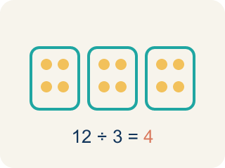
Quotient (Cociente) — The answer when you divide.

Practice
Show your work. Use the blank space under each problem.
1. What is 6 ÷ 1/3?
A. 18
B. 2
C. 6/3
D. 3
______________________________________________________________________
2. What is 3 ÷ 1/5?
A. 15
B. 3/5
C. 5/3
D. 8
______________________________________________________________________
3. Detective Park has 4 cups of flour. Each batch of evidence-cookies needs 1/2 cup. How many batches can he make?
A. 8
B. 2
C. 4
D. 6
______________________________________________________________________
4. The crew has 8 quarts of sports drink. Each detective's water bottle holds 4/5 of a quart. How many bottles can be filled?
A. 10
B. 5
C. 32/5
D. 12
______________________________________________________________________
5. There are 3 bags of trail mix. Each snack pouch needs 2/3 of a bag. How many full pouches can be filled, and is there a leftover?
A. 4 1/2 pouches (4 full, half a pouch left)
B. 4 pouches exactly
C. 2 pouches
D. 6 pouches
______________________________________________________________________
6. Detective Park bakes with 9 cups of batter. Each muffin pan holds 3/4 of a cup. How many pans can he fill?
A. 12
B. 6
C. 27/4
D. 9
______________________________________________________________________
7. Level 2 Extension — Catch the Catering Mistake
Step 1 (Problem): 6 cups of soup ÷ 3/4-cup bowls
Step 2 (Keep, Change, Flip): 6 × 3/4
Step 3 (Multiply): 18/4
Step 4 (Simplify): 4 1/2 bowls
Which step has the mistake? Explain and fix it:
______________________________________________________________________
______________________________________________________________________
______________________________________________________________________
8. Find the Division Error
Step 1 (Problem): 6 ÷ 2/3
Step 2 (Keep, Change, Flip): 6 × 2/3
Step 3 (Multiply): 12/3
Step 4 (Simplify): 4
Which step has the mistake? Explain and fix it:
______________________________________________________________________
______________________________________________________________________
______________________________________________________________________

Answer Key (Teacher)
1. A. 18
6 ÷ 1/3 = 6 × 3/1 = 18. There are 18 thirds in 6 wholes.
Watch for: A common mistake in Divide Whole Numbers by Fractions is doing 'Keep, Change' but skipping the 'Flip' — students multiply by the divisor as it is instead of by its reciprocal. For example, for 6 ÷ 3/4, a student might write 6 × 3/4 = 4 1/2 and stop there, but the divisor 3/4 must be flipped to 4/3 first: 6 × 4/3 = 24/3 = 8. Before you submit, check: did I flip the second fraction (the divisor) upside down before multiplying?
2. A. 15
3 ÷ 1/5 = 3 × 5/1 = 15. There are 15 fifths in 3 wholes.
Watch for: A common mistake in Divide Whole Numbers by Fractions is doing 'Keep, Change' but skipping the 'Flip' — students multiply by the divisor as it is instead of by its reciprocal. For example, for 6 ÷ 3/4, a student might write 6 × 3/4 = 4 1/2 and stop there, but the divisor 3/4 must be flipped to 4/3 first: 6 × 4/3 = 24/3 = 8. Before you submit, check: did I flip the second fraction (the divisor) upside down before multiplying?
3. A. 8
4 ÷ 1/2 = 4 × 2/1 = 8 batches. Each cup makes 2 half-cup batches.
Watch for: A common mistake in Divide Whole Numbers by Fractions is doing 'Keep, Change' but skipping the 'Flip' — students multiply by the divisor as it is instead of by its reciprocal. For example, for 6 ÷ 3/4, a student might write 6 × 3/4 = 4 1/2 and stop there, but the divisor 3/4 must be flipped to 4/3 first: 6 × 4/3 = 24/3 = 8. Before you submit, check: did I flip the second fraction (the divisor) upside down before multiplying?
4. A. 10
8 ÷ 4/5 = 8 × 5/4 = 40/4 = 10 bottles.
Watch for: A common mistake in Divide Whole Numbers by Fractions is doing 'Keep, Change' but skipping the 'Flip' — students multiply by the divisor as it is instead of by its reciprocal. For example, for 6 ÷ 3/4, a student might write 6 × 3/4 = 4 1/2 and stop there, but the divisor 3/4 must be flipped to 4/3 first: 6 × 4/3 = 24/3 = 8. Before you submit, check: did I flip the second fraction (the divisor) upside down before multiplying?
5. A. 4 1/2 pouches (4 full, half a pouch left)
3 ÷ 2/3 = 3 × 3/2 = 9/2 = 4 1/2. You can fill 4 full pouches with half a pouch of mix left over.
Watch for: A common mistake in Divide Whole Numbers by Fractions is doing 'Keep, Change' but skipping the 'Flip' — students multiply by the divisor as it is instead of by its reciprocal. For example, for 6 ÷ 3/4, a student might write 6 × 3/4 = 4 1/2 and stop there, but the divisor 3/4 must be flipped to 4/3 first: 6 × 4/3 = 24/3 = 8. Before you submit, check: did I flip the second fraction (the divisor) upside down before multiplying?
6. A. 12
9 ÷ 3/4 = 9 × 4/3 = 36/3 = 12 pans.
Watch for: A common mistake in Divide Whole Numbers by Fractions is doing 'Keep, Change' but skipping the 'Flip' — students multiply by the divisor as it is instead of by its reciprocal. For example, for 6 ÷ 3/4, a student might write 6 × 3/4 = 4 1/2 and stop there, but the divisor 3/4 must be flipped to 4/3 first: 6 × 4/3 = 24/3 = 8. Before you submit, check: did I flip the second fraction (the divisor) upside down before multiplying?
7. Level 2 Extension — Catch the Catering Mistake
The mistake is in Step 2.
Correct work: Keep the 6 and flip the divisor 3/4 to its reciprocal 4/3: 6 × 4/3 = 24/3 = 8 bowls. The mistake was multiplying by 3/4 instead of flipping it to 4/3.
Watch for: The Keep, Change, Flip step changed the sign but kept 3/4 instead of flipping it to 4/3, which is why the answer came out smaller than 6 instead of larger. The correct work is 6 × 4/3 = 24/3 = 8 bowls. Since each bowl holds less than a full cup, 6 cups must fill more than 6 bowls.
8. Find the Division Error
The mistake is in Step 2.
Correct work: 6 × 3/2 (flip the divisor 2/3 to get 3/2, not keep it as 2/3). Then 6 × 3/2 = 18/2 = 9.
Watch for: The Keep, Change, Flip step kept the divisor as 2/3 instead of flipping it to its reciprocal 3/2. The correct work is 6 × 3/2 = 18/2 = 9. Nine also makes sense as a count: each whole holds one and a half 2/3-size pieces, so 6 wholes hold 9 of them — more than the 6 you started with, not less.

