6.9 Small Group · Group 2 — Homework
Lesson 6-9-group2 • Standard 6.NOS.1
Name: ______________________ Period: ______ Date: ____________

Today's Goals
Content: I can divide a whole number by a fraction by multiplying by the reciprocal, explain why the method works, and use it on a problem I have not seen before.
Language: I can justify my answer to a skeptic and connect it to a second strategy or representation.

Key Words
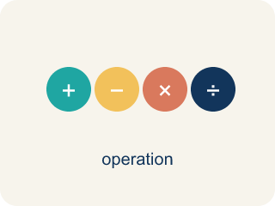
Divide Whole Numbers by Fractions (Dividir números enteros entre fracciones) — Find how many fractional groups fit in a whole number by multiplying by the reciprocal.
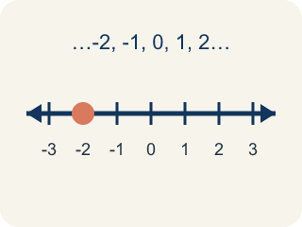
Whole Number (Número entero) — A counting number with no fraction or decimal, like 0, 1, 2, 3.
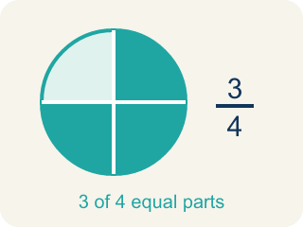
Fraction (Fracción) — A number that shows part of a whole, like 3/4.
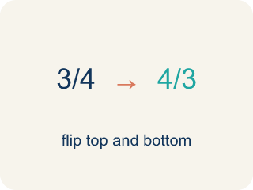
Reciprocal (Recíproco) — A fraction turned upside down.

Keep, Change, Flip (Mantener, cambiar, invertir) — A way to divide fractions: keep the first, change ÷ to ×, flip the second.
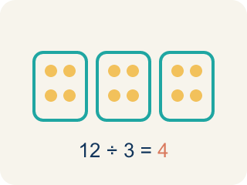
Quotient (Cociente) — The answer when you divide.

Practice
Show your work. Use the blank space under each problem.
1. What is 6 ÷ 2/3?
A. 9
B. 4
C. 12
D. 2/18
______________________________________________________________________
2. Spot the Common Mistake
Step 1 (Problem): 8 ÷ 3/4
Step 2 (Keep, Change, Flip): Flipped the wrong number — wrote 1/8 × 3/4 instead of 8 × 4/3
Step 3 (Multiply): 1/8 × 3/4 = 3/32
Which step has the mistake? Explain and fix it:
______________________________________________________________________
______________________________________________________________________
______________________________________________________________________
3. Find the Division Error
Step 1 (Problem): 6 ÷ 2/3
Step 2 (Keep, Change, Flip): 6 × 2/3
Step 3 (Multiply): 12/3
Step 4 (Simplify): 4
Which step has the mistake? Explain and fix it:
______________________________________________________________________
______________________________________________________________________
______________________________________________________________________
4. A pizza shop has 8 whole pizzas. Each serving is 2/3 of a pizza. How many servings can they make? Write and solve an equation, then explain why the answer is greater than 8.
Sentence starter: The equation is 8 ÷ 2/3 = ___. Using Keep, Change, Flip: 8 × 3/2 = ___. The answer is greater than 8 because ___.
______________________________________________________________________
______________________________________________________________________
______________________________________________________________________
______________________________________________________________________

Answer Key (Teacher)
1. A. 9
6 ÷ 2/3 = 6 × 3/2 = 18/2 = 9. Keep 6, change ÷ to ×, flip 2/3 to 3/2.
Watch for: A common mistake in Divide Whole Numbers by Fractions is doing 'Keep, Change' but skipping the 'Flip' — students multiply by the divisor as it is instead of by its reciprocal. For example, for 6 ÷ 3/4, a student might write 6 × 3/4 = 4 1/2 and stop there, but the divisor 3/4 must be flipped to 4/3 first: 6 × 4/3 = 24/3 = 8. Before you submit, check: did I flip the second fraction (the divisor) upside down before multiplying?
2. Spot the Common Mistake
The mistake is in Step 2.
Correct work: Keep the dividend 8 the same and flip only the divisor: 8 × 4/3 = 32/3 = 10 2/3. The mistake was flipping the whole number 8 into 1/8 instead of flipping the divisor 3/4 into 4/3.
Watch for: Only the divisor gets flipped. The Keep, Change, Flip step turned the dividend 8 into 1/8 and left 3/4 alone, which is backwards; the correct rewrite is 8 × 4/3 = 32/3 = 10 2/3. Since 3/4 is less than 1, more than 8 of those pieces fit into 8 wholes, so a tiny answer like 3/32 cannot be right.
3. Find the Division Error
The mistake is in Step 2.
Correct work: 6 × 3/2 (flip the divisor 2/3 to get 3/2, not keep it as 2/3). Then 6 × 3/2 = 18/2 = 9.
Watch for: The Keep, Change, Flip step kept the divisor as 2/3 instead of flipping it to its reciprocal 3/2. The correct work is 6 × 3/2 = 18/2 = 9. Nine also makes sense as a count: each whole holds one and a half 2/3-size pieces, so 6 wholes hold 9 of them — more than the 6 you started with, not less.
4. Open response — answers will vary.
Look for key words: 12, 8 × 3/2, greater, less than 1, servings, reciprocal.

