Divide Whole Numbers by Fractions — Homework
Lesson 6-9 • Standard 6.NOS.1
Name: ______________________ Period: ______ Date: ____________

Today's Goals
Content: I can divide a whole number by a fraction by multiplying by the reciprocal.
Language: I can explain my steps using the words fraction, reciprocal, quotient, and Keep, Change, Flip.

Key Words
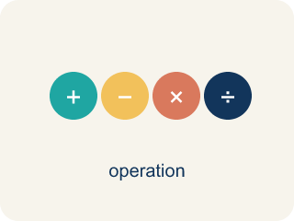
Divide Whole Numbers by Fractions (Dividir números enteros entre fracciones) — Find how many fractional groups fit in a whole number by multiplying by the reciprocal.
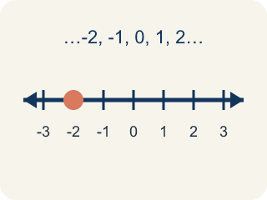
Whole Number (Número entero) — A counting number with no fraction or decimal, like 0, 1, 2, 3.
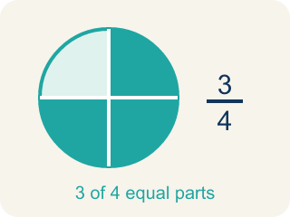
Fraction (Fracción) — A number that shows part of a whole, like 3/4.
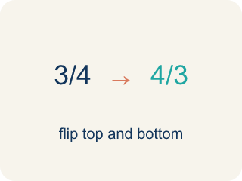
Reciprocal (Recíproco) — A fraction turned upside down.

Keep, Change, Flip (Mantener, cambiar, invertir) — A way to divide fractions: keep the first, change ÷ to ×, flip the second.
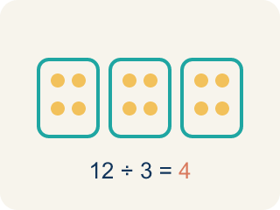
Quotient (Cociente) — The answer when you divide.

Practice
Show your work. Use the blank space under each problem.
1. What is 6 ÷ 1/3?
A. 18
B. 2
C. 6/3
D. 3
______________________________________________________________________
2. What is 3 ÷ 1/5?
A. 15
B. 3/5
C. 5/3
D. 8
______________________________________________________________________
3. Complete the table: Whole Number ÷ Fraction. Use Keep, Change, Flip.
Expression | Rewrite as Multiplication | Quotient
5 ÷ 1/4 | 5 × 4/1 | 20
8 ÷ 1/2 | 8 × 2/1 | 16
3 ÷ 1/6 | 3 × 6/1 | 18
7 ÷ 1/3 | 7 × 3/1 | 21
______________________________________________________________________
4. Match each division expression to its quotient.
Item | Answer choices
____ 4 ÷ 1/3 | F. 30
____ 7 ÷ 1/2 | E. 36
____ 5 ÷ 1/6 | D. 16
____ 2 ÷ 1/8 | C. 30
____ 9 ÷ 1/4 | B. 14
____ 6 ÷ 1/5 | A. 12
______________________________________________________________________
5. What is 6 ÷ 2/3?
A. 9
B. 4
C. 12
D. 2/18
______________________________________________________________________
6. Spot the Common Mistake
Step 1 (Problem): 8 ÷ 3/4
Step 2 (Keep, Change, Flip): Flipped the wrong number — wrote 1/8 × 3/4 instead of 8 × 4/3
Step 3 (Multiply): 1/8 × 3/4 = 3/32
Which step has the mistake? Explain and fix it:
______________________________________________________________________
______________________________________________________________________
______________________________________________________________________
7. Detective Park has 4 cups of flour. Each batch of evidence-cookies needs 1/2 cup. How many batches can he make?
A. 8
B. 2
C. 4
D. 6
______________________________________________________________________
8. The crew has 8 quarts of sports drink. Each detective's water bottle holds 4/5 of a quart. How many bottles can be filled?
A. 10
B. 5
C. 32/5
D. 12
______________________________________________________________________
9. There are 3 bags of trail mix. Each snack pouch needs 2/3 of a bag. How many full pouches can be filled, and is there a leftover?
A. 4 1/2 pouches (4 full, half a pouch left)
B. 4 pouches exactly
C. 2 pouches
D. 6 pouches
______________________________________________________________________
10. Detective Park bakes with 9 cups of batter. Each muffin pan holds 3/4 of a cup. How many pans can he fill?
A. 12
B. 6
C. 27/4
D. 9
______________________________________________________________________

Answer Key (Teacher)
1. A. 18
6 ÷ 1/3 = 6 × 3/1 = 18. There are 18 thirds in 6 wholes.
Watch for: A common mistake in Divide Whole Numbers by Fractions is doing 'Keep, Change' but skipping the 'Flip' — students multiply by the divisor as it is instead of by its reciprocal. For example, for 6 ÷ 3/4, a student might write 6 × 3/4 = 4 1/2 and stop there, but the divisor 3/4 must be flipped to 4/3 first: 6 × 4/3 = 24/3 = 8. Before you submit, check: did I flip the second fraction (the divisor) upside down before multiplying?
2. A. 15
3 ÷ 1/5 = 3 × 5/1 = 15. There are 15 fifths in 3 wholes.
Watch for: A common mistake in Divide Whole Numbers by Fractions is doing 'Keep, Change' but skipping the 'Flip' — students multiply by the divisor as it is instead of by its reciprocal. For example, for 6 ÷ 3/4, a student might write 6 × 3/4 = 4 1/2 and stop there, but the divisor 3/4 must be flipped to 4/3 first: 6 × 4/3 = 24/3 = 8. Before you submit, check: did I flip the second fraction (the divisor) upside down before multiplying?
3. Complete the table: Whole Number ÷ Fraction. Use Keep, Change, Flip.
(See completed table.)

4. Matches:
4 ÷ 1/3 → 12
7 ÷ 1/2 → 14
5 ÷ 1/6 → 30
2 ÷ 1/8 → 16
9 ÷ 1/4 → 36
6 ÷ 1/5 → 30

5. A. 9
6 ÷ 2/3 = 6 × 3/2 = 18/2 = 9. Keep 6, change ÷ to ×, flip 2/3 to 3/2.
Watch for: A common mistake in Divide Whole Numbers by Fractions is doing 'Keep, Change' but skipping the 'Flip' — students multiply by the divisor as it is instead of by its reciprocal. For example, for 6 ÷ 3/4, a student might write 6 × 3/4 = 4 1/2 and stop there, but the divisor 3/4 must be flipped to 4/3 first: 6 × 4/3 = 24/3 = 8. Before you submit, check: did I flip the second fraction (the divisor) upside down before multiplying?
6. Spot the Common Mistake
The mistake is in Step 2.
Correct work: Keep the dividend 8 the same and flip only the divisor: 8 × 4/3 = 32/3 = 10 2/3. The mistake was flipping the whole number 8 into 1/8 instead of flipping the divisor 3/4 into 4/3.
Watch for: Only the divisor gets flipped. The Keep, Change, Flip step turned the dividend 8 into 1/8 and left 3/4 alone, which is backwards; the correct rewrite is 8 × 4/3 = 32/3 = 10 2/3. Since 3/4 is less than 1, more than 8 of those pieces fit into 8 wholes, so a tiny answer like 3/32 cannot be right.
7. A. 8
4 ÷ 1/2 = 4 × 2/1 = 8 batches. Each cup makes 2 half-cup batches.
Watch for: A common mistake in Divide Whole Numbers by Fractions is doing 'Keep, Change' but skipping the 'Flip' — students multiply by the divisor as it is instead of by its reciprocal. For example, for 6 ÷ 3/4, a student might write 6 × 3/4 = 4 1/2 and stop there, but the divisor 3/4 must be flipped to 4/3 first: 6 × 4/3 = 24/3 = 8. Before you submit, check: did I flip the second fraction (the divisor) upside down before multiplying?
8. A. 10
8 ÷ 4/5 = 8 × 5/4 = 40/4 = 10 bottles.
Watch for: A common mistake in Divide Whole Numbers by Fractions is doing 'Keep, Change' but skipping the 'Flip' — students multiply by the divisor as it is instead of by its reciprocal. For example, for 6 ÷ 3/4, a student might write 6 × 3/4 = 4 1/2 and stop there, but the divisor 3/4 must be flipped to 4/3 first: 6 × 4/3 = 24/3 = 8. Before you submit, check: did I flip the second fraction (the divisor) upside down before multiplying?
9. A. 4 1/2 pouches (4 full, half a pouch left)
3 ÷ 2/3 = 3 × 3/2 = 9/2 = 4 1/2. You can fill 4 full pouches with half a pouch of mix left over.
Watch for: A common mistake in Divide Whole Numbers by Fractions is doing 'Keep, Change' but skipping the 'Flip' — students multiply by the divisor as it is instead of by its reciprocal. For example, for 6 ÷ 3/4, a student might write 6 × 3/4 = 4 1/2 and stop there, but the divisor 3/4 must be flipped to 4/3 first: 6 × 4/3 = 24/3 = 8. Before you submit, check: did I flip the second fraction (the divisor) upside down before multiplying?
10. A. 12
9 ÷ 3/4 = 9 × 4/3 = 36/3 = 12 pans.
Watch for: A common mistake in Divide Whole Numbers by Fractions is doing 'Keep, Change' but skipping the 'Flip' — students multiply by the divisor as it is instead of by its reciprocal. For example, for 6 ÷ 3/4, a student might write 6 × 3/4 = 4 1/2 and stop there, but the divisor 3/4 must be flipped to 4/3 first: 6 × 4/3 = 24/3 = 8. Before you submit, check: did I flip the second fraction (the divisor) upside down before multiplying?

