7.1 Small Group · Group 1 — Homework
Lesson 7-1-group1 • Standard 6.NOS.6
Name: ______________________ Period: ______ Date: ____________

Today's Goals
Content: With my small group, I can use integers to represent quantities in everyday life, explain what 0 means in each situation, and name the opposite of an integer on the number line — one step at a time, with support.
Language: I can talk through each step out loud using a sentence frame and the lesson's key words.

Key Words
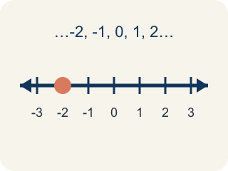
Integer (Número entero) — The counting numbers, their opposites, and 0.
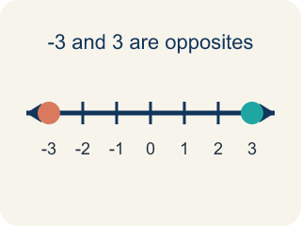
Opposite (Opuesto) — A number that is the same distance from 0 as another number, but on the other side of 0.
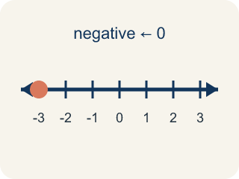
Negative number (Número negativo) — A number less than 0, written with a − sign. On a number line it sits to the left of 0.
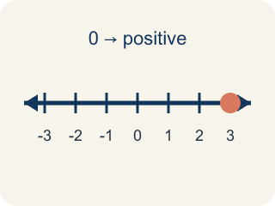
Positive number (Número positivo) — A number greater than 0. On a number line it sits to the right of 0.
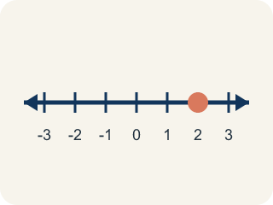
Number line (Recta numérica) — A straight line where numbers are placed in order. It extends to the left of 0 to show values less than 0.

Practice
Show your work. Use the blank space under each problem.
1. Badwater Basin is 86 meters below sea level, and sea level is 0. Which integer represents that elevation?
A. -86
B. 86
C. 0
D. -68
______________________________________________________________________
2. In Reykjavik the temperature was -9°C. What is the opposite of -9?
A. 9
B. -9
C. 0
D. -18
______________________________________________________________________
3. Spot the Mistake: Reykjavik's Temperature Swing
Step 1 (Problem): At 6 a.m. in Reykjavik the temperature was -12°C. At 2 p.m. it was the opposite of the 6 a.m. temperature. What was the temperature at 2 p.m.?
Step 2 (Student thinking): The opposite of a temperature should still be a cold temperature, so I keep the negative sign and just make the number bigger. That gives a temperature farther from 0.
Step 3 (Student answer): The temperature at 2 p.m. was -24°C.
Which step has the mistake? Explain and fix it:
______________________________________________________________________
______________________________________________________________________
______________________________________________________________________
4. Which statement about 0 is TRUE?
A. 0 is an integer, and it is its own opposite
B. 0 is a negative integer because it is not positive
C. 0 is a positive integer because it has no negative sign
D. 0 is not an integer at all
______________________________________________________________________
5. At 6 a.m. in Reykjavik the temperature was -12°C. At 2 p.m. it was the opposite of the 6 a.m. temperature, and at 11 p.m. it was the opposite of the 2 p.m. temperature. What were the temperatures at 2 p.m. and 11 p.m.?
A. 12°C and -12°C
B. -12°C and 12°C
C. 12°C and 24°C
D. 0°C and 12°C
______________________________________________________________________
6. A football team starts at the line of scrimmage, which is 0. During one series they had a 10-yard loss, a 4-yard gain, a 3-yard loss, and a 21-yard gain. Where does the series leave them?
A. 12 yards past the line of scrimmage
B. 8 yards past the line of scrimmage
C. 18 yards past the line of scrimmage
D. 38 yards past the line of scrimmage
______________________________________________________________________
7. Describe two different real-world situations that use negative integers. For each one, tell exactly what 0 means in that situation, write one negative integer it could produce, and explain what the opposite of that integer would mean in the same situation.
Sentence starter: My first situation is ___. In it, 0 means ___, so ___ would represent ___. The opposite of that integer is ___, which would mean ___.
______________________________________________________________________
______________________________________________________________________
______________________________________________________________________
______________________________________________________________________
8. Write the integer that represents each situation. Remember to decide what 0 means first.
Situation | Integer
A football play with a 12-yard loss
A hiker 250 meters above sea level
7 degrees below zero
A submarine resting at the surface of the water
______________________________________________________________________

Answer Key (Teacher)
1. A. -86
Below sea level means less than 0, so the elevation is written with a negative sign: -86 meters.
Watch for: The most common mistake in this lesson is thinking that the opposite of a negative integer is still negative — for example, saying the opposite of -7 is -7, or that the opposite of -12 is -24. Opposites are the same DISTANCE from 0 but on OPPOSITE sides of 0, so taking an opposite always changes the direction and never changes the distance: the opposite of -7 is 7 and the opposite of -12 is 12. The one exception is 0, which is 0 units from itself and is therefore its own opposite. Before you submit, count the units from 0 and check that your answer is on the other side.
2. A. 9
The opposite of a number is the same distance from 0 on the other side, so the opposite of -9 is 9.
Watch for: The most common mistake in this lesson is thinking that the opposite of a negative integer is still negative — for example, saying the opposite of -7 is -7, or that the opposite of -12 is -24. Opposites are the same DISTANCE from 0 but on OPPOSITE sides of 0, so taking an opposite always changes the direction and never changes the distance: the opposite of -7 is 7 and the opposite of -12 is 12. The one exception is 0, which is 0 units from itself and is therefore its own opposite. Before you submit, count the units from 0 and check that your answer is on the other side.
3. Spot the Mistake: Reykjavik's Temperature Swing
The mistake is in Step 2.
Correct work: An opposite never changes the distance from 0 — it changes only the side. -12 is 12 units to the left of 0, so its opposite is 12 units to the RIGHT of 0, which is 12°C. The 2 p.m. temperature was 12°C. (If you then take the opposite again for 11 p.m., you come back to -12°C.)
Watch for: The "Student thinking" step changes the distance from 0 instead of the side, so it produces a number twice as far from zero rather than its mirror image. The definition of opposite fixes the distance at 12 units and moves the point across 0, giving 12°C.
4. A. 0 is an integer, and it is its own opposite
Integers are the counting numbers, their opposites, and 0. Zero is 0 units from itself, so it is its own opposite.
Watch for: The most common mistake in this lesson is thinking that the opposite of a negative integer is still negative — for example, saying the opposite of -7 is -7, or that the opposite of -12 is -24. Opposites are the same DISTANCE from 0 but on OPPOSITE sides of 0, so taking an opposite always changes the direction and never changes the distance: the opposite of -7 is 7 and the opposite of -12 is 12. The one exception is 0, which is 0 units from itself and is therefore its own opposite. Before you submit, count the units from 0 and check that your answer is on the other side.
5. A. 12°C and -12°C
The opposite of -12 is 12, so 2 p.m. was 12°C. The opposite of 12 is -12, so 11 p.m. was back to -12°C.
Watch for: The most common mistake in this lesson is thinking that the opposite of a negative integer is still negative — for example, saying the opposite of -7 is -7, or that the opposite of -12 is -24. Opposites are the same DISTANCE from 0 but on OPPOSITE sides of 0, so taking an opposite always changes the direction and never changes the distance: the opposite of -7 is 7 and the opposite of -12 is 12. The one exception is 0, which is 0 units from itself and is therefore its own opposite. Before you submit, count the units from 0 and check that your answer is on the other side.
6. A. 12 yards past the line of scrimmage
Write each play as an integer: -10, 4, -3, 21. Combining them gives -10 + 4 - 3 + 21 = 12, so the team ends 12 yards past the line of scrimmage.
Watch for: The most common mistake in this lesson is thinking that the opposite of a negative integer is still negative — for example, saying the opposite of -7 is -7, or that the opposite of -12 is -24. Opposites are the same DISTANCE from 0 but on OPPOSITE sides of 0, so taking an opposite always changes the direction and never changes the distance: the opposite of -7 is 7 and the opposite of -12 is 12. The one exception is 0, which is 0 units from itself and is therefore its own opposite. Before you submit, count the units from 0 and check that your answer is on the other side.
7. Open response — answers will vary.
Look for key words: integer, opposite, negative, positive, zero, sea level, temperature, below, above.
8. Write the integer that represents each situation. Remember to decide what 0 means first.
A football play with a 12-yard loss — Integer: -12
A hiker 250 meters above sea level — Integer: 250
7 degrees below zero — Integer: -7
A submarine resting at the surface of the water — Integer: 0

