7.1 Small Group · Group 2 — Homework
Lesson 7-1-group2 • Standard 6.NOS.6
Name: ______________________ Period: ______ Date: ____________

Today's Goals
Content: I can use integers to represent quantities in everyday life, explain what 0 means in each situation, and name the opposite of an integer on the number line, explain what each part stands for, and build one for a situation I have not seen before.
Language: I can justify my answer to a skeptic and connect it to a second strategy or representation.

Key Words
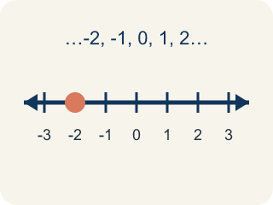
Integer (Número entero) — The counting numbers, their opposites, and 0.
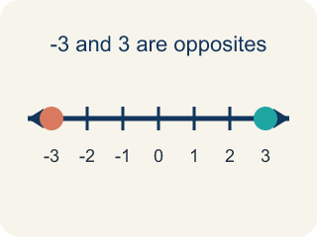
Opposite (Opuesto) — A number that is the same distance from 0 as another number, but on the other side of 0.
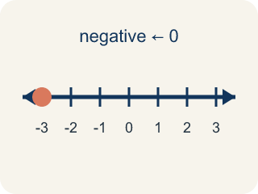
Negative number (Número negativo) — A number less than 0, written with a − sign. On a number line it sits to the left of 0.
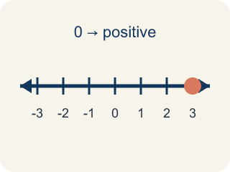
Positive number (Número positivo) — A number greater than 0. On a number line it sits to the right of 0.
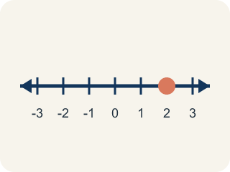
Number line (Recta numérica) — A straight line where numbers are placed in order. It extends to the left of 0 to show values less than 0.

Practice
Show your work. Use the blank space under each problem.
1. Which list of integers is ordered from LEAST to GREATEST?
A. -8, -3, 0, 5
B. -3, -8, 0, 5
C. 0, -3, -8, 5
D. 5, 0, -3, -8
______________________________________________________________________
2. Badwater Basin is at -86 meters. Which elevation is FARTHER below sea level than Badwater Basin?
A. -120 meters
B. -40 meters
C. 0 meters
D. 86 meters
______________________________________________________________________
3. Spot the Mistake: Reykjavik's Temperature Swing
Step 1 (Problem): At 6 a.m. in Reykjavik the temperature was -12°C. At 2 p.m. it was the opposite of the 6 a.m. temperature. What was the temperature at 2 p.m.?
Step 2 (Student thinking): The opposite of a temperature should still be a cold temperature, so I keep the negative sign and just make the number bigger. That gives a temperature farther from 0.
Step 3 (Student answer): The temperature at 2 p.m. was -24°C.
Which step has the mistake? Explain and fix it:
______________________________________________________________________
______________________________________________________________________
______________________________________________________________________
4. Which statement about 0 is TRUE?
A. 0 is an integer, and it is its own opposite
B. 0 is a negative integer because it is not positive
C. 0 is a positive integer because it has no negative sign
D. 0 is not an integer at all
______________________________________________________________________

Answer Key (Teacher)
1. A. -8, -3, 0, 5
Least to greatest reads left to right on the number line: -8, then -3, then 0, then 5.
Watch for: The most common mistake in this lesson is thinking that the opposite of a negative integer is still negative — for example, saying the opposite of -7 is -7, or that the opposite of -12 is -24. Opposites are the same DISTANCE from 0 but on OPPOSITE sides of 0, so taking an opposite always changes the direction and never changes the distance: the opposite of -7 is 7 and the opposite of -12 is 12. The one exception is 0, which is 0 units from itself and is therefore its own opposite. Before you submit, count the units from 0 and check that your answer is on the other side.
2. A. -120 meters
Farther below sea level means farther to the left of 0. -120 is 120 units below 0, which is deeper than 86 units below 0.
Watch for: The most common mistake in this lesson is thinking that the opposite of a negative integer is still negative — for example, saying the opposite of -7 is -7, or that the opposite of -12 is -24. Opposites are the same DISTANCE from 0 but on OPPOSITE sides of 0, so taking an opposite always changes the direction and never changes the distance: the opposite of -7 is 7 and the opposite of -12 is 12. The one exception is 0, which is 0 units from itself and is therefore its own opposite. Before you submit, count the units from 0 and check that your answer is on the other side.
3. Spot the Mistake: Reykjavik's Temperature Swing
The mistake is in Step 2.
Correct work: An opposite never changes the distance from 0 — it changes only the side. -12 is 12 units to the left of 0, so its opposite is 12 units to the RIGHT of 0, which is 12°C. The 2 p.m. temperature was 12°C. (If you then take the opposite again for 11 p.m., you come back to -12°C.)
Watch for: The "Student thinking" step changes the distance from 0 instead of the side, so it produces a number twice as far from zero rather than its mirror image. The definition of opposite fixes the distance at 12 units and moves the point across 0, giving 12°C.
4. A. 0 is an integer, and it is its own opposite
Integers are the counting numbers, their opposites, and 0. Zero is 0 units from itself, so it is its own opposite.
Watch for: The most common mistake in this lesson is thinking that the opposite of a negative integer is still negative — for example, saying the opposite of -7 is -7, or that the opposite of -12 is -24. Opposites are the same DISTANCE from 0 but on OPPOSITE sides of 0, so taking an opposite always changes the direction and never changes the distance: the opposite of -7 is 7 and the opposite of -12 is 12. The one exception is 0, which is 0 units from itself and is therefore its own opposite. Before you submit, count the units from 0 and check that your answer is on the other side.

