7.2 Small Group · Group 1 — Homework
Lesson 7-2-group1 • Standard 6.NOS.6
Name: ______________________ Period: ______ Date: ____________

Today's Goals
Content: With my small group, I can place rational numbers, including fractions and decimals, on a number line — one step at a time, with support.
Language: I can talk through each step out loud using a sentence frame and the lesson's key words.

Key Words
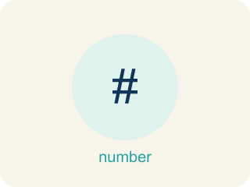
Rational Numbers on the Number Line (Números racionales en la recta numérica) — Fractions, decimals, and integers placed by value on a number line.
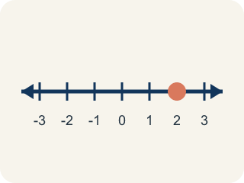
Rational number (Número racional) — Any number you can write as a fraction. This includes fractions, decimals, and integers.
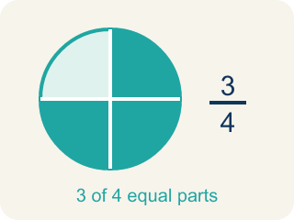
Fraction (Fracción) — A number that shows part of a whole, like 3/4.
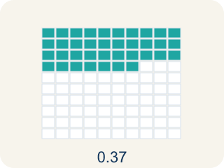
Decimal (Decimal) — A number with a dot, like 0.5, that shows a part less than one.

Number line (Recta numérica) — A straight line where numbers are placed in order; numbers get smaller to the left and larger to the right.

Equivalent (Equivalente) — Having the same value, just written a different way.
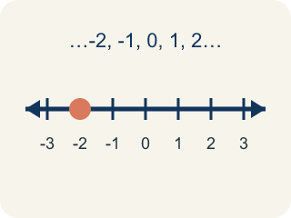
Integer (Número entero) — Whole numbers and their opposites, like -2, -1, 0, 1, 2.

Practice
Show your work. Use the blank space under each problem.
1. Which point is located between -1 and -2 on the number line?
A. -0.5
B. -1.5
C. -2.5
D. 1.5
______________________________________________________________________
2. Which fraction is equivalent to 0.25?
A. 1/4
B. 1/2
C. 2/5
D. 1/3
______________________________________________________________________
3. Which number is farthest to the LEFT on a number line?
A. -1
B. 0
C. -4
D. 2
______________________________________________________________________
4. What is the opposite of -3/4?
A. 3/4
B. -3/4
C. 4/3
D. 0
______________________________________________________________________
5. The first trail marker sits between 0 and 1. Which rational number belongs there?
A. 3/4
B. 1.5
C. -1/2
D. 2
______________________________________________________________________
6. Order these three trail markers from least to greatest: -1.5, 0.5, -0.5.
A. -1.5, -0.5, 0.5
B. 0.5, -0.5, -1.5
C. -0.5, -1.5, 0.5
D. -1.5, 0.5, -0.5
______________________________________________________________________
7. On the trail map, -3/4 sits to the LEFT of which marker?
A. -1/4
B. -1
C. -2
D. -7/8
______________________________________________________________________
8. Level 2 Extension — The Mismarked Trail Post
Step 1 (Problem): Place -3/4 and -1/4 on the trail, then decide which marker is greater.
Step 2 (Student thinking): -3/4 has a 3 on top and -1/4 has a 1 on top. A bigger numerator means a bigger number, so -3/4 is greater.
Step 3 (Student answer): -3/4 is plotted to the RIGHT of -1/4 and called the greater value.
Which step has the mistake? Explain and fix it:
______________________________________________________________________
______________________________________________________________________
______________________________________________________________________

Answer Key (Teacher)
1. B. -1.5
-1.5 is between -1 and -2 because it is 0.5 units to the left of -1 (or 0.5 units to the right of -2).
Watch for: A common mistake in Rational Numbers on the Number Line is treating the numerator and denominator of a negative fraction as two separate whole numbers instead of one value between two integers — for example, plotting -3/4 by going to -3 and then counting 4 more units to the left, landing (incorrectly) at -7, instead of recognizing that -3/4 = -0.75, which sits between 0 and -1. Before you submit an answer, find the two whole numbers your value falls between, then split that space into equal parts.
2. A. 1/4
0.25 means 25 hundredths = 25/100 = 1/4.
Watch for: A common mistake in Rational Numbers on the Number Line is treating the numerator and denominator of a negative fraction as two separate whole numbers instead of one value between two integers — for example, plotting -3/4 by going to -3 and then counting 4 more units to the left, landing (incorrectly) at -7, instead of recognizing that -3/4 = -0.75, which sits between 0 and -1. Before you submit an answer, find the two whole numbers your value falls between, then split that space into equal parts.
3. C. -4
Farther left means more negative: -4 < -1 < 0 < 2, so -4 is farthest left.
Watch for: A common mistake in Rational Numbers on the Number Line is treating the numerator and denominator of a negative fraction as two separate whole numbers instead of one value between two integers — for example, plotting -3/4 by going to -3 and then counting 4 more units to the left, landing (incorrectly) at -7, instead of recognizing that -3/4 = -0.75, which sits between 0 and -1. Before you submit an answer, find the two whole numbers your value falls between, then split that space into equal parts.
4. A. 3/4
The opposite of a number is its reflection across 0, so the opposite of -3/4 is 3/4.
Watch for: A common mistake in Rational Numbers on the Number Line is treating the numerator and denominator of a negative fraction as two separate whole numbers instead of one value between two integers — for example, plotting -3/4 by going to -3 and then counting 4 more units to the left, landing (incorrectly) at -7, instead of recognizing that -3/4 = -0.75, which sits between 0 and -1. Before you submit an answer, find the two whole numbers your value falls between, then split that space into equal parts.
5. A. 3/4
3/4 = 0.75, which lands between 0 and 1. 1.5 and 2 are larger, and -1/2 is to the left of 0.
Watch for: A common mistake in Rational Numbers on the Number Line is treating the numerator and denominator of a negative fraction as two separate whole numbers instead of one value between two integers — for example, plotting -3/4 by going to -3 and then counting 4 more units to the left, landing (incorrectly) at -7, instead of recognizing that -3/4 = -0.75, which sits between 0 and -1. Before you submit an answer, find the two whole numbers your value falls between, then split that space into equal parts.
6. A. -1.5, -0.5, 0.5
The farthest left on the number line comes first: -1.5, then -0.5, then 0.5.
Watch for: A common mistake in Rational Numbers on the Number Line is treating the numerator and denominator of a negative fraction as two separate whole numbers instead of one value between two integers — for example, plotting -3/4 by going to -3 and then counting 4 more units to the left, landing (incorrectly) at -7, instead of recognizing that -3/4 = -0.75, which sits between 0 and -1. Before you submit an answer, find the two whole numbers your value falls between, then split that space into equal parts.
7. A. -1/4
-3/4 = -0.75 and -1/4 = -0.25. Since -0.75 is farther left (less), -3/4 is to the left of -1/4.
Watch for: A common mistake in Rational Numbers on the Number Line is treating the numerator and denominator of a negative fraction as two separate whole numbers instead of one value between two integers — for example, plotting -3/4 by going to -3 and then counting 4 more units to the left, landing (incorrectly) at -7, instead of recognizing that -3/4 = -0.75, which sits between 0 and -1. Before you submit an answer, find the two whole numbers your value falls between, then split that space into equal parts.
8. Level 2 Extension — The Mismarked Trail Post
The mistake is in Step 2.
Correct work: For negative numbers, a bigger numerator does NOT mean a bigger value. -3/4 = -0.75 and -1/4 = -0.25. On the number line, -3/4 is farther LEFT than -1/4, so -3/4 is actually LESS than -1/4. The marker -3/4 should be plotted to the left of -1/4, and -1/4 is the greater value.
Watch for: The "Student thinking" step applies a rule for positive fractions to negative ones. As decimals, −3/4 = −0.75 and −1/4 = −0.25, so −3/4 lies farther left on the number line and is the smaller value. A larger numerator moves a negative fraction farther from zero, which makes it less, so −1/4 is the greater marker and −3/4 belongs to its left.

