7.2 Small Group · Group 2 — Homework
Lesson 7-2-group2 • Standard 6.NOS.6
Name: ______________________ Period: ______ Date: ____________

Today's Goals
Content: I can place rational numbers, including fractions and decimals, on a number line, explain why the method works, and use it on a problem I have not seen before.
Language: I can justify my answer to a skeptic and connect it to a second strategy or representation.

Key Words

Rational Numbers on the Number Line (Números racionales en la recta numérica) — Fractions, decimals, and integers placed by value on a number line.
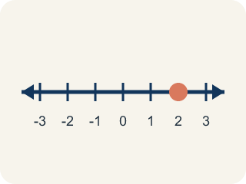
Rational number (Número racional) — Any number you can write as a fraction. This includes fractions, decimals, and integers.
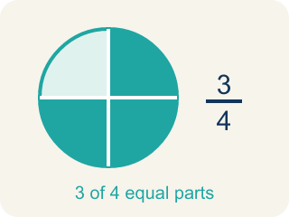
Fraction (Fracción) — A number that shows part of a whole, like 3/4.
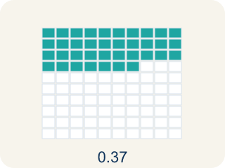
Decimal (Decimal) — A number with a dot, like 0.5, that shows a part less than one.

Number line (Recta numérica) — A straight line where numbers are placed in order; numbers get smaller to the left and larger to the right.

Equivalent (Equivalente) — Having the same value, just written a different way.
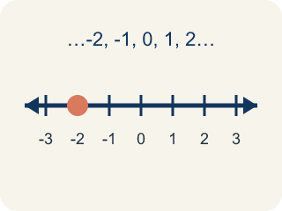
Integer (Número entero) — Whole numbers and their opposites, like -2, -1, 0, 1, 2.

Practice
Show your work. Use the blank space under each problem.
1. Which rational number is closest to 0 on the number line?
A. -1/4
B. 0.5
C. -2
D. 1.75
______________________________________________________________________
2. Spot the Mistake: Plotting -2.25
Step 1 (Problem): Plot -2.25 on the number line.
Step 2 (Student thinking): It is negative, so I go past -2. The .25 is one quarter, so I count toward 0 (to the right) by a quarter unit and land between -2 and -1.
Step 3 (Student answer): Point plotted at -1.75, between -2 and -1.
Which step has the mistake? Explain and fix it:
______________________________________________________________________
______________________________________________________________________
______________________________________________________________________
3. Which number is farthest to the LEFT on a number line?
A. -1
B. 0
C. -4
D. 2
______________________________________________________________________
4. What is the opposite of -3/4?
A. 3/4
B. -3/4
C. 4/3
D. 0
______________________________________________________________________

Answer Key (Teacher)
1. A. -1/4
|-1/4| = 0.25, |0.5| = 0.5, |-2| = 2, |1.75| = 1.75. Since 0.25 is the smallest absolute value, -1/4 is closest to zero.
Watch for: A common mistake in Rational Numbers on the Number Line is treating the numerator and denominator of a negative fraction as two separate whole numbers instead of one value between two integers — for example, plotting -3/4 by going to -3 and then counting 4 more units to the left, landing (incorrectly) at -7, instead of recognizing that -3/4 = -0.75, which sits between 0 and -1. Before you submit an answer, find the two whole numbers your value falls between, then split that space into equal parts.
2. Spot the Mistake: Plotting -2.25
The mistake is in Step 2.
Correct work: Going more negative means moving LEFT, not right. -2.25 is between -2 and -3 (it is a quarter of a unit to the LEFT of -2), not between -2 and -1. I split the space from -2 to -3 into 4 equal parts and place the dot at the first mark past -2, at -2.25.
Watch for: The "Student thinking" step moves right from −2, back toward zero, which makes the number less negative instead of more. The extra .25 has to be added to the negative direction, so −2.25 sits a quarter of a unit to the left of −2, between −2 and −3. Splitting that space into 4 equal parts and marking the first one past −2 puts the dot in the right place.
3. C. -4
Farther left means more negative: -4 < -1 < 0 < 2, so -4 is farthest left.
Watch for: A common mistake in Rational Numbers on the Number Line is treating the numerator and denominator of a negative fraction as two separate whole numbers instead of one value between two integers — for example, plotting -3/4 by going to -3 and then counting 4 more units to the left, landing (incorrectly) at -7, instead of recognizing that -3/4 = -0.75, which sits between 0 and -1. Before you submit an answer, find the two whole numbers your value falls between, then split that space into equal parts.
4. A. 3/4
The opposite of a number is its reflection across 0, so the opposite of -3/4 is 3/4.
Watch for: A common mistake in Rational Numbers on the Number Line is treating the numerator and denominator of a negative fraction as two separate whole numbers instead of one value between two integers — for example, plotting -3/4 by going to -3 and then counting 4 more units to the left, landing (incorrectly) at -7, instead of recognizing that -3/4 = -0.75, which sits between 0 and -1. Before you submit an answer, find the two whole numbers your value falls between, then split that space into equal parts.

