7.3 Small Group · Group 1 — Homework
Lesson 7-3-group1 • Standard 6.NOS.8
Name: ______________________ Period: ______ Date: ____________

Today's Goals
Content: With my small group, I can identify integers and find their absolute value — one step at a time, with support.
Language: I can talk through each step out loud using a sentence frame and the lesson's key words.

Key Words
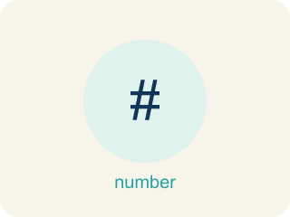
Integers and Absolute Value (Enteros y valor absoluto) — Integers are whole numbers and their opposites; absolute value is their distance from zero.
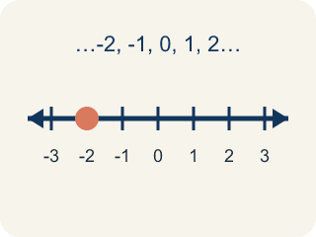
Integer (Número entero) — Whole numbers and their opposites, like -2, -1, 0, 1, 2.
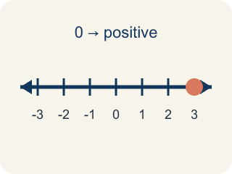
Positive (Positivo) — A number bigger than zero, to the right of zero on a number line.
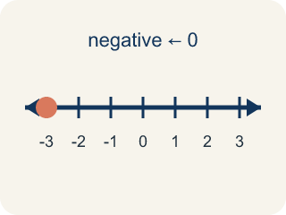
Negative (Negativo) — A number smaller than zero, to the left of zero on a number line.
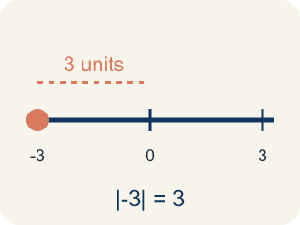
Absolute value (Valor absoluto) — How far a number is from zero. It is never negative.
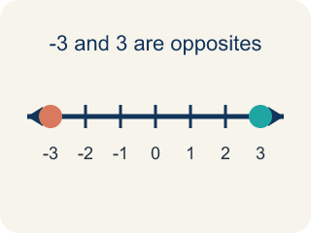
Opposite (Opuesto) — Two numbers the same distance from zero, on opposite sides, like 3 and -3.

Practice
Show your work. Use the blank space under each problem.
1. What is the absolute value of -9?
A. 9
B. -9
C. 0
D. 1
______________________________________________________________________
2. Which integer has the GREATEST absolute value: -3, 7, -5, 2?
A. 7
B. -5
C. -3
D. 2
______________________________________________________________________
3. On a frosty morning at the mountain cache, the thermometer reads -8 degrees. What is the absolute value of -8?
A. 8
B. -8
C. 0
D. 16
______________________________________________________________________
4. Two treasure sites report their temperatures: -5 degrees F at the Ice Cave and -2 degrees F at the Frozen Dock. Which site is COLDER?
A. -5 degrees F (Ice Cave)
B. -2 degrees F (Frozen Dock)
C. They are the same
D. Neither is below zero
______________________________________________________________________
5. Captain Vega compares |-12| (a deep cave) and |7| (a hilltop). Which absolute value is GREATER?
A. |-12| because 12 > 7
B. |7| because 7 is positive
C. They are equal
D. |-12| = -12, so |7| is greater
______________________________________________________________________
6. Level 2 Extension — The Colder Temperature Mistake
Step 1 (Mission): Captain Vega asks: which is colder, -8 degrees F or -2 degrees F?
Step 2 (Crew member's reasoning): 8 is bigger than 2, so -8 must be the warmer one.
Step 3 (Crew member's answer): -2 degrees F is colder than -8 degrees F.
Which step has the mistake? Explain and fix it:
______________________________________________________________________
______________________________________________________________________
______________________________________________________________________
7. Find the Absolute Value Error
Step 1 (Problem): Find |-6|
Step 2 (Student thinking): The number is -6, and absolute value makes it the opposite
Step 3 (Student answer): |-6| = 6, and since we take the opposite, the answer is -6
Which step has the mistake? Explain and fix it:
______________________________________________________________________
______________________________________________________________________
______________________________________________________________________
8. A submarine is at -150 meters and a bird is flying at +150 meters. A student says the submarine is closer to sea level because -150 is less than 150. Is the student correct? Explain using absolute value.
Sentence starter: The student is ___ because absolute value measures ___. Since |-150| = ___ and |150| = ___, both are ___ from sea level. The student confused ___ with ___.
______________________________________________________________________
______________________________________________________________________
______________________________________________________________________
______________________________________________________________________

Answer Key (Teacher)
1. A. 9
Absolute value is the distance from zero. -9 is 9 units from zero, so |-9| = 9.
Watch for: A common mistake in Integers and Absolute Value is judging size by the digits alone instead of position on the number line — students think -8 is 'more' than -3 because 8 > 3, when really -8 sits farther left (colder, deeper, or lower) and is actually the SMALLER integer. Absolute value measures distance from zero and is always positive or zero, but that distance does not decide which integer is greater — only left-to-right order on the number line does. Before you submit, ask: am I comparing distance from zero (absolute value) or position on the number line (greater/less than)?
2. A. 7
|-3| = 3, |7| = 7, |-5| = 5, |2| = 2. The greatest absolute value is 7.
Watch for: A common mistake in Integers and Absolute Value is judging size by the digits alone instead of position on the number line — students think -8 is 'more' than -3 because 8 > 3, when really -8 sits farther left (colder, deeper, or lower) and is actually the SMALLER integer. Absolute value measures distance from zero and is always positive or zero, but that distance does not decide which integer is greater — only left-to-right order on the number line does. Before you submit, ask: am I comparing distance from zero (absolute value) or position on the number line (greater/less than)?
3. A. 8
Absolute value is the distance from zero, so |-8| = 8.
Watch for: A common mistake in Integers and Absolute Value is judging size by the digits alone instead of position on the number line — students think -8 is 'more' than -3 because 8 > 3, when really -8 sits farther left (colder, deeper, or lower) and is actually the SMALLER integer. Absolute value measures distance from zero and is always positive or zero, but that distance does not decide which integer is greater — only left-to-right order on the number line does. Before you submit, ask: am I comparing distance from zero (absolute value) or position on the number line (greater/less than)?
4. A. -5 degrees F (Ice Cave)
On a number line, -5 is to the left of -2, so -5 is the smaller (colder) temperature.
Watch for: A common mistake in Integers and Absolute Value is judging size by the digits alone instead of position on the number line — students think -8 is 'more' than -3 because 8 > 3, when really -8 sits farther left (colder, deeper, or lower) and is actually the SMALLER integer. Absolute value measures distance from zero and is always positive or zero, but that distance does not decide which integer is greater — only left-to-right order on the number line does. Before you submit, ask: am I comparing distance from zero (absolute value) or position on the number line (greater/less than)?
5. A. |-12| because 12 > 7
|-12| = 12 and |7| = 7. Since 12 > 7, the absolute value of -12 is greater.
Watch for: A common mistake in Integers and Absolute Value is judging size by the digits alone instead of position on the number line — students think -8 is 'more' than -3 because 8 > 3, when really -8 sits farther left (colder, deeper, or lower) and is actually the SMALLER integer. Absolute value measures distance from zero and is always positive or zero, but that distance does not decide which integer is greater — only left-to-right order on the number line does. Before you submit, ask: am I comparing distance from zero (absolute value) or position on the number line (greater/less than)?
6. Level 2 Extension — The Colder Temperature Mistake
The mistake is in Step 2.
Correct work: For negative numbers, the one farther left on the number line is colder. -8 is to the LEFT of -2, so -8 degrees F is colder than -2 degrees F. Comparing the digits 8 and 2 only works for positive numbers; with negatives the order flips.
Watch for: The reasoning step compares the digits 8 and 2 as if the numbers were positive. On a number line -8 sits farther left than -2, and farther left means colder, so -8 degrees F is the colder temperature — with negatives, a bigger digit means a smaller value.
7. Find the Absolute Value Error
The mistake is in Step 3.
Correct work: Absolute value gives the DISTANCE from zero, which is always positive or zero. |-6| = 6. The student incorrectly applied 'opposite' a second time.
Watch for: The student found |-6| = 6 correctly and then took the opposite a second time, landing back on -6. Absolute value is a distance from zero, so it stops at 6 — there is no extra sign flip after the bars come off.
8. Open response — answers will vary.
Look for key words: absolute value, distance, sea level, zero, equal, negative, less than, position.

