7.3 Small Group · Group 2 — Homework
Lesson 7-3-group2 • Standard 6.NOS.8
Name: ______________________ Period: ______ Date: ____________

Today's Goals
Content: I can identify integers and find their absolute value, explain how I can tell, and judge a case I have not seen before.
Language: I can justify my answer to a skeptic and connect it to a second strategy or representation.

Key Words
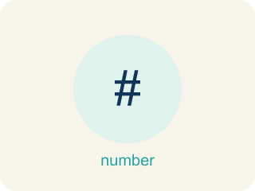
Integers and Absolute Value (Enteros y valor absoluto) — Integers are whole numbers and their opposites; absolute value is their distance from zero.
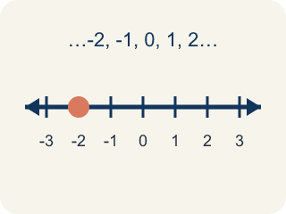
Integer (Número entero) — Whole numbers and their opposites, like -2, -1, 0, 1, 2.
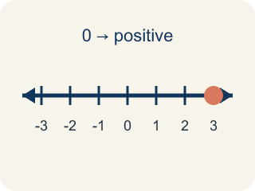
Positive (Positivo) — A number bigger than zero, to the right of zero on a number line.
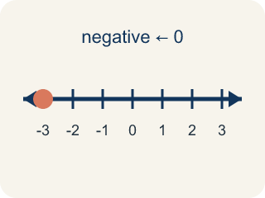
Negative (Negativo) — A number smaller than zero, to the left of zero on a number line.
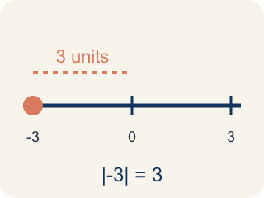
Absolute value (Valor absoluto) — How far a number is from zero. It is never negative.
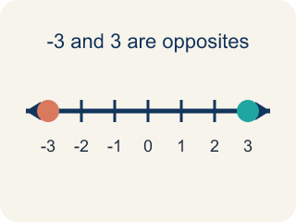
Opposite (Opuesto) — Two numbers the same distance from zero, on opposite sides, like 3 and -3.

Practice
Show your work. Use the blank space under each problem.
1. Which statement about absolute value is TRUE?
A. |-4| = |4| because both are 4 units from zero
B. |-4| = -4 because the number is negative
C. |4| > |-4| because positive is always bigger
D. |-4| = 0 because negatives cancel out
______________________________________________________________________
2. Confusing Opposite with Absolute Value
Step 1 (Problem): Complete the table for the integer 9: find its absolute value and its opposite.
Step 2 (Student's thinking): Absolute value and opposite both just make a number positive, so they should give the same answer as each other.
Step 3 (Student's answer): Absolute value of 9 = 9, and opposite of 9 = 9.
Which step has the mistake? Explain and fix it:
______________________________________________________________________
______________________________________________________________________
______________________________________________________________________
3. Find the Absolute Value Error
Step 1 (Problem): Find |-6|
Step 2 (Student thinking): The number is -6, and absolute value makes it the opposite
Step 3 (Student answer): |-6| = 6, and since we take the opposite, the answer is -6
Which step has the mistake? Explain and fix it:
______________________________________________________________________
______________________________________________________________________
______________________________________________________________________
4. A submarine is at -150 meters and a bird is flying at +150 meters. A student says the submarine is closer to sea level because -150 is less than 150. Is the student correct? Explain using absolute value.
Sentence starter: The student is ___ because absolute value measures ___. Since |-150| = ___ and |150| = ___, both are ___ from sea level. The student confused ___ with ___.
______________________________________________________________________
______________________________________________________________________
______________________________________________________________________
______________________________________________________________________

Answer Key (Teacher)
1. A. |-4| = |4| because both are 4 units from zero
Absolute value measures distance from zero. Both -4 and 4 are 4 units from zero, so |-4| = |4| = 4.
Watch for: A common mistake in Integers and Absolute Value is judging size by the digits alone instead of position on the number line — students think -8 is 'more' than -3 because 8 > 3, when really -8 sits farther left (colder, deeper, or lower) and is actually the SMALLER integer. Absolute value measures distance from zero and is always positive or zero, but that distance does not decide which integer is greater — only left-to-right order on the number line does. Before you submit, ask: am I comparing distance from zero (absolute value) or position on the number line (greater/less than)?
2. Confusing Opposite with Absolute Value
The mistake is in Step 2.
Correct work: Absolute value and opposite are different operations. Absolute value measures distance from zero and is never negative: |9| = 9. Opposite reflects a number to the other side of zero, flipping its sign: the opposite of 9 is -9, not 9. The two operations only give the same result for the number 0 — every other number has a different absolute value and opposite.
Watch for: The student's thinking step treats absolute value and opposite as the same operation, but they are not. Absolute value gives the distance from zero, so |9| = 9, while the opposite reflects the number across zero, so the opposite of 9 is -9 — the two only agree for the number 0.
3. Find the Absolute Value Error
The mistake is in Step 3.
Correct work: Absolute value gives the DISTANCE from zero, which is always positive or zero. |-6| = 6. The student incorrectly applied 'opposite' a second time.
Watch for: The student found |-6| = 6 correctly and then took the opposite a second time, landing back on -6. Absolute value is a distance from zero, so it stops at 6 — there is no extra sign flip after the bars come off.
4. Open response — answers will vary.
Look for key words: absolute value, distance, sea level, zero, equal, negative, less than, position.

