9.1–9.3 Catch-Up — Homework
Lesson 7-4-catchup • Standard 6.NOS.8
Name: ______________________ Period: ______ Date: ____________

Today's Goals
Content: I can show I am caught up on Lessons 9.1–9.3 by using each lesson's big idea in mixed practice.
Language: I can explain which lesson's big idea I used and how, using key vocabulary from Lessons 9.1–9.3.

Key Words
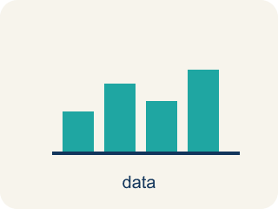
Graph on the Coordinate Plane (Representar en el plano de coordenadas) — Plot a point by moving horizontally to its x-coordinate and vertically to its y-coordinate.
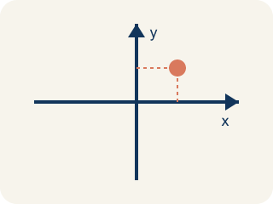
Coordinate plane (Plano cartesiano) — A grid with a line going across and a line going up to plot points.
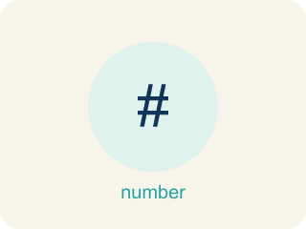
Integers and Absolute Value (Enteros y valor absoluto) — Integers are whole numbers and their opposites; absolute value is their distance from zero.
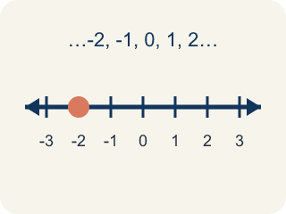
Integer (Número entero) — Whole numbers and their opposites, like -2, -1, 0, 1, 2.

Compare and Order Integers (Comparar y ordenar enteros) — Use a number line to decide which integers are greater or less and place them in order.
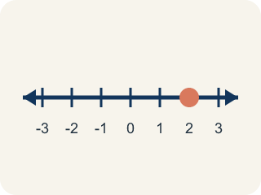
Number line (Recta numérica) — A straight line where numbers are placed in order; numbers get smaller to the left and larger to the right.
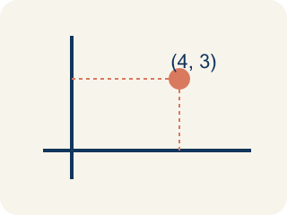
Ordered pair (Par ordenado) — Two numbers (x, y) that tell where a point is on a grid.
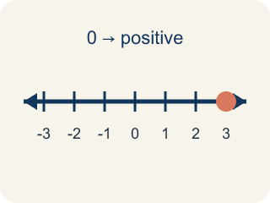
Positive (Positivo) — A number bigger than zero, to the right of zero on a number line.
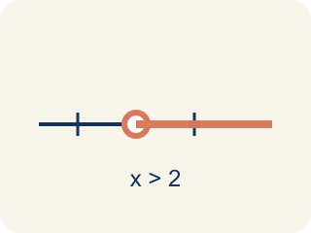
Compare (Comparar) — To see if a number is bigger, smaller, or equal to another.

Practice
Show your work. Use the blank space under each problem.
1. (Lesson 9.1) Which ordered pair names a point 3 units right and 7 units up from the origin?
A. (3, 7)
B. (7, 3)
C. (3, 3)
D. (0, 7)
______________________________________________________________________
2. (Lesson 9.1) What are the coordinates of the origin?
A. (0, 0)
B. (1, 1)
C. (0, 1)
D. (1, 0)
______________________________________________________________________
3. (Lesson 9.1) Spot the Common Mistake
Step 1 (Clue): Plot the point (4, 0).
Step 2 (Move right): Move 4 units to the right along the x-axis. Good.
Step 3 (Move up): Move 4 units up, because the pair has a 4 in it.
Step 4 (Plot the point): Place the dot at (4, 4).
Which step has the mistake? Explain and fix it:
______________________________________________________________________
______________________________________________________________________
______________________________________________________________________
4. (Lesson 9.2) Which statement about absolute value is TRUE?
A. |-4| = |4| because both are 4 units from zero
B. |-4| = -4 because the number is negative
C. |4| > |-4| because positive is always bigger
D. |-4| = 0 because negatives cancel out
______________________________________________________________________
5. (Lesson 9.2) Confusing Opposite with Absolute Value
Step 1 (Problem): Complete the table for the integer 9: find its absolute value and its opposite.
Step 2 (Student's thinking): Absolute value and opposite both just make a number positive, so they should give the same answer as each other.
Step 3 (Student's answer): Absolute value of 9 = 9, and opposite of 9 = 9.
Which step has the mistake? Explain and fix it:
______________________________________________________________________
______________________________________________________________________
______________________________________________________________________
6. (Lesson 9.3) Three cities have temperatures of -12°F, -5°F, and 3°F. Which city is warmest?
A. 3°F
B. -5°F
C. -12°F
D. They are equal
______________________________________________________________________
7. (Lesson 9.3) Spot the Common Mistake
Step 1 (Read): Order -8 and -15 from least to greatest.
Step 2 (Attempt): The student wrote -8, -15, because 8 is smaller than 15.
Step 3 (Check): -15 is farther left than -8 on the number line, so -15 is the least. The correct order is -15, -8.
Which step has the mistake? Explain and fix it:
______________________________________________________________________
______________________________________________________________________
______________________________________________________________________
8. (Lesson 9.1) Spot 1 — Captain Vega's first clue says the Sandy Dock is right 7 and up 2 from the origin. Which ordered pair names the Sandy Dock?
A. (7, 2)
B. (2, 7)
C. (7, 0)
D. (2, 2)
______________________________________________________________________
9. (Lesson 9.2) On a frosty morning at the mountain cache, the thermometer reads -8 degrees. What is the absolute value of -8?
A. 8
B. -8
C. 0
D. 16
______________________________________________________________________
10. (Lesson 9.3) Four spots: -3 m, 2 m, -7 m, 0 m. Order them from least to greatest.
A. -7, -3, 0, 2
B. -3, -7, 0, 2
C. 2, 0, -3, -7
D. -7, -3, 2, 0
______________________________________________________________________

Answer Key (Teacher)
1. A. (3, 7)
The first coordinate is horizontal (right 3), the second is vertical (up 7). So (3, 7).
Watch for: A common mistake in Compare and Order Integers is thinking that a negative number with a bigger digit is the bigger value — for example, believing -15 is greater than -8 because 15 is greater than 8. It's the opposite for negatives: the number farther to the left on the number line (farther from zero) is always the LESSER value, so -15 < -8. Before you submit, check your comparison against the number line, not just the digits.
2. A. (0, 0)
The origin is where the x-axis and y-axis cross, at (0, 0).
Watch for: A common mistake in Compare and Order Integers is thinking that a negative number with a bigger digit is the bigger value — for example, believing -15 is greater than -8 because 15 is greater than 8. It's the opposite for negatives: the number farther to the left on the number line (farther from zero) is always the LESSER value, so -15 < -8. Before you submit, check your comparison against the number line, not just the digits.
3. (Lesson 9.1) Spot the Common Mistake
The mistake is in Step 3.
Correct work: The y-coordinate is 0, not 4. After moving 4 right, the up move is 0 units, so the point stays on the x-axis at (4, 0). The student reused the x-value instead of reading the second number (0).
Watch for: The up move comes from the SECOND number, and the second number in (4, 0) is 0. Reusing the 4 pushes the point off the axis to (4, 4). With a y-coordinate of 0 there is no upward move at all, so the point stays right on the x-axis at (4, 0).
4. A. |-4| = |4| because both are 4 units from zero
Absolute value measures distance from zero. Both -4 and 4 are 4 units from zero, so |-4| = |4| = 4.
Watch for: A common mistake in Compare and Order Integers is thinking that a negative number with a bigger digit is the bigger value — for example, believing -15 is greater than -8 because 15 is greater than 8. It's the opposite for negatives: the number farther to the left on the number line (farther from zero) is always the LESSER value, so -15 < -8. Before you submit, check your comparison against the number line, not just the digits.
5. (Lesson 9.2) Confusing Opposite with Absolute Value
The mistake is in Step 2.
Correct work: Absolute value and opposite are different operations. Absolute value measures distance from zero and is never negative: |9| = 9. Opposite reflects a number to the other side of zero, flipping its sign: the opposite of 9 is -9, not 9. The two operations only give the same result for the number 0 — every other number has a different absolute value and opposite.
Watch for: The student's thinking step treats absolute value and opposite as the same operation, but they are not. Absolute value gives the distance from zero, so |9| = 9, while the opposite reflects the number across zero, so the opposite of 9 is -9 — the two only agree for the number 0.
6. A. 3°F
3°F is the greatest because it is farthest to the right on the number line. The order from coldest to warmest is -12, -5, 3.
Watch for: A common mistake in Compare and Order Integers is thinking that a negative number with a bigger digit is the bigger value — for example, believing -15 is greater than -8 because 15 is greater than 8. It's the opposite for negatives: the number farther to the left on the number line (farther from zero) is always the LESSER value, so -15 < -8. Before you submit, check your comparison against the number line, not just the digits.
7. (Lesson 9.3) Spot the Common Mistake
The mistake is in Step 2.
Correct work: Least to greatest: -15, -8. The more negative a number is, the less its value — so -15 < -8.
Watch for: The reasoning treats -8 and -15 like 8 and 15, so it puts -8 first. On the number line -15 sits farther left than -8, which makes it the smaller value, so least to greatest is -15, -8.
8. A. (7, 2)
The x-coordinate is the sideways move (right 7) and the y-coordinate is the up move (up 2), so the Sandy Dock is (7, 2).
Watch for: A common mistake in Compare and Order Integers is thinking that a negative number with a bigger digit is the bigger value — for example, believing -15 is greater than -8 because 15 is greater than 8. It's the opposite for negatives: the number farther to the left on the number line (farther from zero) is always the LESSER value, so -15 < -8. Before you submit, check your comparison against the number line, not just the digits.
9. A. 8
Absolute value is the distance from zero, so |-8| = 8.
Watch for: A common mistake in Compare and Order Integers is thinking that a negative number with a bigger digit is the bigger value — for example, believing -15 is greater than -8 because 15 is greater than 8. It's the opposite for negatives: the number farther to the left on the number line (farther from zero) is always the LESSER value, so -15 < -8. Before you submit, check your comparison against the number line, not just the digits.
10. A. -7, -3, 0, 2
The deepest spot is the cave at -7 (farthest left), then the tide pool -3, then the boat deck 0, then the flag at 2. Least to greatest: -7, -3, 0, 2.
Watch for: A common mistake in Compare and Order Integers is thinking that a negative number with a bigger digit is the bigger value — for example, believing -15 is greater than -8 because 15 is greater than 8. It's the opposite for negatives: the number farther to the left on the number line (farther from zero) is always the LESSER value, so -15 < -8. Before you submit, check your comparison against the number line, not just the digits.

