7.4 Small Group · Group 1 — Homework
Lesson 7-4-group1 • Standard 6.NOS.8
Name: ______________________ Period: ______ Date: ____________

Today's Goals
Content: With my small group, I can compare and order integers using a number line — one step at a time, with support.
Language: I can talk through each step out loud using a sentence frame and the lesson's key words.

Key Words
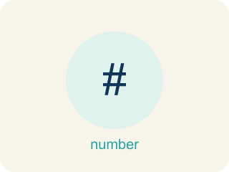
Compare and Order Integers (Comparar y ordenar enteros) — Use a number line to decide which integers are greater or less and place them in order.
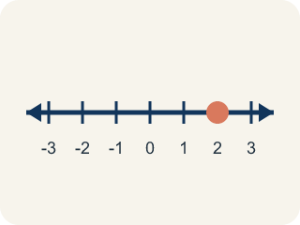
Number line (Recta numérica) — A straight line where numbers are placed in order; numbers get smaller to the left and larger to the right.
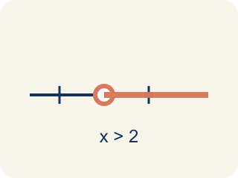
Compare (Comparar) — To see if a number is bigger, smaller, or equal to another.

Order (Ordenar) — To put numbers in order, smallest to biggest or biggest to smallest.
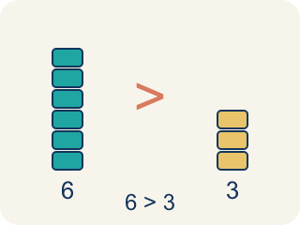
Greater than (Mayor que) — The > sign, showing one number is bigger.
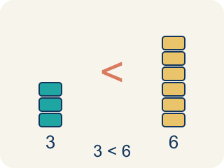
Less than (Menor que) — The < sign, showing one number is smaller.
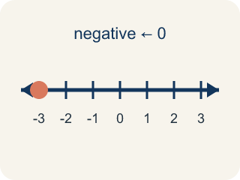
Negative integer (Entero negativo) — A whole number smaller than zero, like -5.
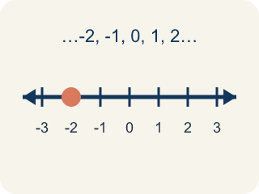
Integer (Número entero) — Whole numbers and their opposites, like -2, -1, 0, 1, 2.

Practice
Show your work. Use the blank space under each problem.
1. Which statement is TRUE?
A. -3 > -1
B. -5 < -2
C. -4 > 0
D. -1 < -6
______________________________________________________________________
2. Which integer is the LEAST: -3, 5, -8, 2, 0?
A. -8
B. -3
C. 0
D. 5
______________________________________________________________________
3. Three buried chests sit at -9 m, -4 m, and -15 m below sea level. Which chest is at the GREATEST elevation (closest to the surface)?
A. -4 m
B. -9 m
C. -15 m
D. They are equal
______________________________________________________________________
4. On the map, a sunken lantern is at -8 m and a coral shelf is at -3 m. Which symbol makes the comparison true: -8 ___ -3 ?
A. <
B. >
C. =
D. ≥
______________________________________________________________________
5. Level 2 Extension — The Mis-Ranked Treasure Map
Step 1 (Problem): Order the chest depths from least to greatest: -8 m and -15 m.
Step 2 (Crew thinking): 15 has bigger digits than 8, so -15 must be the bigger number. I'll list -8 first because it must be smaller.
Step 3 (Crew answer): Least to greatest: -8, -15
Which step has the mistake? Explain and fix it:
______________________________________________________________________
______________________________________________________________________
______________________________________________________________________
6. Find the Comparison Error
Step 1 (Problem): Compare -3 and -8. Which is greater?
Step 2 (Student thinking): 8 is bigger than 3, so -8 must be greater than -3
Step 3 (Student answer): -8 > -3
Which step has the mistake? Explain and fix it:
______________________________________________________________________
______________________________________________________________________
______________________________________________________________________
7. A student says: 'Negative numbers are always less than positive numbers, so -100 is less than 1.' Is this correct? Now the student says: '-100 is less than -1 because 100 is greater than 1.' Is THIS correct? Explain the difference.
Sentence starter: The first statement is ___ because ___. The second statement is ___ because with negative numbers, ___. On the number line, -100 is ___ of -1, so ___.
______________________________________________________________________
______________________________________________________________________
______________________________________________________________________
______________________________________________________________________
8. Sort each item into the correct group.
• undefined → __________________
• undefined → __________________
• undefined → __________________
• undefined → __________________
• undefined → __________________
• undefined → __________________
______________________________________________________________________

Answer Key (Teacher)
1. B. -5 < -2
-5 is farther to the left on the number line than -2, so -5 < -2 is true.
Watch for: A common mistake in Compare and Order Integers is thinking that a negative number with a bigger digit is the bigger value — for example, believing -15 is greater than -8 because 15 is greater than 8. It's the opposite for negatives: the number farther to the left on the number line (farther from zero) is always the LESSER value, so -15 < -8. Before you submit, check your comparison against the number line, not just the digits.
2. A. -8
-8 is farthest to the left on the number line, making it the least (smallest) integer.
Watch for: A common mistake in Compare and Order Integers is thinking that a negative number with a bigger digit is the bigger value — for example, believing -15 is greater than -8 because 15 is greater than 8. It's the opposite for negatives: the number farther to the left on the number line (farther from zero) is always the LESSER value, so -15 < -8. Before you submit, check your comparison against the number line, not just the digits.
3. A. -4 m
Closer to zero means greater for negatives. -4 is only 4 below the surface, so -4 is the greatest of -9, -4, and -15.
Watch for: A common mistake in Compare and Order Integers is thinking that a negative number with a bigger digit is the bigger value — for example, believing -15 is greater than -8 because 15 is greater than 8. It's the opposite for negatives: the number farther to the left on the number line (farther from zero) is always the LESSER value, so -15 < -8. Before you submit, check your comparison against the number line, not just the digits.
4. A. <
-8 is farther left (deeper) than -3, so -8 is less than -3. The symbol is <.
Watch for: A common mistake in Compare and Order Integers is thinking that a negative number with a bigger digit is the bigger value — for example, believing -15 is greater than -8 because 15 is greater than 8. It's the opposite for negatives: the number farther to the left on the number line (farther from zero) is always the LESSER value, so -15 < -8. Before you submit, check your comparison against the number line, not just the digits.
5. Level 2 Extension — The Mis-Ranked Treasure Map
The mistake is in Step 2.
Correct work: For negative numbers, MORE distance from zero means SMALLER, not bigger. -15 is 15 below the surface (deeper and farther left), so -15 is actually less than -8. The correct order from least to greatest is -15, -8.
Watch for: The crew read 15 as bigger than 8 and assumed -15 must be the bigger number too. Depth works the other way: -15 m is deeper and farther left on the number line, so -15 < -8 and the correct order from least to greatest is -15, -8.
6. Find the Comparison Error
The mistake is in Step 2.
Correct work: With negative numbers, the number closer to zero is GREATER. -3 is closer to zero than -8, so -3 > -8. The student compared the digits without considering that negatives work in the opposite direction.
Watch for: The student's reasoning stops at the digits: because 8 > 3, they concluded -8 > -3. Distance from zero works in the opposite direction for negatives, so -3, which is only 3 units below zero, is greater than -8, which is 8 units below, making the correct statement -3 > -8.
7. Open response — answers will vary.
Look for key words: negative, positive, less than, greater than, number line, left, right, closer to zero, farther.
8. Correct groups:
undefined → undefined
undefined → undefined
undefined → undefined
undefined → undefined
undefined → undefined
undefined → undefined

