7.4 Small Group · Group 2 — Homework
Lesson 7-4-group2 • Standard 6.NOS.8
Name: ______________________ Period: ______ Date: ____________

Today's Goals
Content: I can compare and order integers using a number line, explain how I can tell, and judge a case I have not seen before.
Language: I can justify my answer to a skeptic and connect it to a second strategy or representation.

Key Words
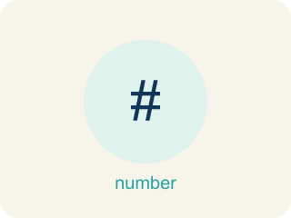
Compare and Order Integers (Comparar y ordenar enteros) — Use a number line to decide which integers are greater or less and place them in order.
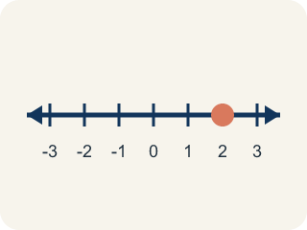
Number line (Recta numérica) — A straight line where numbers are placed in order; numbers get smaller to the left and larger to the right.
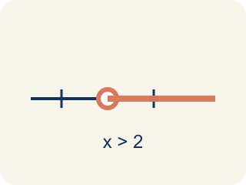
Compare (Comparar) — To see if a number is bigger, smaller, or equal to another.

Order (Ordenar) — To put numbers in order, smallest to biggest or biggest to smallest.
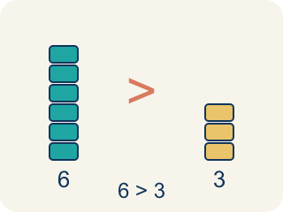
Greater than (Mayor que) — The > sign, showing one number is bigger.
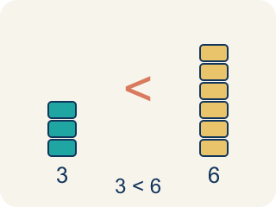
Less than (Menor que) — The < sign, showing one number is smaller.
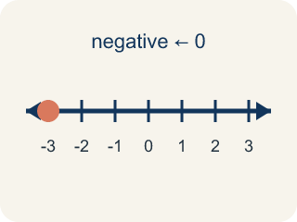
Negative integer (Entero negativo) — A whole number smaller than zero, like -5.
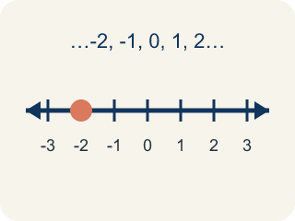
Integer (Número entero) — Whole numbers and their opposites, like -2, -1, 0, 1, 2.

Practice
Show your work. Use the blank space under each problem.
1. Three cities have temperatures of -12°F, -5°F, and 3°F. Which city is warmest?
A. 3°F
B. -5°F
C. -12°F
D. They are equal
______________________________________________________________________
2. Spot the Common Mistake
Step 1 (Read): Order -8 and -15 from least to greatest.
Step 2 (Attempt): The student wrote -8, -15, because 8 is smaller than 15.
Step 3 (Check): -15 is farther left than -8 on the number line, so -15 is the least. The correct order is -15, -8.
Which step has the mistake? Explain and fix it:
______________________________________________________________________
______________________________________________________________________
______________________________________________________________________
3. Find the Comparison Error
Step 1 (Problem): Compare -3 and -8. Which is greater?
Step 2 (Student thinking): 8 is bigger than 3, so -8 must be greater than -3
Step 3 (Student answer): -8 > -3
Which step has the mistake? Explain and fix it:
______________________________________________________________________
______________________________________________________________________
______________________________________________________________________
4. A student says: 'Negative numbers are always less than positive numbers, so -100 is less than 1.' Is this correct? Now the student says: '-100 is less than -1 because 100 is greater than 1.' Is THIS correct? Explain the difference.
Sentence starter: The first statement is ___ because ___. The second statement is ___ because with negative numbers, ___. On the number line, -100 is ___ of -1, so ___.
______________________________________________________________________
______________________________________________________________________
______________________________________________________________________
______________________________________________________________________

Answer Key (Teacher)
1. A. 3°F
3°F is the greatest because it is farthest to the right on the number line. The order from coldest to warmest is -12, -5, 3.
Watch for: A common mistake in Compare and Order Integers is thinking that a negative number with a bigger digit is the bigger value — for example, believing -15 is greater than -8 because 15 is greater than 8. It's the opposite for negatives: the number farther to the left on the number line (farther from zero) is always the LESSER value, so -15 < -8. Before you submit, check your comparison against the number line, not just the digits.
2. Spot the Common Mistake
The mistake is in Step 2.
Correct work: Least to greatest: -15, -8. The more negative a number is, the less its value — so -15 < -8.
Watch for: The reasoning treats -8 and -15 like 8 and 15, so it puts -8 first. On the number line -15 sits farther left than -8, which makes it the smaller value, so least to greatest is -15, -8.
3. Find the Comparison Error
The mistake is in Step 2.
Correct work: With negative numbers, the number closer to zero is GREATER. -3 is closer to zero than -8, so -3 > -8. The student compared the digits without considering that negatives work in the opposite direction.
Watch for: The student's reasoning stops at the digits: because 8 > 3, they concluded -8 > -3. Distance from zero works in the opposite direction for negatives, so -3, which is only 3 units below zero, is greater than -8, which is 8 units below, making the correct statement -3 > -8.
4. Open response — answers will vary.
Look for key words: negative, positive, less than, greater than, number line, left, right, closer to zero, farther.

