7.5 Small Group · Group 1 — Homework
Lesson 7-5-group1 • Standard 6.NOS.6
Name: ______________________ Period: ______ Date: ____________

Today's Goals
Content: With my small group, I can plot and identify points on the coordinate plane using ordered pairs — one step at a time, with support.
Language: I can talk through each step out loud using a sentence frame and the lesson's key words.

Key Words
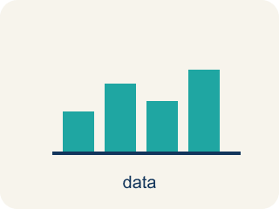
Graph on the Coordinate Plane (Representar en el plano de coordenadas) — Plot a point by moving horizontally to its x-coordinate and vertically to its y-coordinate.
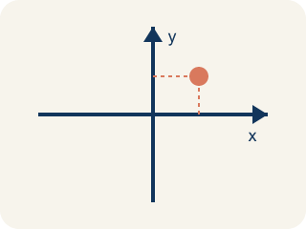
Coordinate plane (Plano cartesiano) — A grid with a line going across and a line going up to plot points.
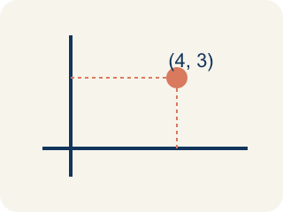
Ordered pair (Par ordenado) — Two numbers (x, y) that tell where a point is on a grid.
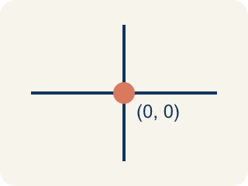
Origin (Origen) — The point (0, 0) where the two grid lines cross.
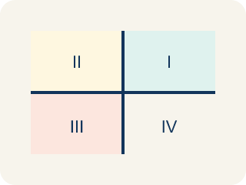
Quadrant (Cuadrante) — One of the four parts of a coordinate grid, numbered I to IV.
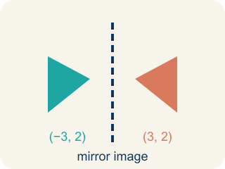
Reflection (Reflexión) — A flipped, mirror image across a line.
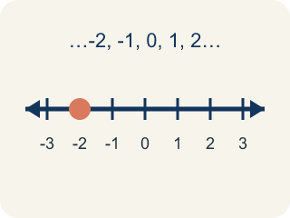
Integer (Número entero) — Whole numbers and their opposites, like -2, -1, 0, 1, 2.

Practice
Show your work. Use the blank space under each problem.
1. Which ordered pair names a point 3 units right and 7 units up from the origin?
A. (3, 7)
B. (7, 3)
C. (3, 3)
D. (0, 7)
______________________________________________________________________
2. What are the coordinates of the origin?
A. (0, 0)
B. (1, 1)
C. (0, 1)
D. (1, 0)
______________________________________________________________________
3. Spot 3 — Vega writes: 'The Coconut Grove is 3 across and 8 up.' Which point on the map is the Coconut Grove?
A. (3, 8)
B. (8, 3)
C. (3, 3)
D. (0, 8)
______________________________________________________________________
4. Level 2 Extension — Captain Vega's Misread Coordinate
Step 1 (Clue): The Pirate Flag is at (3, 6).
Step 2 (Read the x-coordinate): Move 3 units to the right along the x-axis.
Step 3 (Read the y-coordinate): Move 1 unit up along the y-axis.
Step 4 (Plot the point): Place the flag where (3, 1) would go.
Which step has the mistake? Explain and fix it:
______________________________________________________________________
______________________________________________________________________
______________________________________________________________________
5. Miscounted Grid Lines
Step 1 (Ordered pair): (7, 3)
Step 2 (Move along the x-axis): Start at the origin (0, 0) and count 7 units to the right.
Step 3 (Move along the y-axis): Count up from the x-axis: 1, 2, 3, 4 — stop on 4.
Step 4 (Plot the point): Place the dot at (7, 4).
Which step has the mistake? Explain and fix it:
______________________________________________________________________
______________________________________________________________________
______________________________________________________________________
6. A student says that (3, 5) and (5, 3) are the same point because they use the same numbers. Is the student correct? Explain why or why not, and describe where each point is located on the coordinate plane.
Sentence starter: The student is ___ because (3, 5) means ___ while (5, 3) means ___. The ORDER matters because ___.
______________________________________________________________________
______________________________________________________________________
______________________________________________________________________
______________________________________________________________________
7. Sort each item into the correct group.
• undefined → __________________
• undefined → __________________
• undefined → __________________
• undefined → __________________
______________________________________________________________________
8. Match each ordered pair to its description.
Item | Answer choices
____ (0, 0) | F. On the y-axis
____ (4, 2) | E. On the x-axis
____ (1, 6) | D. Right 5, Up 5
____ (5, 5) | C. Right 1, Up 6
____ (3, 0) | B. Right 4, Up 2
____ (0, 4) | A. Origin
______________________________________________________________________

Answer Key (Teacher)
1. A. (3, 7)
The first coordinate is horizontal (right 3), the second is vertical (up 7). So (3, 7).
Watch for: A common mistake in Graph on the Coordinate Plane is swapping the order of the coordinates — moving up/down first instead of right/left first. For example, when plotting (5, 2), students often move up 5 and right 2, landing on the wrong point (2, 5) instead of (5, 2). Remember: the x-coordinate (first number) always tells you how far to move right or left along the x-axis; the y-coordinate (second number) tells you how far up or down along the y-axis.
2. A. (0, 0)
The origin is where the x-axis and y-axis cross, at (0, 0).
Watch for: A common mistake in Graph on the Coordinate Plane is swapping the order of the coordinates — moving up/down first instead of right/left first. For example, when plotting (5, 2), students often move up 5 and right 2, landing on the wrong point (2, 5) instead of (5, 2). Remember: the x-coordinate (first number) always tells you how far to move right or left along the x-axis; the y-coordinate (second number) tells you how far up or down along the y-axis.
3. A. (3, 8)
Across (3) is the x-coordinate and up (8) is the y-coordinate, so the Coconut Grove is at (3, 8).
Watch for: A common mistake in Graph on the Coordinate Plane is swapping the order of the coordinates — moving up/down first instead of right/left first. For example, when plotting (5, 2), students often move up 5 and right 2, landing on the wrong point (2, 5) instead of (5, 2). Remember: the x-coordinate (first number) always tells you how far to move right or left along the x-axis; the y-coordinate (second number) tells you how far up or down along the y-axis.
4. Level 2 Extension — Captain Vega's Misread Coordinate
The mistake is in Step 3.
Correct work: The x move is correct (3 right), but the y-coordinate is 6, not 1. The navigator should move 6 units up, placing the flag at (3, 6) — not (3, 1).
Watch for: The x move is right: 3 units across. The mistake is the y move — the second number in (3, 6) is 6, not 1, so the flag should rise 6 units after the 3 right. Placing it at (3, 1) puts the Pirate Flag five units too low.
5. Miscounted Grid Lines
The mistake is in Step 3.
Correct work: The x-axis itself is 0, not 1. Counting up correctly: 1, 2, 3 — the third count lands on y = 3, so the point is (7, 3), not (7, 4). The student started counting one gridline too high by treating the x-axis as unit 1 instead of unit 0.
Watch for: Counting up has to start with the x-axis as 0, not 1. The first line above the x-axis is 1, the second is 2, and the third is 3, so 3 units up lands on y = 3. Treating the axis itself as unit 1 pushes every count one gridline too high, which is how (7, 3) turned into (7, 4).
6. Open response — answers will vary.
Look for key words: order, x-coordinate, y-coordinate, horizontal, vertical, different, right, up.
7. Correct groups:
undefined → undefined
undefined → undefined
undefined → undefined
undefined → undefined

8. Matches:
(0, 0) → Origin
(4, 2) → Right 4, Up 2
(1, 6) → Right 1, Up 6
(5, 5) → Right 5, Up 5
(3, 0) → On the x-axis
(0, 4) → On the y-axis

