7.5 Small Group · Group 2 — Homework
Lesson 7-5-group2 • Standard 6.NOS.6
Name: ______________________ Period: ______ Date: ____________

Today's Goals
Content: I can plot and identify points on the coordinate plane using ordered pairs, explain what each part stands for, and build one for a situation I have not seen before.
Language: I can justify my answer to a skeptic and connect it to a second strategy or representation.

Key Words
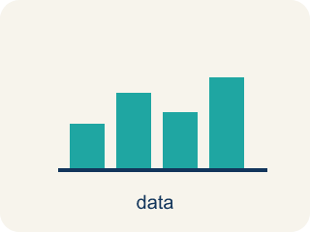
Graph on the Coordinate Plane (Representar en el plano de coordenadas) — Plot a point by moving horizontally to its x-coordinate and vertically to its y-coordinate.
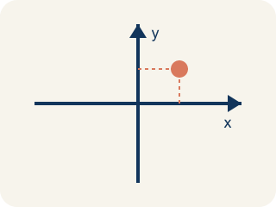
Coordinate plane (Plano cartesiano) — A grid with a line going across and a line going up to plot points.
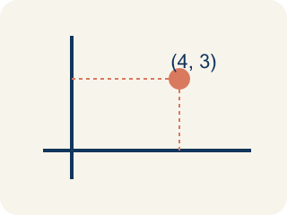
Ordered pair (Par ordenado) — Two numbers (x, y) that tell where a point is on a grid.
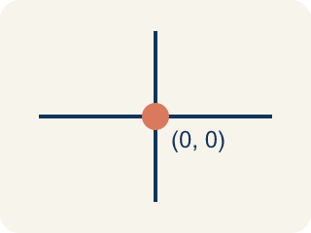
Origin (Origen) — The point (0, 0) where the two grid lines cross.
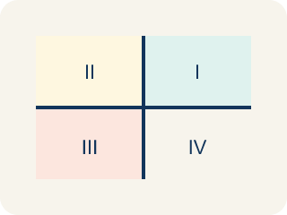
Quadrant (Cuadrante) — One of the four parts of a coordinate grid, numbered I to IV.
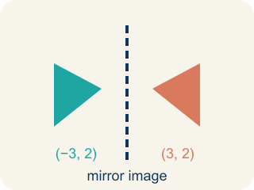
Reflection (Reflexión) — A flipped, mirror image across a line.
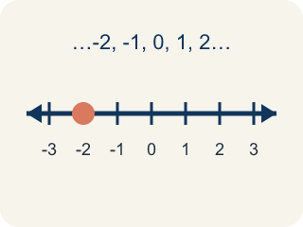
Integer (Número entero) — Whole numbers and their opposites, like -2, -1, 0, 1, 2.

Practice
Show your work. Use the blank space under each problem.
1. Spot the Common Mistake
Step 1 (Clue): Plot the point (4, 0).
Step 2 (Move right): Move 4 units to the right along the x-axis. Good.
Step 3 (Move up): Move 4 units up, because the pair has a 4 in it.
Step 4 (Plot the point): Place the dot at (4, 4).
Which step has the mistake? Explain and fix it:
______________________________________________________________________
______________________________________________________________________
______________________________________________________________________
2. Miscounted Grid Lines
Step 1 (Ordered pair): (7, 3)
Step 2 (Move along the x-axis): Start at the origin (0, 0) and count 7 units to the right.
Step 3 (Move along the y-axis): Count up from the x-axis: 1, 2, 3, 4 — stop on 4.
Step 4 (Plot the point): Place the dot at (7, 4).
Which step has the mistake? Explain and fix it:
______________________________________________________________________
______________________________________________________________________
______________________________________________________________________
3. A student says that (3, 5) and (5, 3) are the same point because they use the same numbers. Is the student correct? Explain why or why not, and describe where each point is located on the coordinate plane.
Sentence starter: The student is ___ because (3, 5) means ___ while (5, 3) means ___. The ORDER matters because ___.
______________________________________________________________________
______________________________________________________________________
______________________________________________________________________
______________________________________________________________________
4. Spot 1 — Captain Vega's first clue says the Sandy Dock is right 7 and up 2 from the origin. Which ordered pair names the Sandy Dock?
A. (7, 2)
B. (2, 7)
C. (7, 0)
D. (2, 2)
______________________________________________________________________

Answer Key (Teacher)
1. Spot the Common Mistake
The mistake is in Step 3.
Correct work: The y-coordinate is 0, not 4. After moving 4 right, the up move is 0 units, so the point stays on the x-axis at (4, 0). The student reused the x-value instead of reading the second number (0).
Watch for: The up move comes from the SECOND number, and the second number in (4, 0) is 0. Reusing the 4 pushes the point off the axis to (4, 4). With a y-coordinate of 0 there is no upward move at all, so the point stays right on the x-axis at (4, 0).
2. Miscounted Grid Lines
The mistake is in Step 3.
Correct work: The x-axis itself is 0, not 1. Counting up correctly: 1, 2, 3 — the third count lands on y = 3, so the point is (7, 3), not (7, 4). The student started counting one gridline too high by treating the x-axis as unit 1 instead of unit 0.
Watch for: Counting up has to start with the x-axis as 0, not 1. The first line above the x-axis is 1, the second is 2, and the third is 3, so 3 units up lands on y = 3. Treating the axis itself as unit 1 pushes every count one gridline too high, which is how (7, 3) turned into (7, 4).
3. Open response — answers will vary.
Look for key words: order, x-coordinate, y-coordinate, horizontal, vertical, different, right, up.
4. A. (7, 2)
The x-coordinate is the sideways move (right 7) and the y-coordinate is the up move (up 2), so the Sandy Dock is (7, 2).
Watch for: A common mistake in Graph on the Coordinate Plane is swapping the order of the coordinates — moving up/down first instead of right/left first. For example, when plotting (5, 2), students often move up 5 and right 2, landing on the wrong point (2, 5) instead of (5, 2). Remember: the x-coordinate (first number) always tells you how far to move right or left along the x-axis; the y-coordinate (second number) tells you how far up or down along the y-axis.

