7.6 Small Group · Group 1 — Homework
Lesson 7-6-group1 • Standard 6.NOS.9
Name: ______________________ Period: ______ Date: ____________

Today's Goals
Content: With my small group, I can find the distance between two points on the coordinate plane using absolute value — one step at a time, with support.
Language: I can talk through each step out loud using a sentence frame and the lesson's key words.

Key Words
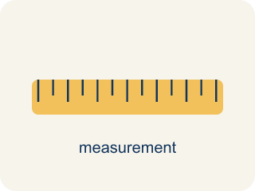
Distance on the Coordinate Plane (Distancia en el plano de coordenadas) — The positive space between points, found from the absolute difference of coordinates on a horizontal or vertical line.
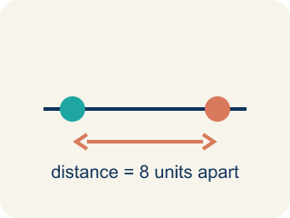
Distance (Distancia) — How far apart two points are. It is never negative.
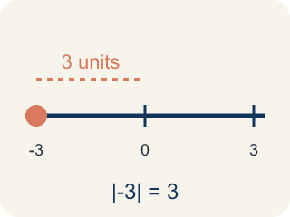
Absolute value (Valor absoluto) — How far a number is from zero. It is never negative.

Horizontal distance (Distancia horizontal) — How far apart two points are going left or right.

Vertical distance (Distancia vertical) — How far apart two points are going up or down.
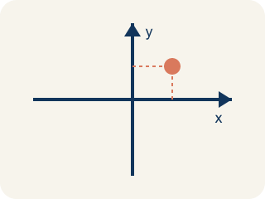
Coordinate plane (Plano cartesiano) — A grid with a line going across and a line going up to plot points.
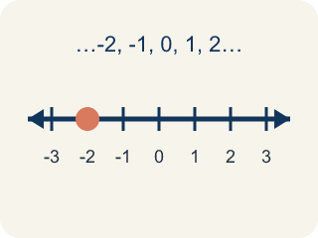
Integer (Número entero) — Whole numbers and their opposites, like -2, -1, 0, 1, 2.

Practice
Show your work. Use the blank space under each problem.
1. What is the distance between (-4, 3) and (2, 3)?
A. 2 units
B. 4 units
C. 6 units
D. 8 units
______________________________________________________________________
2. What is the distance between (5, -2) and (5, 4)?
A. 2 units
B. 4 units
C. 6 units
D. 10 units
______________________________________________________________________
3. What is the distance between (-4, 1) and (3, 1)?
A. 1 unit
B. 12 units
C. 7 units
D. -7 units
______________________________________________________________________
4. The Bank is at (2, 3) and the Library is at (2, 9). How many blocks apart are they?
A. 6 blocks
B. 12 blocks
C. 3 blocks
D. 11 blocks
______________________________________________________________________
5. The Park is at (-4, 5) and City Hall is at (3, 5). How many blocks apart are they?
A. 1 block
B. 7 blocks
C. 12 blocks
D. 5 blocks
______________________________________________________________________
6. The Café is at (-2, 1) and the Gym is at (-2, -4). How many blocks apart are they?
A. 3 blocks
B. 5 blocks
C. 6 blocks
D. 2 blocks
______________________________________________________________________
7. Level 2 Extension — City Block Distance Mistake
Step 1 (Problem): Find the blocks between the Park (-4, 5) and City Hall (3, 5).
Step 2 (Student thinking): Both have y = 5, so subtract the x-values: 4 - 3 = 1.
Step 3 (Student answer): The distance is 1 block.
Which step has the mistake? Explain and fix it:
______________________________________________________________________
______________________________________________________________________
______________________________________________________________________
8. Find the Distance Error
Step 1 (Problem): Find the distance between (-3, 4) and (5, 4)
Step 2 (Student thinking): Subtract: 5 - 3 = 2
Step 3 (Student answer): The distance is 2 units
Which step has the mistake? Explain and fix it:
______________________________________________________________________
______________________________________________________________________
______________________________________________________________________

Answer Key (Teacher)
1. C. 6 units
Both points have y = 3, so this is a horizontal distance. |2 - (-4)| = |2 + 4| = 6 units.
Watch for: A common mistake in Distance on the Coordinate Plane is subtracting the coordinates as if both points were on the same side of zero, instead of adding their absolute values when the points are on opposite sides. For example, to find the distance between (-6, 3) and (2, 3), a student might subtract 6 − 2 = 4, but since -6 and 2 are on opposite sides of zero, the absolute values must be added instead: |-6| + |2| = 6 + 2 = 8. The correct distance is 8 units, not 4. Before you submit, ask: 'Are these two points on opposite sides of zero — and if so, did I add the absolute values instead of subtracting?'
2. C. 6 units
Both points have x = 5, so this is a vertical distance. |4 - (-2)| = |4 + 2| = 6 units.
Watch for: A common mistake in Distance on the Coordinate Plane is subtracting the coordinates as if both points were on the same side of zero, instead of adding their absolute values when the points are on opposite sides. For example, to find the distance between (-6, 3) and (2, 3), a student might subtract 6 − 2 = 4, but since -6 and 2 are on opposite sides of zero, the absolute values must be added instead: |-6| + |2| = 6 + 2 = 8. The correct distance is 8 units, not 4. Before you submit, ask: 'Are these two points on opposite sides of zero — and if so, did I add the absolute values instead of subtracting?'
3. C. 7 units
The y-coordinates match, so distance = |3 - (-4)| = 7 units.
Watch for: A common mistake in Distance on the Coordinate Plane is subtracting the coordinates as if both points were on the same side of zero, instead of adding their absolute values when the points are on opposite sides. For example, to find the distance between (-6, 3) and (2, 3), a student might subtract 6 − 2 = 4, but since -6 and 2 are on opposite sides of zero, the absolute values must be added instead: |-6| + |2| = 6 + 2 = 8. The correct distance is 8 units, not 4. Before you submit, ask: 'Are these two points on opposite sides of zero — and if so, did I add the absolute values instead of subtracting?'
4. A. 6 blocks
Same x = 2, so the segment is vertical. Distance = |9 - 3| = 6 blocks.
Watch for: A common mistake in Distance on the Coordinate Plane is subtracting the coordinates as if both points were on the same side of zero, instead of adding their absolute values when the points are on opposite sides. For example, to find the distance between (-6, 3) and (2, 3), a student might subtract 6 − 2 = 4, but since -6 and 2 are on opposite sides of zero, the absolute values must be added instead: |-6| + |2| = 6 + 2 = 8. The correct distance is 8 units, not 4. Before you submit, ask: 'Are these two points on opposite sides of zero — and if so, did I add the absolute values instead of subtracting?'
5. B. 7 blocks
Same y = 5, so the segment is horizontal. The points are on opposite sides of zero, so add the absolute values: |-4| + |3| = 4 + 3 = 7 blocks.
Watch for: A common mistake in Distance on the Coordinate Plane is subtracting the coordinates as if both points were on the same side of zero, instead of adding their absolute values when the points are on opposite sides. For example, to find the distance between (-6, 3) and (2, 3), a student might subtract 6 − 2 = 4, but since -6 and 2 are on opposite sides of zero, the absolute values must be added instead: |-6| + |2| = 6 + 2 = 8. The correct distance is 8 units, not 4. Before you submit, ask: 'Are these two points on opposite sides of zero — and if so, did I add the absolute values instead of subtracting?'
6. B. 5 blocks
Same x = -2, so the segment is vertical. The points are on opposite sides of zero: |1| + |-4| = 1 + 4 = 5 blocks.
Watch for: A common mistake in Distance on the Coordinate Plane is subtracting the coordinates as if both points were on the same side of zero, instead of adding their absolute values when the points are on opposite sides. For example, to find the distance between (-6, 3) and (2, 3), a student might subtract 6 − 2 = 4, but since -6 and 2 are on opposite sides of zero, the absolute values must be added instead: |-6| + |2| = 6 + 2 = 8. The correct distance is 8 units, not 4. Before you submit, ask: 'Are these two points on opposite sides of zero — and if so, did I add the absolute values instead of subtracting?'
7. Level 2 Extension — City Block Distance Mistake
The mistake is in Step 2.
Correct work: The student dropped the negative sign and used 4 instead of -4. Because the Park is at x = -4 and City Hall is at x = 3, the points sit on opposite sides of zero. Add the absolute values: |-4| + |3| = 4 + 3 = 7 blocks. (You can also write it as |3 - (-4)| = |3 + 4| = 7.) The correct distance is 7 blocks, not 1.
Watch for: The subtraction step used 4 instead of -4, so the Park's negative sign was lost. The Park sits left of the y-axis and City Hall sits right of it, so the absolute values add: |-4| + |3| = 7 blocks, which matches |3 - (-4)| = |3 + 4| = 7.
8. Find the Distance Error
The mistake is in Step 2.
Correct work: The student subtracted 5 - 3, but the first x-coordinate is -3, not 3. The correct calculation is |5 - (-3)| = |5 + 3| = 8 units. When points span opposite sides of an axis, you must add the absolute values: |-3| + |5| = 3 + 5 = 8.
Watch for: The subtraction step used 3 in place of -3, so the negative sign disappeared. Keeping it gives |5 - (-3)| = |5 + 3| = 8 units, which is the same as adding the absolute values |-3| + |5| = 3 + 5 = 8 because the points straddle the y-axis.

