7.6 Small Group · Group 2 — Homework
Lesson 7-6-group2 • Standard 6.NOS.9
Name: ______________________ Period: ______ Date: ____________

Today's Goals
Content: I can find the distance between two points on the coordinate plane using absolute value, explain why the method works, and use it on a problem I have not seen before.
Language: I can justify my answer to a skeptic and connect it to a second strategy or representation.

Key Words
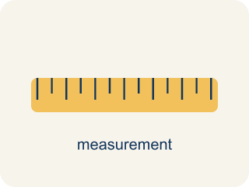
Distance on the Coordinate Plane (Distancia en el plano de coordenadas) — The positive space between points, found from the absolute difference of coordinates on a horizontal or vertical line.
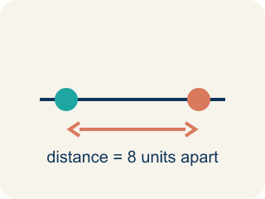
Distance (Distancia) — How far apart two points are. It is never negative.
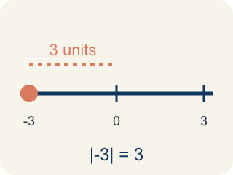
Absolute value (Valor absoluto) — How far a number is from zero. It is never negative.

Horizontal distance (Distancia horizontal) — How far apart two points are going left or right.

Vertical distance (Distancia vertical) — How far apart two points are going up or down.
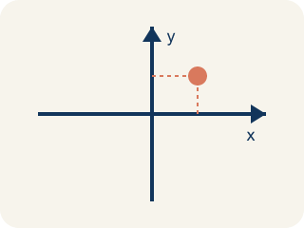
Coordinate plane (Plano cartesiano) — A grid with a line going across and a line going up to plot points.
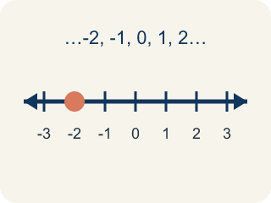
Integer (Número entero) — Whole numbers and their opposites, like -2, -1, 0, 1, 2.

Practice
Show your work. Use the blank space under each problem.
1. Two points are at (-3, -7) and (-3, 5). What is the distance between them?
A. 12 units
B. 2 units
C. 7 units
D. 8 units
______________________________________________________________________
2. Spot the Common Mistake
Step 1 (Problem): Find the distance between (-5, 2) and (3, 2).
Step 2 (Student thinking): Both share y = 2, so subtract the x-values: 5 - 3 = 2.
Step 3 (Student answer): The distance is 2 units.
Which step has the mistake? Explain and fix it:
______________________________________________________________________
______________________________________________________________________
______________________________________________________________________
3. What is the distance between (2, 3) and (2, 8)?
A. 11 units
B. 5 units
C. 6 units
D. 5.5 units
______________________________________________________________________
4. What is the distance between (-4, 1) and (3, 1)?
A. 1 unit
B. 12 units
C. 7 units
D. -7 units
______________________________________________________________________

Answer Key (Teacher)
1. A. 12 units
Same x = -3. Distance = |5 - (-7)| = |5 + 7| = 12 units.
Watch for: A common mistake in Distance on the Coordinate Plane is subtracting the coordinates as if both points were on the same side of zero, instead of adding their absolute values when the points are on opposite sides. For example, to find the distance between (-6, 3) and (2, 3), a student might subtract 6 − 2 = 4, but since -6 and 2 are on opposite sides of zero, the absolute values must be added instead: |-6| + |2| = 6 + 2 = 8. The correct distance is 8 units, not 4. Before you submit, ask: 'Are these two points on opposite sides of zero — and if so, did I add the absolute values instead of subtracting?'
2. Spot the Common Mistake
The mistake is in Step 2.
Correct work: The student dropped the negative sign and used 5 instead of -5. The point is at x = -5, so the two points sit on opposite sides of zero. Add the absolute values: |-5| + |3| = 5 + 3 = 8 units. (You can also write |3 - (-5)| = |3 + 5| = 8.) The correct distance is 8 units, not 2.
Watch for: The student-thinking step dropped the negative sign and treated -5 as 5. Because the points really sit on opposite sides of the y-axis, the distance is |-5| + |3| = 8 units, which matches |3 - (-5)| = |3 + 5| = 8.
3. B. 5 units
The x-coordinates match, so distance = |8 - 3| = 5 units.
Watch for: A common mistake in Distance on the Coordinate Plane is subtracting the coordinates as if both points were on the same side of zero, instead of adding their absolute values when the points are on opposite sides. For example, to find the distance between (-6, 3) and (2, 3), a student might subtract 6 − 2 = 4, but since -6 and 2 are on opposite sides of zero, the absolute values must be added instead: |-6| + |2| = 6 + 2 = 8. The correct distance is 8 units, not 4. Before you submit, ask: 'Are these two points on opposite sides of zero — and if so, did I add the absolute values instead of subtracting?'
4. C. 7 units
The y-coordinates match, so distance = |3 - (-4)| = 7 units.
Watch for: A common mistake in Distance on the Coordinate Plane is subtracting the coordinates as if both points were on the same side of zero, instead of adding their absolute values when the points are on opposite sides. For example, to find the distance between (-6, 3) and (2, 3), a student might subtract 6 − 2 = 4, but since -6 and 2 are on opposite sides of zero, the absolute values must be added instead: |-6| + |2| = 6 + 2 = 8. The correct distance is 8 units, not 4. Before you submit, ask: 'Are these two points on opposite sides of zero — and if so, did I add the absolute values instead of subtracting?'

