7.8 Small Group · Group 1 — Homework
Lesson 7-8-group1 • Standard 6.NOS.7
Name: ______________________ Period: ______ Date: ____________

Today's Goals
Content: With my small group, I can plot ordered pairs in all four quadrants of the coordinate plane — one step at a time, with support.
Language: I can talk through each step out loud using a sentence frame and the lesson's key words.

Key Words
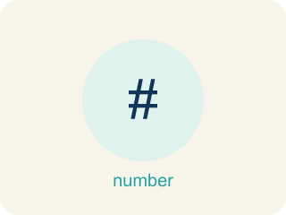
Ordered Pairs in All Four Quadrants (Pares ordenados en los cuatro cuadrantes) — Points written as (x, y) whose positive or negative coordinates place them in one of four quadrants.
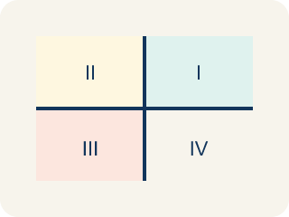
Quadrant (Cuadrante) — One of the four parts of a coordinate grid, numbered I to IV.
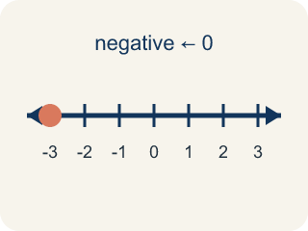
Negative coordinate (Coordenada negativa) — A coordinate less than zero. It means left or below the center point.
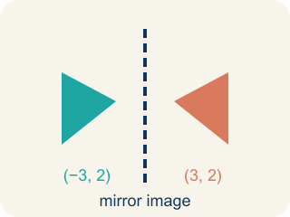
Reflection (Reflexión) — A flipped, mirror image across a line.
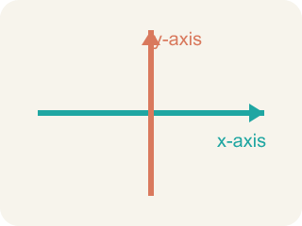
Axis (Eje) — A line on the grid. The x-axis goes across; the y-axis goes up.
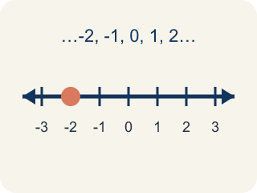
Integer (Número entero) — Whole numbers and their opposites, like -2, -1, 0, 1, 2.

Practice
Show your work. Use the blank space under each problem.
1. In which quadrant is the point (-4, 5)?
A. Quadrant I
B. Quadrant II
C. Quadrant III
D. Quadrant IV
______________________________________________________________________
2. A point has a positive x-coordinate and a negative y-coordinate. Which quadrant is it in?
A. Quadrant I
B. Quadrant II
C. Quadrant III
D. Quadrant IV
______________________________________________________________________
3. What are the coordinates of a point 4 units right and 2 units down from the origin?
A. (-4, 2)
B. (2, -4)
C. (4, -2)
D. (-2, 4)
______________________________________________________________________
4. A sonar ping locates an enemy submarine at (-5, -2). In which quadrant should Captain Vega aim her shot?
A. Quadrant I
B. Quadrant II
C. Quadrant III
D. Quadrant IV
______________________________________________________________________
5. Captain Vega's lookout reports a ship in Quadrant II. What signs will its coordinates (x, y) have?
A. (+, +)
B. (-, +)
C. (-, -)
D. (+, -)
______________________________________________________________________
6. Level 2 Extension — The Misfired Shot
Step 1 (Target): An enemy ship is at (-3, 4). In which quadrant should Captain Vega fire?
Step 2 (Gunner's thinking): Ignore the signs and just use the numbers 3 and 4. Both numbers are there, so it must be a bottom-left target.
Step 3 (Gunner's answer): Fire on Quadrant III
Which step has the mistake? Explain and fix it:
______________________________________________________________________
______________________________________________________________________
______________________________________________________________________
7. Find the Quadrant Error
Step 1 (Problem): Identify the quadrant for (-3, -5)
Step 2 (Student thinking): The x is -3, so I go left 3. The y is -5, so I go up 5.
Step 3 (Student answer): (-3, -5) is in Quadrant II
Which step has the mistake? Explain and fix it:
______________________________________________________________________
______________________________________________________________________
______________________________________________________________________
8. A point starts in Quadrant I at (4, 6). Describe a move that puts it in Quadrant III. What must happen to both coordinates? Can you give the exact new coordinates after your move?
Sentence starter: To move from Quadrant I to Quadrant III, both coordinates must become ___. Starting at (4, 6), I could move ___ units left and ___ units down to reach (___,___), which is in Quadrant III because ___.
______________________________________________________________________
______________________________________________________________________
______________________________________________________________________
______________________________________________________________________

Answer Key (Teacher)
1. B. Quadrant II
The x-coordinate is negative (left) and the y-coordinate is positive (up). Left and up is Quadrant II.
Watch for: A common mistake in Ordered Pairs in All Four Quadrants is matching each sign to the wrong axis — for example, seeing (-2, 5) and thinking "the x is negative so I move DOWN, and the y is positive so I move RIGHT," which lands the point in Quadrant IV. But the x-coordinate always controls left/right, never up/down: negative x means LEFT (not down), and positive y means UP (not right). So (-2, 5) is actually left 2, up 5 — Quadrant II. Before you submit, check that you used the x-coordinate for left/right and the y-coordinate for up/down, and never swapped them.
2. D. Quadrant IV
Positive x (right) and negative y (down) = Quadrant IV (bottom-right).
Watch for: A common mistake in Ordered Pairs in All Four Quadrants is matching each sign to the wrong axis — for example, seeing (-2, 5) and thinking "the x is negative so I move DOWN, and the y is positive so I move RIGHT," which lands the point in Quadrant IV. But the x-coordinate always controls left/right, never up/down: negative x means LEFT (not down), and positive y means UP (not right). So (-2, 5) is actually left 2, up 5 — Quadrant II. Before you submit, check that you used the x-coordinate for left/right and the y-coordinate for up/down, and never swapped them.
3. C. (4, -2)
Right is +x and down is -y, so the point is (4, -2).
Watch for: A common mistake in Ordered Pairs in All Four Quadrants is matching each sign to the wrong axis — for example, seeing (-2, 5) and thinking "the x is negative so I move DOWN, and the y is positive so I move RIGHT," which lands the point in Quadrant IV. But the x-coordinate always controls left/right, never up/down: negative x means LEFT (not down), and positive y means UP (not right). So (-2, 5) is actually left 2, up 5 — Quadrant II. Before you submit, check that you used the x-coordinate for left/right and the y-coordinate for up/down, and never swapped them.
4. C. Quadrant III
A negative x means left and a negative y means down, so (-5, -2) is in Quadrant III, where both coordinates are negative.
Watch for: A common mistake in Ordered Pairs in All Four Quadrants is matching each sign to the wrong axis — for example, seeing (-2, 5) and thinking "the x is negative so I move DOWN, and the y is positive so I move RIGHT," which lands the point in Quadrant IV. But the x-coordinate always controls left/right, never up/down: negative x means LEFT (not down), and positive y means UP (not right). So (-2, 5) is actually left 2, up 5 — Quadrant II. Before you submit, check that you used the x-coordinate for left/right and the y-coordinate for up/down, and never swapped them.
5. B. (-, +)
Quadrant II is up and to the left of the origin, so x is negative and y is positive: (-, +).
Watch for: A common mistake in Ordered Pairs in All Four Quadrants is matching each sign to the wrong axis — for example, seeing (-2, 5) and thinking "the x is negative so I move DOWN, and the y is positive so I move RIGHT," which lands the point in Quadrant IV. But the x-coordinate always controls left/right, never up/down: negative x means LEFT (not down), and positive y means UP (not right). So (-2, 5) is actually left 2, up 5 — Quadrant II. Before you submit, check that you used the x-coordinate for left/right and the y-coordinate for up/down, and never swapped them.
6. Level 2 Extension — The Misfired Shot
The mistake is in Step 2.
Correct work: You cannot ignore the signs! The x is -3 (negative = left) and the y is 4 (positive = up). Left and up is Quadrant II, not Quadrant III. Captain Vega should fire on Quadrant II.
Watch for: Ignoring the signs throws away the only information that names a quadrant. With x = -3 the ship is 3 units to the left, and with y = 4 it is 4 units up, which is the top-left region. Left and up is Quadrant II, so firing on Quadrant III would miss entirely.
7. Find the Quadrant Error
The mistake is in Step 2.
Correct work: A negative y-coordinate means DOWN, not up. Go left 3 and DOWN 5. The point (-3, -5) is in Quadrant III (both negative), not Quadrant II.
Watch for: A negative y-coordinate means down, not up. From the origin you go left 3 and DOWN 5, landing in the bottom-left region. Both coordinates are negative, and (-, -) is Quadrant III, not Quadrant II.
8. Open response — answers will vary.
Look for key words: negative, quadrant, left, down, x-coordinate, y-coordinate, sign change.

