7.8 Small Group · Group 2 — Homework
Lesson 7-8-group2 • Standard 6.NOS.7
Name: ______________________ Period: ______ Date: ____________

Today's Goals
Content: I can plot ordered pairs in all four quadrants of the coordinate plane, explain what each part stands for, and build one for a situation I have not seen before.
Language: I can justify my answer to a skeptic and connect it to a second strategy or representation.

Key Words
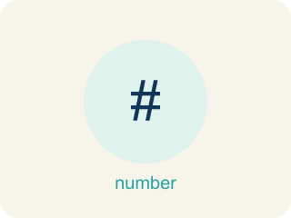
Ordered Pairs in All Four Quadrants (Pares ordenados en los cuatro cuadrantes) — Points written as (x, y) whose positive or negative coordinates place them in one of four quadrants.
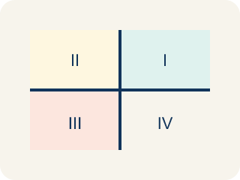
Quadrant (Cuadrante) — One of the four parts of a coordinate grid, numbered I to IV.
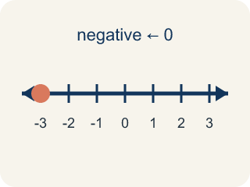
Negative coordinate (Coordenada negativa) — A coordinate less than zero. It means left or below the center point.
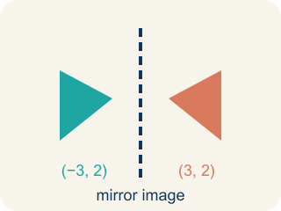
Reflection (Reflexión) — A flipped, mirror image across a line.
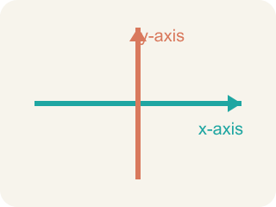
Axis (Eje) — A line on the grid. The x-axis goes across; the y-axis goes up.
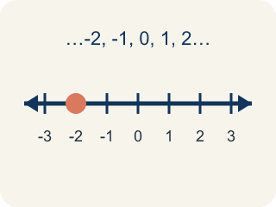
Integer (Número entero) — Whole numbers and their opposites, like -2, -1, 0, 1, 2.

Practice
Show your work. Use the blank space under each problem.
1. Point A is at (-5, 3). If you move 8 units to the right, what are the new coordinates?
A. (3, 3)
B. (-13, 3)
C. (-5, 11)
D. (-5, -5)
______________________________________________________________________
2. Spot the Common Mistake
Step 1 (Problem): Name the quadrant for the point (6, -1).
Step 2 (Student thinking): I'll read the coordinates as (y, x), so I treat this like (-1, 6): the first number -1 is negative (left) and the second number 6 is positive (up).
Step 3 (Student answer): (6, -1) is in Quadrant II.
Which step has the mistake? Explain and fix it:
______________________________________________________________________
______________________________________________________________________
______________________________________________________________________
3. In which quadrant is the point (-3, 5)?
A. Quadrant I
B. Quadrant II
C. Quadrant III
D. Quadrant IV
______________________________________________________________________
4. What are the coordinates of a point 4 units right and 2 units down from the origin?
A. (-4, 2)
B. (2, -4)
C. (4, -2)
D. (-2, 4)
______________________________________________________________________

Answer Key (Teacher)
1. A. (3, 3)
Moving right means adding to the x-coordinate: -5 + 8 = 3. The y stays the same. New point: (3, 3).
Watch for: A common mistake in Ordered Pairs in All Four Quadrants is matching each sign to the wrong axis — for example, seeing (-2, 5) and thinking "the x is negative so I move DOWN, and the y is positive so I move RIGHT," which lands the point in Quadrant IV. But the x-coordinate always controls left/right, never up/down: negative x means LEFT (not down), and positive y means UP (not right). So (-2, 5) is actually left 2, up 5 — Quadrant II. Before you submit, check that you used the x-coordinate for left/right and the y-coordinate for up/down, and never swapped them.
2. Spot the Common Mistake
The mistake is in Step 2.
Correct work: The order was reversed. In an ordered pair (x, y), x ALWAYS comes first. Here x = 6 (positive → right) and y = -1 (negative → down). Right and down is Quadrant IV, not Quadrant II.
Watch for: An ordered pair is always (x, y), so the first number is the horizontal move and the order cannot be swapped. Here x = 6 sends you right and y = -1 sends you down, which is the bottom-right region — Quadrant IV. Reading it as (-1, 6) described a completely different point.
3. B. Quadrant II
Negative x with positive y places the point in Quadrant II.
Watch for: A common mistake in Ordered Pairs in All Four Quadrants is matching each sign to the wrong axis — for example, seeing (-2, 5) and thinking "the x is negative so I move DOWN, and the y is positive so I move RIGHT," which lands the point in Quadrant IV. But the x-coordinate always controls left/right, never up/down: negative x means LEFT (not down), and positive y means UP (not right). So (-2, 5) is actually left 2, up 5 — Quadrant II. Before you submit, check that you used the x-coordinate for left/right and the y-coordinate for up/down, and never swapped them.
4. C. (4, -2)
Right is +x and down is -y, so the point is (4, -2).
Watch for: A common mistake in Ordered Pairs in All Four Quadrants is matching each sign to the wrong axis — for example, seeing (-2, 5) and thinking "the x is negative so I move DOWN, and the y is positive so I move RIGHT," which lands the point in Quadrant IV. But the x-coordinate always controls left/right, never up/down: negative x means LEFT (not down), and positive y means UP (not right). So (-2, 5) is actually left 2, up 5 — Quadrant II. Before you submit, check that you used the x-coordinate for left/right and the y-coordinate for up/down, and never swapped them.

