Ordered Pairs in All Four Quadrants — Homework
Lesson 7-8 • Standard 6.NOS.7
Name: ______________________ Period: ______ Date: ____________

Today's Goals
Content: I can plot ordered pairs in all four quadrants of the coordinate plane.
Language: I can explain my work using the words quadrant, negative coordinate, reflection, and axis.

Key Words
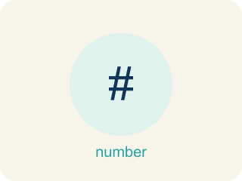
Ordered Pairs in All Four Quadrants (Pares ordenados en los cuatro cuadrantes) — Points written as (x, y) whose positive or negative coordinates place them in one of four quadrants.
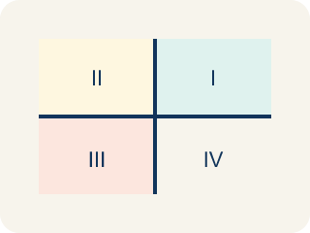
Quadrant (Cuadrante) — One of the four parts of a coordinate grid, numbered I to IV.
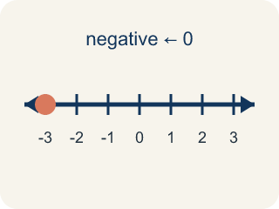
Negative coordinate (Coordenada negativa) — A coordinate less than zero. It means left or below the center point.
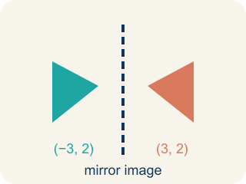
Reflection (Reflexión) — A flipped, mirror image across a line.
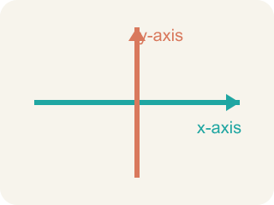
Axis (Eje) — One of the two number lines that frame a graph: the x-axis runs across, the y-axis runs up and down.
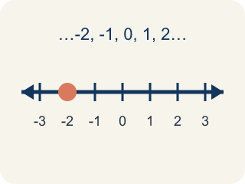
Integer (Número entero) — Whole numbers and their opposites, like -2, -1, 0, 1, 2.

Practice
Show your work. Use the blank space under each problem.
1. In which quadrant is the point (-4, 5)?
A. Quadrant I
B. Quadrant II
C. Quadrant III
D. Quadrant IV
______________________________________________________________________
2. A point has a positive x-coordinate and a negative y-coordinate. Which quadrant is it in?
A. Quadrant I
B. Quadrant II
C. Quadrant III
D. Quadrant IV
______________________________________________________________________
3. For each ordered pair, write the signs of x and y and name the quadrant (or axis).
Point | x sign | y sign | Quadrant or Axis
(6, -2)
(-3, -5)
(0, 7)
(-1, 8)
(4, 0)
______________________________________________________________________
4. Match each quadrant to its coordinate sign pattern.
Item | Answer choices
____ Quadrant I | F. x = 0
____ Quadrant II | E. y = 0
____ Quadrant III | D. (+, -)
____ Quadrant IV | C. (-, -)
____ x-axis | B. (-, +)
____ y-axis | A. (+, +)
______________________________________________________________________
5. Point A is at (-5, 3). If you move 8 units to the right, what are the new coordinates?
A. (3, 3)
B. (-13, 3)
C. (-5, 11)
D. (-5, -5)
______________________________________________________________________
6. Spot the Common Mistake
Step 1 (Problem): Name the quadrant for the point (6, -1).
Step 2 (Student thinking): I'll read the coordinates as (y, x), so I treat this like (-1, 6): the first number -1 is negative (left) and the second number 6 is positive (up).
Step 3 (Student answer): (6, -1) is in Quadrant II.
Which step has the mistake? Explain and fix it:
______________________________________________________________________
______________________________________________________________________
______________________________________________________________________
7. In which quadrant is the point (-3, 5)?
A. Quadrant I
B. Quadrant II
C. Quadrant III
D. Quadrant IV
______________________________________________________________________
8. What are the coordinates of a point 4 units right and 2 units down from the origin?
A. (-4, 2)
B. (2, -4)
C. (4, -2)
D. (-2, 4)
______________________________________________________________________
9. Captain Vega spotted four enemy ships. Drag each ship's coordinates into the correct quadrant of the map.
Groups: Quadrant I | Quadrant II | Quadrant III | Quadrant IV
• (3, 2) → __________________
• (-4, 1) → __________________
• (-2, -5) → __________________
• (6, -3) → __________________
______________________________________________________________________
10. A sonar ping locates an enemy submarine at (-5, -2). In which quadrant should Captain Vega aim her shot?
A. Quadrant I
B. Quadrant II
C. Quadrant III
D. Quadrant IV
______________________________________________________________________

Answer Key (Teacher)
1. B. Quadrant II
The x-coordinate is negative (left) and the y-coordinate is positive (up). Left and up is Quadrant II.
Watch for: A common mistake in Ordered Pairs in All Four Quadrants is matching each sign to the wrong axis — for example, seeing (-2, 5) and thinking "the x is negative so I move DOWN, and the y is positive so I move RIGHT," which lands the point in Quadrant IV. But the x-coordinate always controls left/right, never up/down: negative x means LEFT (not down), and positive y means UP (not right). So (-2, 5) is actually left 2, up 5 — Quadrant II. Before you submit, check that you used the x-coordinate for left/right and the y-coordinate for up/down, and never swapped them.
2. D. Quadrant IV
Positive x (right) and negative y (down) = Quadrant IV (bottom-right).
Watch for: A common mistake in Ordered Pairs in All Four Quadrants is matching each sign to the wrong axis — for example, seeing (-2, 5) and thinking "the x is negative so I move DOWN, and the y is positive so I move RIGHT," which lands the point in Quadrant IV. But the x-coordinate always controls left/right, never up/down: negative x means LEFT (not down), and positive y means UP (not right). So (-2, 5) is actually left 2, up 5 — Quadrant II. Before you submit, check that you used the x-coordinate for left/right and the y-coordinate for up/down, and never swapped them.
3. For each ordered pair, write the signs of x and y and name the quadrant (or axis).
(6, -2) — x sign: +
(6, -2) — y sign: -
(6, -2) — Quadrant or Axis: IV
(-3, -5) — x sign: -
(-3, -5) — y sign: -
(-3, -5) — Quadrant or Axis: III
(0, 7) — x sign: 0
(0, 7) — y sign: +
(0, 7) — Quadrant or Axis: y-axis
(-1, 8) — x sign: -
(-1, 8) — y sign: +
(-1, 8) — Quadrant or Axis: II
(4, 0) — x sign: +
(4, 0) — y sign: 0
(4, 0) — Quadrant or Axis: x-axis

4. Matches:
Quadrant I → (+, +)
Quadrant II → (-, +)
Quadrant III → (-, -)
Quadrant IV → (+, -)
x-axis → y = 0
y-axis → x = 0

5. A. (3, 3)
Moving right means adding to the x-coordinate: -5 + 8 = 3. The y stays the same. New point: (3, 3).
Watch for: A common mistake in Ordered Pairs in All Four Quadrants is matching each sign to the wrong axis — for example, seeing (-2, 5) and thinking "the x is negative so I move DOWN, and the y is positive so I move RIGHT," which lands the point in Quadrant IV. But the x-coordinate always controls left/right, never up/down: negative x means LEFT (not down), and positive y means UP (not right). So (-2, 5) is actually left 2, up 5 — Quadrant II. Before you submit, check that you used the x-coordinate for left/right and the y-coordinate for up/down, and never swapped them.
6. Spot the Common Mistake
The mistake is in Step 2.
Correct work: The order was reversed. In an ordered pair (x, y), x ALWAYS comes first. Here x = 6 (positive → right) and y = -1 (negative → down). Right and down is Quadrant IV, not Quadrant II.
Watch for: An ordered pair is always (x, y), so the first number is the horizontal move and the order cannot be swapped. Here x = 6 sends you right and y = -1 sends you down, which is the bottom-right region — Quadrant IV. Reading it as (-1, 6) described a completely different point.
7. B. Quadrant II
Negative x with positive y places the point in Quadrant II.
Watch for: A common mistake in Ordered Pairs in All Four Quadrants is matching each sign to the wrong axis — for example, seeing (-2, 5) and thinking "the x is negative so I move DOWN, and the y is positive so I move RIGHT," which lands the point in Quadrant IV. But the x-coordinate always controls left/right, never up/down: negative x means LEFT (not down), and positive y means UP (not right). So (-2, 5) is actually left 2, up 5 — Quadrant II. Before you submit, check that you used the x-coordinate for left/right and the y-coordinate for up/down, and never swapped them.
8. C. (4, -2)
Right is +x and down is -y, so the point is (4, -2).
Watch for: A common mistake in Ordered Pairs in All Four Quadrants is matching each sign to the wrong axis — for example, seeing (-2, 5) and thinking "the x is negative so I move DOWN, and the y is positive so I move RIGHT," which lands the point in Quadrant IV. But the x-coordinate always controls left/right, never up/down: negative x means LEFT (not down), and positive y means UP (not right). So (-2, 5) is actually left 2, up 5 — Quadrant II. Before you submit, check that you used the x-coordinate for left/right and the y-coordinate for up/down, and never swapped them.
9. Correct groups:
(3, 2) → Quadrant I
(-4, 1) → Quadrant II
(-2, -5) → Quadrant III
(6, -3) → Quadrant IV

10. C. Quadrant III
A negative x means left and a negative y means down, so (-5, -2) is in Quadrant III, where both coordinates are negative.
Watch for: A common mistake in Ordered Pairs in All Four Quadrants is matching each sign to the wrong axis — for example, seeing (-2, 5) and thinking "the x is negative so I move DOWN, and the y is positive so I move RIGHT," which lands the point in Quadrant IV. But the x-coordinate always controls left/right, never up/down: negative x means LEFT (not down), and positive y means UP (not right). So (-2, 5) is actually left 2, up 5 — Quadrant II. Before you submit, check that you used the x-coordinate for left/right and the y-coordinate for up/down, and never swapped them.

