7.4–7.9 Catch-Up — Homework
Lesson 7-9-catchup • Standard 6.NOS.7
Name: ______________________ Period: ______ Date: ____________

Today's Goals
Content: I can show I am caught up on Lessons 7.4–7.9 by using each lesson's big idea in mixed practice.
Language: I can explain which lesson's big idea I used and how, using key vocabulary from Lessons 7.4–7.9.

Key Words
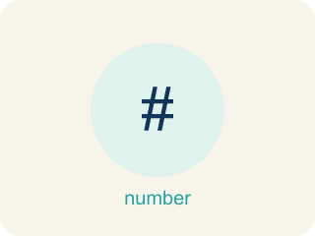
Compare and Order Integers (Comparar y ordenar enteros) — Use a number line to decide which integers are greater or less and place them in order.
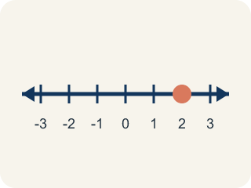
Number line (Recta numérica) — A straight line where numbers are placed in order; numbers get smaller to the left and larger to the right.
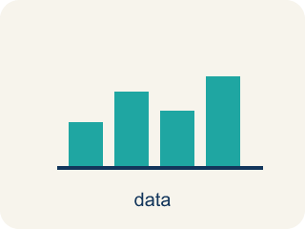
Graph on the Coordinate Plane (Representar en el plano de coordenadas) — Plot a point by moving horizontally to its x-coordinate and vertically to its y-coordinate.
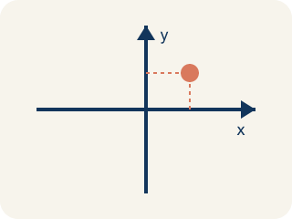
Coordinate plane (Plano cartesiano) — A grid with a line going across and a line going up to plot points.
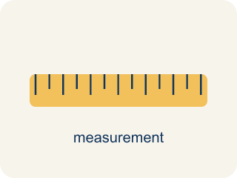
Distance on the Coordinate Plane (Distancia en el plano de coordenadas) — The positive space between points, found from the absolute difference of coordinates on a horizontal or vertical line.
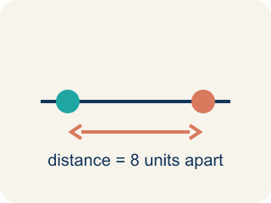
Distance (Distancia) — How far apart two points are. It is never negative.
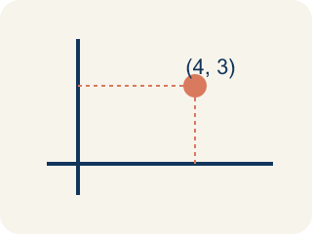
vertex (vértice) — A corner point of a polygon, named by an ordered pair on the coordinate plane.
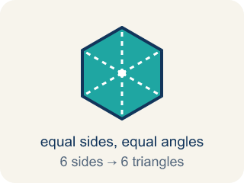
polygon (polígono) — A closed figure made of line segments; on the plane you draw it by plotting the vertices and connecting them in order.

Ordered Pairs in All Four Quadrants (Pares ordenados en los cuatro cuadrantes) — Points written as (x, y) whose positive or negative coordinates place them in one of four quadrants.
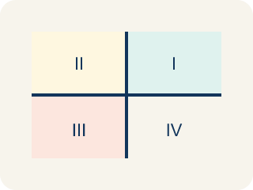
Quadrant (Cuadrante) — One of the four parts of a coordinate grid, numbered I to IV.

Reflect Points Across Axes (Reflejar puntos sobre los ejes) — Flip a point across an axis so it stays the same perpendicular distance from that axis.
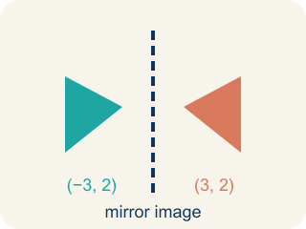
Reflection (Reflexión) — A flipped, mirror image across a line.

Rational Numbers on the Number Line (Números racionales en la recta numérica) — Fractions, decimals, and integers placed by value on a number line.

Rational number (Número racional) — Any number you can write as a fraction. This includes fractions, decimals, and integers.
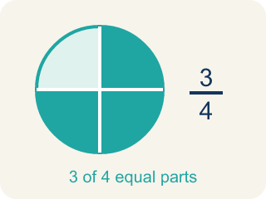
Fraction (Fracción) — A number that shows part of a whole, like 3/4.
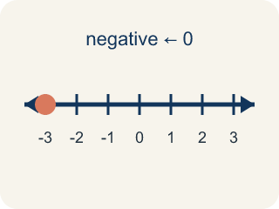
Negative coordinate (Coordenada negativa) — A coordinate less than zero. It means left or below the center point.
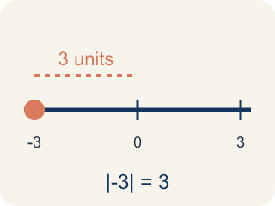
Absolute value (Valor absoluto) — How far a number is from zero. It is never negative.
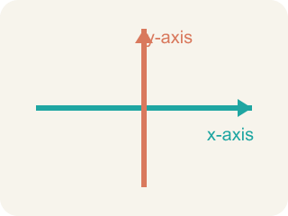
x-axis (Eje x) — The line that goes across the grid. Flipping over it changes the y sign.
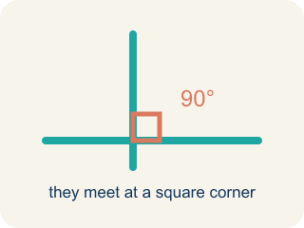
Perpendicular (Perpendicular) — Two lines that meet to make a square corner (90 degrees).

Practice
Show your work. Use the blank space under each problem.
1. (Lesson 7.4) Which statement is TRUE?
A. -3 > -1
B. -5 < -2
C. -4 > 0
D. -1 < -6
______________________________________________________________________
2. (Lesson 7.4) Which integer is the LEAST: -3, 5, -8, 2, 0?
A. -8
B. -3
C. 0
D. 5
______________________________________________________________________
3. (Lesson 7.4) Three cities have temperatures of -12°F, -5°F, and 3°F. Which city is warmest?
A. 3°F
B. -5°F
C. -12°F
D. They are equal
______________________________________________________________________
4. (Lesson 7.4) Spot the Common Mistake
Step 1 (Read): Order -8 and -15 from least to greatest.
Step 2 (Attempt): The student wrote -8, -15, because 8 is smaller than 15.
Step 3 (Check): -15 is farther left than -8 on the number line, so -15 is the least. The correct order is -15, -8.
Which step has the mistake? Explain and fix it:
______________________________________________________________________
______________________________________________________________________
______________________________________________________________________
5. (Lesson 7.5) Spot the Common Mistake
Step 1 (Clue): Plot the point (4, 0).
Step 2 (Move right): Move 4 units to the right along the x-axis. Good.
Step 3 (Move up): Move 4 units up, because the pair has a 4 in it.
Step 4 (Plot the point): Place the dot at (4, 4).
Which step has the mistake? Explain and fix it:
______________________________________________________________________
______________________________________________________________________
______________________________________________________________________
6. (Lesson 7.6) Two points are at (-3, -7) and (-3, 5). What is the distance between them?
A. 12 units
B. 2 units
C. 7 units
D. 8 units
______________________________________________________________________
7. (Lesson 7.6) Spot the Common Mistake
Step 1 (Problem): Find the distance between (-5, 2) and (3, 2).
Step 2 (Student thinking): Both share y = 2, so subtract the x-values: 5 - 3 = 2.
Step 3 (Student answer): The distance is 2 units.
Which step has the mistake? Explain and fix it:
______________________________________________________________________
______________________________________________________________________
______________________________________________________________________
8. (Lesson 7.7) The park's marked vertices are 3 units apart and each unit is 100 feet. What is the park's width?
A. 300 feet
B. 3 feet
C. 103 feet
D. 30 feet
______________________________________________________________________
9. (Lesson 7.7) The park's area must be 240,000 sq ft and its width is 300 ft. What is its length?
A. 800 feet
B. 80,000 feet
C. 720 feet
D. 240,300 feet
______________________________________________________________________
10. (Lesson 7.8) Point A is at (-5, 3). If you move 8 units to the right, what are the new coordinates?
A. (3, 3)
B. (-13, 3)
C. (-5, 11)
D. (-5, -5)
______________________________________________________________________

Answer Key (Teacher)
1. B. -5 < -2
-5 is farther to the left on the number line than -2, so -5 < -2 is true.
Watch for: A common mistake in Reflect Points Across Axes is flipping the sign of the wrong coordinate — changing the x-coordinate when reflecting over the x-axis, instead of the y-coordinate (or vice versa for the y-axis). For example, to reflect (3, -5) over the x-axis, a student might flip the x-coordinate and write (-3, -5), but reflecting over the x-axis only changes the sign of the y-coordinate: (3, -5) becomes (3, 5). Before you submit, ask: 'Did I flip the sign of the coordinate that matches the axis I'm reflecting over — y for the x-axis, x for the y-axis?'
2. A. -8
-8 is farthest to the left on the number line, making it the least (smallest) integer.
Watch for: A common mistake in Reflect Points Across Axes is flipping the sign of the wrong coordinate — changing the x-coordinate when reflecting over the x-axis, instead of the y-coordinate (or vice versa for the y-axis). For example, to reflect (3, -5) over the x-axis, a student might flip the x-coordinate and write (-3, -5), but reflecting over the x-axis only changes the sign of the y-coordinate: (3, -5) becomes (3, 5). Before you submit, ask: 'Did I flip the sign of the coordinate that matches the axis I'm reflecting over — y for the x-axis, x for the y-axis?'
3. A. 3°F
3°F is the greatest because it is farthest to the right on the number line. The order from coldest to warmest is -12, -5, 3.
Watch for: A common mistake in Reflect Points Across Axes is flipping the sign of the wrong coordinate — changing the x-coordinate when reflecting over the x-axis, instead of the y-coordinate (or vice versa for the y-axis). For example, to reflect (3, -5) over the x-axis, a student might flip the x-coordinate and write (-3, -5), but reflecting over the x-axis only changes the sign of the y-coordinate: (3, -5) becomes (3, 5). Before you submit, ask: 'Did I flip the sign of the coordinate that matches the axis I'm reflecting over — y for the x-axis, x for the y-axis?'
4. (Lesson 7.4) Spot the Common Mistake
The mistake is in Step 2.
Correct work: Least to greatest: -15, -8. The more negative a number is, the less its value — so -15 < -8.
Watch for: The reasoning treats -8 and -15 like 8 and 15, so it puts -8 first. On the number line -15 sits farther left than -8, which makes it the smaller value, so least to greatest is -15, -8.
5. (Lesson 7.5) Spot the Common Mistake
The mistake is in Step 3.
Correct work: The y-coordinate is 0, not 4. After moving 4 right, the up move is 0 units, so the point stays on the x-axis at (4, 0). The student reused the x-value instead of reading the second number (0).
Watch for: The up move comes from the SECOND number, and the second number in (4, 0) is 0. Reusing the 4 pushes the point off the axis to (4, 4). With a y-coordinate of 0 there is no upward move at all, so the point stays right on the x-axis at (4, 0).
6. A. 12 units
Same x = -3. Distance = |5 - (-7)| = |5 + 7| = 12 units.
Watch for: A common mistake in Reflect Points Across Axes is flipping the sign of the wrong coordinate — changing the x-coordinate when reflecting over the x-axis, instead of the y-coordinate (or vice versa for the y-axis). For example, to reflect (3, -5) over the x-axis, a student might flip the x-coordinate and write (-3, -5), but reflecting over the x-axis only changes the sign of the y-coordinate: (3, -5) becomes (3, 5). Before you submit, ask: 'Did I flip the sign of the coordinate that matches the axis I'm reflecting over — y for the x-axis, x for the y-axis?'
7. (Lesson 7.6) Spot the Common Mistake
The mistake is in Step 2.
Correct work: The student dropped the negative sign and used 5 instead of -5. The point is at x = -5, so the two points sit on opposite sides of zero. Add the absolute values: |-5| + |3| = 5 + 3 = 8 units. (You can also write |3 - (-5)| = |3 + 5| = 8.) The correct distance is 8 units, not 2.
Watch for: The student-thinking step dropped the negative sign and treated -5 as 5. Because the points really sit on opposite sides of the y-axis, the distance is |-5| + |3| = 8 units, which matches |3 - (-5)| = |3 + 5| = 8.
8. A. 300 feet
3 units × 100 feet per unit = 300 feet.
Watch for: A common mistake in Reflect Points Across Axes is flipping the sign of the wrong coordinate — changing the x-coordinate when reflecting over the x-axis, instead of the y-coordinate (or vice versa for the y-axis). For example, to reflect (3, -5) over the x-axis, a student might flip the x-coordinate and write (-3, -5), but reflecting over the x-axis only changes the sign of the y-coordinate: (3, -5) becomes (3, 5). Before you submit, ask: 'Did I flip the sign of the coordinate that matches the axis I'm reflecting over — y for the x-axis, x for the y-axis?'
9. A. 800 feet
Length = area ÷ width = 240,000 ÷ 300 = 800 feet.
Watch for: A common mistake in Reflect Points Across Axes is flipping the sign of the wrong coordinate — changing the x-coordinate when reflecting over the x-axis, instead of the y-coordinate (or vice versa for the y-axis). For example, to reflect (3, -5) over the x-axis, a student might flip the x-coordinate and write (-3, -5), but reflecting over the x-axis only changes the sign of the y-coordinate: (3, -5) becomes (3, 5). Before you submit, ask: 'Did I flip the sign of the coordinate that matches the axis I'm reflecting over — y for the x-axis, x for the y-axis?'
10. A. (3, 3)
Moving right means adding to the x-coordinate: -5 + 8 = 3. The y stays the same. New point: (3, 3).
Watch for: A common mistake in Reflect Points Across Axes is flipping the sign of the wrong coordinate — changing the x-coordinate when reflecting over the x-axis, instead of the y-coordinate (or vice versa for the y-axis). For example, to reflect (3, -5) over the x-axis, a student might flip the x-coordinate and write (-3, -5), but reflecting over the x-axis only changes the sign of the y-coordinate: (3, -5) becomes (3, 5). Before you submit, ask: 'Did I flip the sign of the coordinate that matches the axis I'm reflecting over — y for the x-axis, x for the y-axis?'

