7.9 Small Group · Group 1 — Homework
Lesson 7-9-group1 • Standard 6.NOS.7
Name: ______________________ Period: ______ Date: ____________

Today's Goals
Content: With my small group, I can reflect points across the x-axis and y-axis on the coordinate plane — one step at a time, with support.
Language: I can talk through each step out loud using a sentence frame and the lesson's key words.

Key Words
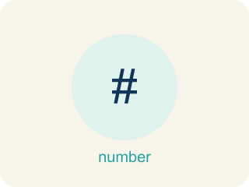
Reflect Points Across Axes (Reflejar puntos sobre los ejes) — Flip a point across an axis so it stays the same perpendicular distance from that axis.
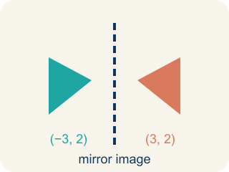
Reflection (Reflexión) — A flipped, mirror image across a line.
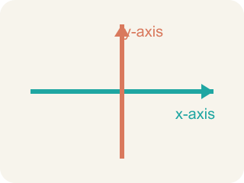
x-axis (Eje x) — The line that goes across the grid. Flipping over it changes the y sign.

y-axis (Eje y) — The line that goes up the grid. Flipping over it changes the x sign.
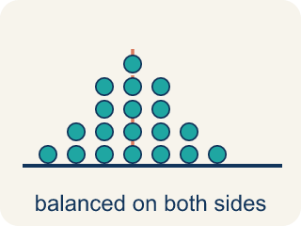
Symmetry (Simetría) — When a shape looks the same on both sides of a line.
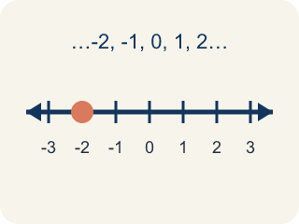
Integer (Número entero) — Whole numbers and their opposites, like -2, -1, 0, 1, 2.
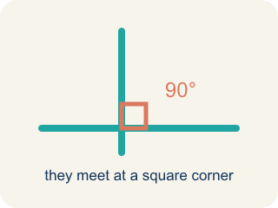
Perpendicular (Perpendicular) — Two lines that meet to make a square corner (90 degrees).

Practice
Show your work. Use the blank space under each problem.
1. What is the reflection of (4, -3) over the x-axis?
A. (-4, -3)
B. (4, 3)
C. (-4, 3)
D. (3, -4)
______________________________________________________________________
2. What is the reflection of (-2, 6) over the y-axis?
A. (2, 6)
B. (-2, -6)
C. (2, -6)
D. (6, -2)
______________________________________________________________________
3. A buried chest is marked at (-5, 3). Vega folds the map along the y-axis to find its mirror twin. Where is the twin?
A. (5, 3)
B. (-5, -3)
C. (5, -3)
D. (3, -5)
______________________________________________________________________
4. Vega reflects a palm-tree marker at (8, -6) across the x-axis. Which coordinate changes its sign?
A. The y-coordinate
B. The x-coordinate
C. Both coordinates
D. Neither coordinate
______________________________________________________________________
5. Level 2 Extension — Vega's Fold Mix-Up
Step 1 (Problem): Reflect the marker (6, 4) across the x-axis.
Step 2 (Step 1): The x-axis is the fold line, so flip the sign of the x-coordinate.
Step 3 (Step 2): Change 6 to -6 and keep y as 4.
Step 4 (Answer): (-6, 4)
Which step has the mistake? Explain and fix it:
______________________________________________________________________
______________________________________________________________________
______________________________________________________________________
6. Find the Reflection Error
Step 1 (Problem): Reflect (-3, 5) over the y-axis
Step 2 (Student thinking): The y-axis is vertical, so I change the y-coordinate
Step 3 (Student answer): (-3, -5)
Which step has the mistake? Explain and fix it:
______________________________________________________________________
______________________________________________________________________
______________________________________________________________________
7. A triangle has vertices at A(1, 2), B(4, 2), and C(4, 6). If you reflect the entire triangle over the y-axis, what are the new vertices? What do you notice about the size and shape of the reflected triangle compared to the original?
Sentence starter: The reflected vertices are A'(___), B'(___), C'(___). I found each by ___. The reflected triangle is ___ compared to the original because reflections ___.
______________________________________________________________________
______________________________________________________________________
______________________________________________________________________
______________________________________________________________________
8. Match each point and axis to its reflection.
Item | Answer choices
____ (2, 5) over y-axis | F. (6, 3)
____ (-3, 1) over y-axis | E. (5, -2)
____ (4, -6) over x-axis | D. (-1, 4)
____ (-1, -4) over x-axis | C. (4, 6)
____ (5, 2) over x-axis | B. (3, 1)
____ (-6, 3) over y-axis | A. (-2, 5)
______________________________________________________________________

Answer Key (Teacher)
1. B. (4, 3)
Reflecting over the x-axis changes the sign of the y-coordinate. The x stays the same (4), and the y changes from -3 to 3. The answer is (4, 3).
Watch for: A common mistake in Reflect Points Across Axes is flipping the sign of the wrong coordinate — changing the x-coordinate when reflecting over the x-axis, instead of the y-coordinate (or vice versa for the y-axis). For example, to reflect (3, -5) over the x-axis, a student might flip the x-coordinate and write (-3, -5), but reflecting over the x-axis only changes the sign of the y-coordinate: (3, -5) becomes (3, 5). Before you submit, ask: 'Did I flip the sign of the coordinate that matches the axis I'm reflecting over — y for the x-axis, x for the y-axis?'
2. A. (2, 6)
Reflecting over the y-axis changes the sign of the x-coordinate. x goes from -2 to 2, and y stays 6. The answer is (2, 6).
Watch for: A common mistake in Reflect Points Across Axes is flipping the sign of the wrong coordinate — changing the x-coordinate when reflecting over the x-axis, instead of the y-coordinate (or vice versa for the y-axis). For example, to reflect (3, -5) over the x-axis, a student might flip the x-coordinate and write (-3, -5), but reflecting over the x-axis only changes the sign of the y-coordinate: (3, -5) becomes (3, 5). Before you submit, ask: 'Did I flip the sign of the coordinate that matches the axis I'm reflecting over — y for the x-axis, x for the y-axis?'
3. A. (5, 3)
Reflecting across the y-axis flips the sign of the x-coordinate only. (-5, 3) becomes (5, 3).
Watch for: A common mistake in Reflect Points Across Axes is flipping the sign of the wrong coordinate — changing the x-coordinate when reflecting over the x-axis, instead of the y-coordinate (or vice versa for the y-axis). For example, to reflect (3, -5) over the x-axis, a student might flip the x-coordinate and write (-3, -5), but reflecting over the x-axis only changes the sign of the y-coordinate: (3, -5) becomes (3, 5). Before you submit, ask: 'Did I flip the sign of the coordinate that matches the axis I'm reflecting over — y for the x-axis, x for the y-axis?'
4. A. The y-coordinate
Across the x-axis the rule is (x, y) -> (x, -y), so only the y-coordinate flips sign. (8, -6) becomes (8, 6).
Watch for: A common mistake in Reflect Points Across Axes is flipping the sign of the wrong coordinate — changing the x-coordinate when reflecting over the x-axis, instead of the y-coordinate (or vice versa for the y-axis). For example, to reflect (3, -5) over the x-axis, a student might flip the x-coordinate and write (-3, -5), but reflecting over the x-axis only changes the sign of the y-coordinate: (3, -5) becomes (3, 5). Before you submit, ask: 'Did I flip the sign of the coordinate that matches the axis I'm reflecting over — y for the x-axis, x for the y-axis?'
5. Level 2 Extension — Vega's Fold Mix-Up
The mistake is in Step 2.
Correct work: Reflecting across the x-axis follows the rule (x, y) -> (x, -y): keep the x-coordinate and flip the y-coordinate. Vega flipped the x instead of the y. The correct mirror image of (6, 4) is (6, -4).
Watch for: Step 1 says to flip the x-coordinate for an x-axis fold, but the axis you fold over is the one whose coordinate stays put. The rule is (x, y) → (x, -y), so the marker (6, 4) mirrors to (6, -4), landing straight below the original.
6. Find the Reflection Error
The mistake is in Step 2.
Correct work: Reflecting over the y-axis changes the x-coordinate, not the y-coordinate. The correct reflection of (-3, 5) over the y-axis is (3, 5). The student confused which coordinate changes for each axis.
Watch for: The student's thinking step says the vertical y-axis changes the y-coordinate, but the axis name tells you which coordinate stays the same. Over the y-axis the rule is (x, y) → (-x, y), so (-3, 5) reflects to (3, 5), not (-3, -5).
7. Open response — answers will vary.
Look for key words: reflection, y-axis, x-coordinate, opposite, congruent, same size, same shape, mirror.
8. Matches:
(2, 5) over y-axis → (-2, 5)
(-3, 1) over y-axis → (3, 1)
(4, -6) over x-axis → (4, 6)
(-1, -4) over x-axis → (-1, 4)
(5, 2) over x-axis → (5, -2)
(-6, 3) over y-axis → (6, 3)

