7.9 Small Group · Group 2 — Homework
Lesson 7-9-group2 • Standard 6.NOS.7
Name: ______________________ Period: ______ Date: ____________

Today's Goals
Content: I can reflect points across the x-axis and y-axis on the coordinate plane, explain why the method works, and use it on a problem I have not seen before.
Language: I can justify my answer to a skeptic and connect it to a second strategy or representation.

Key Words
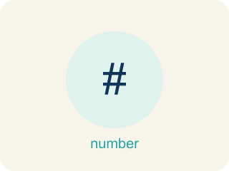
Reflect Points Across Axes (Reflejar puntos sobre los ejes) — Flip a point across an axis so it stays the same perpendicular distance from that axis.
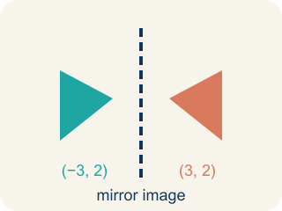
Reflection (Reflexión) — A flipped, mirror image across a line.
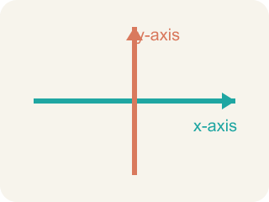
x-axis (Eje x) — The line that goes across the grid. Flipping over it changes the y sign.

y-axis (Eje y) — The line that goes up the grid. Flipping over it changes the x sign.
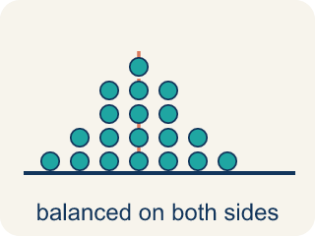
Symmetry (Simetría) — When a shape looks the same on both sides of a line.
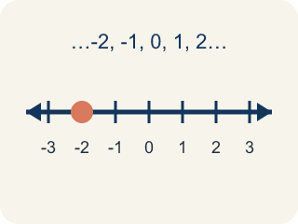
Integer (Número entero) — Whole numbers and their opposites, like -2, -1, 0, 1, 2.
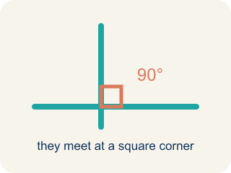
Perpendicular (Perpendicular) — Two lines that meet to make a square corner (90 degrees).

Practice
Show your work. Use the blank space under each problem.
1. Point A is at (-3, 5). It is reflected over the x-axis to A', then A' is reflected over the y-axis to A''. What are the coordinates of A''?
A. (3, -5)
B. (-3, -5)
C. (3, 5)
D. (-3, 5)
______________________________________________________________________
2. Spot the Common Mistake
Step 1 (Problem): Reflect the point (-3, -8) over the x-axis.
Step 2 (Attempt): Both coordinates are negative, so I will flip the x-coordinate: -3 becomes 3. The answer is (3, -8).
Step 3 (Check): Folding over the horizontal x-axis should send the point up across the axis, but this answer kept it below the axis.
Which step has the mistake? Explain and fix it:
______________________________________________________________________
______________________________________________________________________
______________________________________________________________________
3. Find the Reflection Error
Step 1 (Problem): Reflect (-3, 5) over the y-axis
Step 2 (Student thinking): The y-axis is vertical, so I change the y-coordinate
Step 3 (Student answer): (-3, -5)
Which step has the mistake? Explain and fix it:
______________________________________________________________________
______________________________________________________________________
______________________________________________________________________
4. A triangle has vertices at A(1, 2), B(4, 2), and C(4, 6). If you reflect the entire triangle over the y-axis, what are the new vertices? What do you notice about the size and shape of the reflected triangle compared to the original?
Sentence starter: The reflected vertices are A'(___), B'(___), C'(___). I found each by ___. The reflected triangle is ___ compared to the original because reflections ___.
______________________________________________________________________
______________________________________________________________________
______________________________________________________________________
______________________________________________________________________

Answer Key (Teacher)
1. A. (3, -5)
Over x-axis: (-3, 5) → (-3, -5). Then over y-axis: (-3, -5) → (3, -5). Both coordinates changed sign.
Watch for: A common mistake in Reflect Points Across Axes is flipping the sign of the wrong coordinate — changing the x-coordinate when reflecting over the x-axis, instead of the y-coordinate (or vice versa for the y-axis). For example, to reflect (3, -5) over the x-axis, a student might flip the x-coordinate and write (-3, -5), but reflecting over the x-axis only changes the sign of the y-coordinate: (3, -5) becomes (3, 5). Before you submit, ask: 'Did I flip the sign of the coordinate that matches the axis I'm reflecting over — y for the x-axis, x for the y-axis?'
2. Spot the Common Mistake
The mistake is in Step 2.
Correct work: Reflecting over the x-axis changes the y-coordinate, not the x-coordinate. The rule is (x, y) -> (x, -y). For (-3, -8), keep x as -3 and flip y: -8 becomes 8. The correct reflection is (-3, 8), not (3, -8). The negative signs do not change which coordinate flips — the axis does.
Watch for: The Attempt step flips the x-coordinate because both numbers are negative, but the signs of the coordinates never decide which one flips — the axis does. Over the x-axis the rule is (x, y) → (x, -y), so (-3, -8) reflects to (-3, 8), moving up across the horizontal axis.
3. Find the Reflection Error
The mistake is in Step 2.
Correct work: Reflecting over the y-axis changes the x-coordinate, not the y-coordinate. The correct reflection of (-3, 5) over the y-axis is (3, 5). The student confused which coordinate changes for each axis.
Watch for: The student's thinking step says the vertical y-axis changes the y-coordinate, but the axis name tells you which coordinate stays the same. Over the y-axis the rule is (x, y) → (-x, y), so (-3, 5) reflects to (3, 5), not (-3, -5).
4. Open response — answers will vary.
Look for key words: reflection, y-axis, x-coordinate, opposite, congruent, same size, same shape, mirror.

