UNIT 7 · LESSON 9 STANDARD 6.NOS.7

Reflect Points Across Axes
Student Notes Packet
Name: ______________________ Date: ____________ Period: ________

Today's Goals
Content: I can reflect points across the x-axis and y-axis on the coordinate plane.
Language: I can explain my work using the words reflection, x-axis, y-axis, and symmetry.

Key Vocabulary
Look at the picture, read the word, then read what it means.
 | Reflect Points Across Axes Reflejar puntos sobre los ejes  Flip a point across an axis so it stays the same perpendicular distance from that axis.  Example: Across the x-axis: (3, 2) → (3, −2).
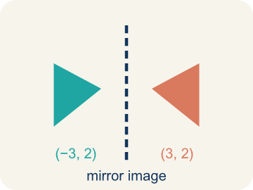 | Reflection Reflexión  A flipped, mirror image across a line.  Example: (3, 2) reflected over the y-axis becomes (-3, 2) — x changes sign, y stays
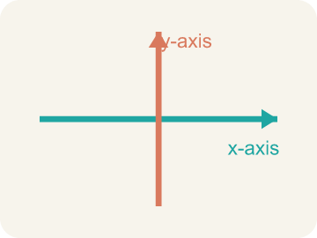 | x-axis Eje x  The line that goes across the grid. Flipping over it changes the y sign.  Example: (4, 3) → (4, -3): the y flips from +3 to -3, like folding the paper along the horizontal line
 | y-axis Eje y  The line that goes up the grid. Flipping over it changes the x sign.  Example: (4, 3) → (-4, 3): the x flips from +4 to -4, like folding the paper along the vertical line
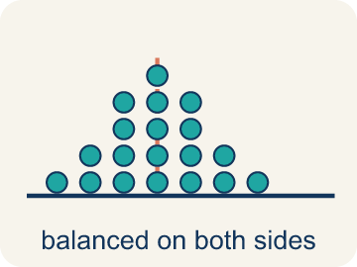 | Symmetry Simetría  When a shape looks the same on both sides of a line.  Example: A butterfly's wings are symmetric — fold it down the middle and both sides match
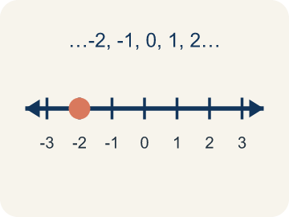 | Integer Número entero  Whole numbers and their opposites, like -2, -1, 0, 1, 2.  Example: ..., -3, -2, -1, 0, 1, 2, 3, ...
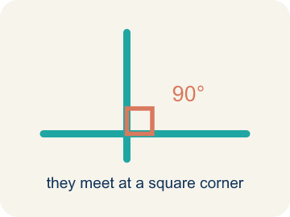 | Perpendicular Perpendicular  Two lines that meet to make a square corner (90 degrees).  Example: The dashed height meets the base at a square corner — the small 90° box is what makes it perpendicular, not slanted.

Guided Notes
Fill in each blank as we go. Use the Word Bank to help you.
WORD BANK
Reflect Points Across Axes • Reflection • x-axis • y-axis • Symmetry • Integer • Perpendicular

1. __________ — Flip a point across an axis so it stays the same perpendicular distance from that axis.
2. A flip of a point or shape over an axis to make a mirror image is a ___.
3. The horizontal number line on the coordinate plane is the ___.
4. The vertical number line on the coordinate plane is the ___.
5. When two halves are mirror images of each other, the figure has ___.
6. A whole number or its opposite, with no fraction part, is an ___.
7. Two lines that meet at a 90° square corner are ___.

Write About the Math
Use the support level you need. Every level answers the same math question.

1. Understand the Question explain
How do reflections help the game designer create a balanced, symmetric level?
Your job: Answer the question. Use math evidence. Explain how the evidence proves your answer.
Responde la pregunta. Usa evidencia matemática. Explica cómo la evidencia demuestra tu respuesta.

2. Plan Your Math Words check at least two
☐ Reflect Points Across Axes — Flip a point across an axis so it stays the same perpendicular distance from that axis.
Reflejar puntos sobre los ejes — Voltear un punto sobre un eje para que quede a la misma distancia perpendicular de ese eje.
☐ Reflection — A flipped, mirror image across a line.
Reflexión — Una imagen reflejada al otro lado de una línea.
☐ x-axis — The line that goes across the grid. Flipping over it changes the y sign.
Eje x — La línea que va de lado en la cuadrícula. Voltear sobre ella cambia el signo de y.
☐ y-axis — The line that goes up the grid. Flipping over it changes the x sign.
Eje y — La línea que va hacia arriba en la cuadrícula. Voltear sobre ella cambia el signo de x.
☐ Symmetry — When a shape looks the same on both sides of a line.
Simetría — Cuando una figura se ve igual a ambos lados de una línea.
Say it first: Say your idea to a partner or quietly to yourself before you write.
The enemy reflected over the y-axis is at ___ because ___. The enemy reflected over the x-axis is at ___ because ___. Reflections help game designers because ___.
Di tu respuesta primero: Mi respuesta es ___ porque ___.

3. Build Your Explanation choose your support
This model shows the parts of an explanation. It does not answer your writing question.
Claim: Reflecting over the y-axis changes the ___ coordinate because ___.
Evidence: Student states reflecting over the y-axis flips the sign of the x-coordinate while the y-coordinate stays the same, so (3,2) becomes (-3,2).
Reasoning: This evidence connects the definition of reflect points across axes to the mathematical claim.

Start Most language support
Complete the frames. Use the word bank.
Completa las oraciones. Usa el banco de palabras.
The enemy reflected over the y-axis is at ___ because ___. The enemy reflected over the x-axis is at ___ because ___. Reflections help game designers because ___.
My answer is ___.
Mi respuesta es ___.

Build Some language support
Write two connected sentences. Use because, so, or but.
Escribe dos oraciones conectadas. Usa porque, entonces o pero.
My claim is ___.
Mi afirmación es ___.
I know because ___.
Lo sé porque ___.
So ___.
Entonces ___.

Explain Light language support
Write a claim, give math evidence, and explain your reasoning.
Escribe una afirmación, da evidencia matemática y explica tu razonamiento.
My claim is ___.
Mi afirmación es ___.
My math evidence is ___.
Mi evidencia matemática es ___.
This proves ___ because ___.
Esto demuestra ___ porque ___.

4. Check Your Explanation five quick checks
☐ I answered the question.
Respondí la pregunta.
☐ I used math evidence: numbers, an equation, a model, or a comparison.
Usé evidencia matemática: números, una ecuación, un modelo o una comparación.
☐ I explained how the evidence proves my answer.
Expliqué cómo la evidencia demuestra mi respuesta.
☐ I used at least two math words.
Usé por lo menos dos palabras matemáticas.
☐ I reread complete sentences and punctuation.
Volví a leer mis oraciones completas y la puntuación.

Worked Example

Watch & Read I Do — follow along with your teacher
Mirror Images on the Map
Captain Vega discovers that her treasure map has a magic mirror trick! When she folds the map along the x-axis, some clues match up perfectly with clues on the other side. For example, a marker at (2, 4) has a matching marker at (2, -4) when reflected over the x-axis. Another pair reflects over the y-axis: (5, 3) and (-5, 3). How does reflection change the coordinates?

Think about:
• When (2, 4) reflects over the x-axis to (2, -4), which coordinate changed?
• When (5, 3) reflects over the y-axis to (-5, 3), which coordinate changed?
• What stays the same in each reflection?
• What happens if you reflect a point over BOTH axes?
• Can a point be its own reflection?

Solved Example I Do — watch each step
Problem: What is the reflection of (4, -3) over the x-axis?
A) (-4, -3)
B) (4, 3)
C) (-4, 3)
D) (3, -4)
Step 1: Reflecting over the x-axis changes the sign of the y-coordinate.
Step 2: The x stays the same (4), and the y changes from -3 to 3.
Step 3: The answer is (4, 3).
Answer: B. (4, 3)

Guided Practice

Solve Together We Do — work with your class
Problem: What is the reflection of (-2, 6) over the y-axis?
A) (2, 6)
B) (-2, -6)
C) (2, -6)
D) (6, -2)
Step 1:

Step 2:

Step 3:

Answer:

A game designer creates a spaceship at (3, 2) and wants to place enemy ships as reflections to make the level symmetric. One enemy is reflected over the y-axis, and another is reflected over the x-axis.
How do reflections help the game designer create a balanced, symmetric level?

Sentence frame: The enemy reflected over the y-axis is at ___ because ___. The enemy reflected over the x-axis is at ___ because ___. Reflections help game designers because ___.

Turn & Talk discuss with a partner
1. [Launch] When you reflect the point (3, 2) over the y-axis, which coordinate changes its sign and which stays the same? Why?
Start with: The ___ coordinate changes sign.
La coordenada ___ cambia de signo.
Word bank: reflection, x-axis, y-axis, ordered pair, coordinate plane
2. [Explore] Reflect (4, -5) over the x-axis. Talk through how the coordinates change and where the new point lands.
Start with: Over the x-axis, the ___ coordinate flips sign.
Sobre el eje x, la coordenada ___ cambia de signo.
Word bank: reflection, x-axis, y-axis, ordered pair, coordinate plane
3. [Connect] How is reflecting a point over an axis like looking at it in a mirror placed on that axis?
Start with: The axis acts like the ___.
El eje actua como el ___.
Word bank: reflection, x-axis, y-axis, coordinate plane, ordered pair
4. [Reflect] A classmate reflected (2, 3) over the x-axis and got (-2, 3). What did they do wrong, and what is the correct image?
Start with: Over the x-axis, they should have changed the ___ coordinate.
Sobre el eje x, debieron cambiar la coordenada ___.
Word bank: reflection, x-axis, y-axis, ordered pair, coordinate plane
5. [Practice] During practice on Reflect Points Across Axes, what strategy did you use when a problem felt tricky?
Start with: Over the x-axis, the ___ coordinate flips sign.
Sobre el eje x, la coordenada ___ cambia de signo.
Word bank: Reflection, x-axis, y-axis, Symmetry

Independent Practice

On Your Own You Do — show your work
Solve each problem. Show your thinking in the work box.

Level 1 Support extra scaffolding
1. Which point is on the y-axis?
A) (0, 5)
B) (5, 0)
C) (3, 3)
D) (-2, 4)

On Level grade-level practice
2. Point A is at (-3, 5). It is reflected over the x-axis to A', then A' is reflected over the y-axis to A''. What are the coordinates of A''?
A) (3, -5)
B) (-3, -5)
C) (3, 5)
D) (-3, 5)

Exit Ticket
Answer on your own. This shows what you learned today.
★ What is the reflection of (-5, 2) over the y-axis?
A) (-5, -2)
B) (5, -2)
C) (5, 2)
D) (2, -5)

