Reflect Points Across Axes — Homework
Lesson 7-9 • Standard 6.NOS.7
Name: ______________________ Period: ______ Date: ____________

Today's Goals
Content: I can reflect points across the x-axis and y-axis on the coordinate plane.
Language: I can explain my work using the words reflection, x-axis, y-axis, and symmetry.

Key Words
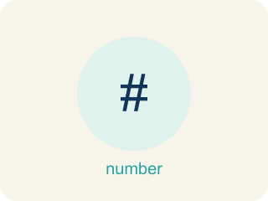
Reflect Points Across Axes (Reflejar puntos sobre los ejes) — Flip a point across an axis so it stays the same perpendicular distance from that axis.
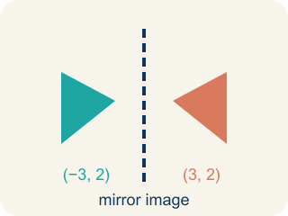
Reflection (Reflexión) — A flipped, mirror image across a line.
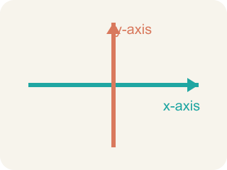
x-axis (Eje x) — The line that goes across the grid. Flipping over it changes the y sign.

y-axis (Eje y) — The line that goes up the grid. Flipping over it changes the x sign.
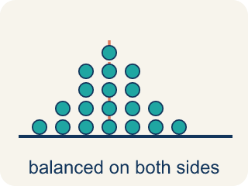
Symmetry (Simetría) — When a shape looks the same on both sides of a line.
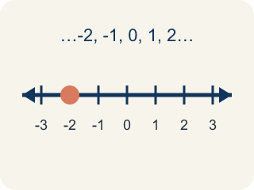
Integer (Número entero) — Whole numbers and their opposites, like -2, -1, 0, 1, 2.
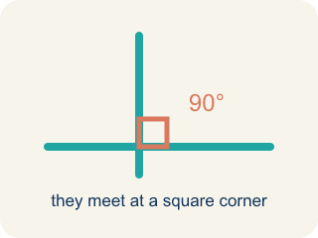
Perpendicular (Perpendicular) — Two lines that meet to make a square corner (90 degrees).

Practice
Show your work. Use the blank space under each problem.
1. What is the reflection of (4, -3) over the x-axis?
A. (-4, -3)
B. (4, 3)
C. (-4, 3)
D. (3, -4)
______________________________________________________________________
2. What is the reflection of (-2, 6) over the y-axis?
A. (2, 6)
B. (-2, -6)
C. (2, -6)
D. (6, -2)
______________________________________________________________________
3. Find the reflection of each point over the given axis.
Original Point | Axis | Reflected Point
(3, -7) | x-axis
(-5, 2) | y-axis
(8, -1) | x-axis
(-4, -6) | y-axis
(0, 9) | x-axis
(-3, 0) | y-axis
______________________________________________________________________
4. Match each reflection rule to its description.
Item | Answer choices
____ Over x-axis | F. Reflects to itself over any axis
____ Over y-axis | E. Reflects to itself over y-axis
____ Over both axes | D. Reflects to itself over x-axis
____ Point on x-axis | C. Both coordinates change sign
____ Point on y-axis | B. x-coordinate changes sign
____ (0, 0) | A. y-coordinate changes sign
______________________________________________________________________
5. Point A is at (-3, 5). It is reflected over the x-axis to A', then A' is reflected over the y-axis to A''. What are the coordinates of A''?
A. (3, -5)
B. (-3, -5)
C. (3, 5)
D. (-3, 5)
______________________________________________________________________
6. Spot the Common Mistake
Step 1 (Problem): Reflect the point (-3, -8) over the x-axis.
Step 2 (Attempt): Both coordinates are negative, so I will flip the x-coordinate: -3 becomes 3. The answer is (3, -8).
Step 3 (Check): Folding over the horizontal x-axis should send the point up across the axis, but this answer kept it below the axis.
Which step has the mistake? Explain and fix it:
______________________________________________________________________
______________________________________________________________________
______________________________________________________________________
7. Captain Vega folds the map along the x-axis. A marker at (7, 2) lands on its mirror image. What are the new coordinates?
A. (7, -2)
B. (-7, 2)
C. (-7, -2)
D. (2, 7)
______________________________________________________________________
8. A buried chest is marked at (-5, 3). Vega folds the map along the y-axis to find its mirror twin. Where is the twin?
A. (5, 3)
B. (-5, -3)
C. (5, -3)
D. (3, -5)
______________________________________________________________________
9. Vega reflects a palm-tree marker at (8, -6) across the x-axis. Which coordinate changes its sign?
A. The y-coordinate
B. The x-coordinate
C. Both coordinates
D. Neither coordinate
______________________________________________________________________
10. Match each map marker and fold line to its mirror image.
Item | Answer choices
____ (1, 7) folded over x-axis | D. (1, -6)
____ (-8, 2) folded over y-axis | C. (9, 3)
____ (9, -3) folded over x-axis | B. (8, 2)
____ (-1, -6) folded over y-axis | A. (1, -7)
______________________________________________________________________

Answer Key (Teacher)
1. B. (4, 3)
Reflecting over the x-axis changes the sign of the y-coordinate. The x stays the same (4), and the y changes from -3 to 3. The answer is (4, 3).
Watch for: A common mistake in Reflect Points Across Axes is flipping the sign of the wrong coordinate — changing the x-coordinate when reflecting over the x-axis, instead of the y-coordinate (or vice versa for the y-axis). For example, to reflect (3, -5) over the x-axis, a student might flip the x-coordinate and write (-3, -5), but reflecting over the x-axis only changes the sign of the y-coordinate: (3, -5) becomes (3, 5). Before you submit, ask: 'Did I flip the sign of the coordinate that matches the axis I'm reflecting over — y for the x-axis, x for the y-axis?'
2. A. (2, 6)
Reflecting over the y-axis changes the sign of the x-coordinate. x goes from -2 to 2, and y stays 6. The answer is (2, 6).
Watch for: A common mistake in Reflect Points Across Axes is flipping the sign of the wrong coordinate — changing the x-coordinate when reflecting over the x-axis, instead of the y-coordinate (or vice versa for the y-axis). For example, to reflect (3, -5) over the x-axis, a student might flip the x-coordinate and write (-3, -5), but reflecting over the x-axis only changes the sign of the y-coordinate: (3, -5) becomes (3, 5). Before you submit, ask: 'Did I flip the sign of the coordinate that matches the axis I'm reflecting over — y for the x-axis, x for the y-axis?'
3. Find the reflection of each point over the given axis.
(3, -7) — Reflected Point: (3, 7)
(-5, 2) — Reflected Point: (5, 2)
(8, -1) — Reflected Point: (8, 1)
(-4, -6) — Reflected Point: (4, -6)
(0, 9) — Reflected Point: (0, -9)
(-3, 0) — Reflected Point: (3, 0)

4. Matches:
Over x-axis → y-coordinate changes sign
Over y-axis → x-coordinate changes sign
Over both axes → Both coordinates change sign
Point on x-axis → Reflects to itself over x-axis
Point on y-axis → Reflects to itself over y-axis
(0, 0) → Reflects to itself over any axis

5. A. (3, -5)
Over x-axis: (-3, 5) → (-3, -5). Then over y-axis: (-3, -5) → (3, -5). Both coordinates changed sign.
Watch for: A common mistake in Reflect Points Across Axes is flipping the sign of the wrong coordinate — changing the x-coordinate when reflecting over the x-axis, instead of the y-coordinate (or vice versa for the y-axis). For example, to reflect (3, -5) over the x-axis, a student might flip the x-coordinate and write (-3, -5), but reflecting over the x-axis only changes the sign of the y-coordinate: (3, -5) becomes (3, 5). Before you submit, ask: 'Did I flip the sign of the coordinate that matches the axis I'm reflecting over — y for the x-axis, x for the y-axis?'
6. Spot the Common Mistake
The mistake is in Step 2.
Correct work: Reflecting over the x-axis changes the y-coordinate, not the x-coordinate. The rule is (x, y) -> (x, -y). For (-3, -8), keep x as -3 and flip y: -8 becomes 8. The correct reflection is (-3, 8), not (3, -8). The negative signs do not change which coordinate flips — the axis does.
Watch for: The Attempt step flips the x-coordinate because both numbers are negative, but the signs of the coordinates never decide which one flips — the axis does. Over the x-axis the rule is (x, y) → (x, -y), so (-3, -8) reflects to (-3, 8), moving up across the horizontal axis.
7. A. (7, -2)
Folding along (reflecting across) the x-axis flips the sign of the y-coordinate only. (7, 2) becomes (7, -2).
Watch for: A common mistake in Reflect Points Across Axes is flipping the sign of the wrong coordinate — changing the x-coordinate when reflecting over the x-axis, instead of the y-coordinate (or vice versa for the y-axis). For example, to reflect (3, -5) over the x-axis, a student might flip the x-coordinate and write (-3, -5), but reflecting over the x-axis only changes the sign of the y-coordinate: (3, -5) becomes (3, 5). Before you submit, ask: 'Did I flip the sign of the coordinate that matches the axis I'm reflecting over — y for the x-axis, x for the y-axis?'
8. A. (5, 3)
Reflecting across the y-axis flips the sign of the x-coordinate only. (-5, 3) becomes (5, 3).
Watch for: A common mistake in Reflect Points Across Axes is flipping the sign of the wrong coordinate — changing the x-coordinate when reflecting over the x-axis, instead of the y-coordinate (or vice versa for the y-axis). For example, to reflect (3, -5) over the x-axis, a student might flip the x-coordinate and write (-3, -5), but reflecting over the x-axis only changes the sign of the y-coordinate: (3, -5) becomes (3, 5). Before you submit, ask: 'Did I flip the sign of the coordinate that matches the axis I'm reflecting over — y for the x-axis, x for the y-axis?'
9. A. The y-coordinate
Across the x-axis the rule is (x, y) -> (x, -y), so only the y-coordinate flips sign. (8, -6) becomes (8, 6).
Watch for: A common mistake in Reflect Points Across Axes is flipping the sign of the wrong coordinate — changing the x-coordinate when reflecting over the x-axis, instead of the y-coordinate (or vice versa for the y-axis). For example, to reflect (3, -5) over the x-axis, a student might flip the x-coordinate and write (-3, -5), but reflecting over the x-axis only changes the sign of the y-coordinate: (3, -5) becomes (3, 5). Before you submit, ask: 'Did I flip the sign of the coordinate that matches the axis I'm reflecting over — y for the x-axis, x for the y-axis?'
10. Matches:
(1, 7) folded over x-axis → (1, -7)
(-8, 2) folded over y-axis → (8, 2)
(9, -3) folded over x-axis → (9, 3)
(-1, -6) folded over y-axis → (1, -6)

