8.1 Small Group · Group 1 — Homework
Lesson 8-1-group1 • Standard 6.AT.8
Name: ______________________ Period: ______ Date: ____________

Today's Goals
Content: With my small group, I can write an equation to represent a real-world situation — one step at a time, with support.
Language: I can talk through each step out loud using a sentence frame and the lesson's key words.

Key Words
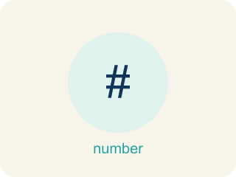
Write Equations (Escribir ecuaciones) — Represent a relationship with expressions joined by an equal sign.
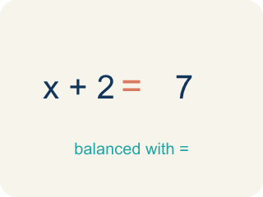
Equation (Ecuación) — A math sentence with an equal sign showing both sides are the same.
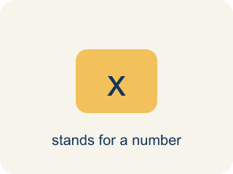
Variable (Variable) — A letter that stands for a number that is unknown or can change.

Equal sign (Signo igual) — The = sign, showing both sides are the same.
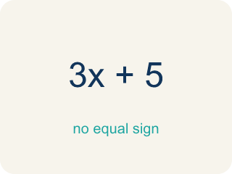
Expression (Expresión) — A math phrase with numbers and letters, but no equal sign.
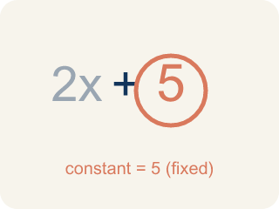
Constant (Constante) — A fixed number in an expression or equation that does not change.

Unknown (Incógnita) — The value you are trying to find, usually shown with a variable.

Practice
Show your work. Use the blank space under each problem.
1. Which equation represents: 'A number plus 12 equals 30'?
A. n + 12 = 30
B. n − 12 = 30
C. 12n = 30
D. n / 12 = 30
______________________________________________________________________
2. Which equation represents: 'Seven less than a number is 18'?
A. n − 7 = 18
B. 7 − n = 18
C. n + 7 = 18
D. n / 7 = 18
______________________________________________________________________
3. Crack the Equation Error
Step 1 (Clue): A number of case files divided by 3 equals 6.
Step 2 (Choose a variable): Let n be the number of case files.
Step 3 (Write the equation): 3n = 6
Which step has the mistake? Explain and fix it:
______________________________________________________________________
______________________________________________________________________
______________________________________________________________________
4. A witness statement reads: 'A number c of security cameras plus 6 more equals 19.' Which equation matches?
A. c + 6 = 19
B. 6c = 19
C. c − 6 = 19
D. c / 6 = 19
______________________________________________________________________
5. The lab tech says: '5 times the number of evidence bags b equals 35.' Which equation represents this clue?
A. 5b = 35
B. b + 5 = 35
C. b − 5 = 35
D. b / 5 = 35
______________________________________________________________________
6. A torn note reads: 'A suspect's case minutes m, after 9 fewer, leaves 24.' Which equation fits?
A. m − 9 = 24
B. m + 9 = 24
C. 9m = 24
D. m / 9 = 24
______________________________________________________________________
7. Level 2 Extension — Crack the Detective's Mistake
Step 1 (Clue): A number of footprints divided by 4 equals 6.
Step 2 (Choose a variable): Let f represent the number of footprints.
Step 3 (Write the equation): 4f = 6
Which step has the mistake? Explain and fix it:
______________________________________________________________________
______________________________________________________________________
______________________________________________________________________
8. Find the Equation Error
Step 1 (Situation): Twice a number is 16
Step 2 (Identify operation): Twice means addition
Step 3 (Write equation): n + 2 = 16
Which step has the mistake? Explain and fix it:
______________________________________________________________________
______________________________________________________________________
______________________________________________________________________

Answer Key (Teacher)
1. A. n + 12 = 30
'Plus' means addition, so the equation is n + 12 = 30.
Watch for: A common mistake in Write Equations is writing subtraction and division clues in the wrong order — putting the number from the clue first instead of the variable first. For 'a number decreased by 8 equals 5,' students often write 8 − n = 5 instead of the correct n − 8 = 5; for 'a number divided by 4 equals 6,' they write 4 ÷ n (or 4n) instead of n / 4 = 6. Always start with the variable, then attach the operation in the order the words describe it, and check by substituting your answer back in.
2. A. n − 7 = 18
'Seven less than a number' means start with the number and subtract 7: n − 7 = 18.
Watch for: A common mistake in Write Equations is writing subtraction and division clues in the wrong order — putting the number from the clue first instead of the variable first. For 'a number decreased by 8 equals 5,' students often write 8 − n = 5 instead of the correct n − 8 = 5; for 'a number divided by 4 equals 6,' they write 4 ÷ n (or 4n) instead of n / 4 = 6. Always start with the variable, then attach the operation in the order the words describe it, and check by substituting your answer back in.
3. Crack the Equation Error
The mistake is in Step 3.
Correct work: 'Divided by 3' means division, not multiplication. The correct equation is n / 3 = 6, not 3n = 6. Check: 18 / 3 = 6.
Watch for: The clue says the case files are divided by 3, but the equation 3n = 6 multiplies instead. Dividing means splitting n into 3 equal groups, so the equation is n / 3 = 6, and 18 / 3 = 6 confirms it.
4. A. c + 6 = 19
'Plus 6 more' means + 6 and 'equals 19' means = 19, so c + 6 = 19. Check: 13 + 6 = 19.
Watch for: A common mistake in Write Equations is writing subtraction and division clues in the wrong order — putting the number from the clue first instead of the variable first. For 'a number decreased by 8 equals 5,' students often write 8 − n = 5 instead of the correct n − 8 = 5; for 'a number divided by 4 equals 6,' they write 4 ÷ n (or 4n) instead of n / 4 = 6. Always start with the variable, then attach the operation in the order the words describe it, and check by substituting your answer back in.
5. A. 5b = 35
'5 times the number' means 5 times b, so 5b = 35. Check: 5 × 7 = 35.
Watch for: A common mistake in Write Equations is writing subtraction and division clues in the wrong order — putting the number from the clue first instead of the variable first. For 'a number decreased by 8 equals 5,' students often write 8 − n = 5 instead of the correct n − 8 = 5; for 'a number divided by 4 equals 6,' they write 4 ÷ n (or 4n) instead of n / 4 = 6. Always start with the variable, then attach the operation in the order the words describe it, and check by substituting your answer back in.
6. A. m − 9 = 24
'9 fewer' means subtract 9, so m − 9 = 24. Check: 33 − 9 = 24.
Watch for: A common mistake in Write Equations is writing subtraction and division clues in the wrong order — putting the number from the clue first instead of the variable first. For 'a number decreased by 8 equals 5,' students often write 8 − n = 5 instead of the correct n − 8 = 5; for 'a number divided by 4 equals 6,' they write 4 ÷ n (or 4n) instead of n / 4 = 6. Always start with the variable, then attach the operation in the order the words describe it, and check by substituting your answer back in.
7. Level 2 Extension — Crack the Detective's Mistake
The mistake is in Step 3.
Correct work: 'Divided by 4' means division, not multiplication. The correct equation is f / 4 = 6. Check: 24 / 4 = 6.
Watch for: Choosing f for the footprints was fine, but the equation 4f = 6 turns the division into a multiplication. 'Divided by 4' means f is split into 4 equal groups, so the equation is f / 4 = 6, and 24 / 4 = 6 confirms it.
8. Find the Equation Error
The mistake is in Step 2.
Correct work: 'Twice' means multiply by 2, not add 2. The correct equation is 2n = 16.
Watch for: The operation was named wrong at the start: 'twice' was called addition, which led to n + 2 = 16. Twice a number means two of that number, which is multiplication, so the equation is 2n = 16.

