8.1 Small Group · Group 2 — Homework
Lesson 8-1-group2 • Standard 6.AT.8
Name: ______________________ Period: ______ Date: ____________

Today's Goals
Content: I can write an equation to represent a real-world situation, explain what each part stands for, and build one for a situation I have not seen before.
Language: I can justify my answer to a skeptic and connect it to a second strategy or representation.

Key Words
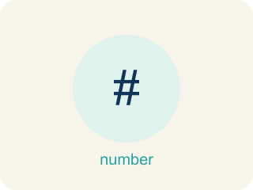
Write Equations (Escribir ecuaciones) — Represent a relationship with expressions joined by an equal sign.
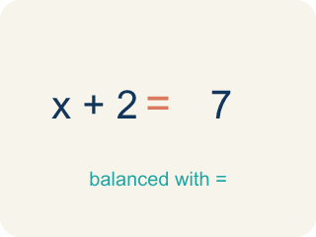
Equation (Ecuación) — A math sentence with an equal sign showing both sides are the same.
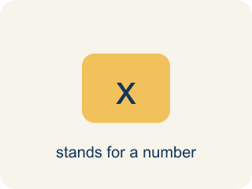
Variable (Variable) — A letter that stands for a number that is unknown or can change.

Equal sign (Signo igual) — The = sign, showing both sides are the same.
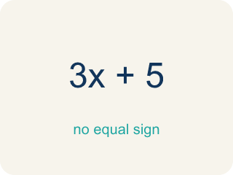
Expression (Expresión) — A math phrase with numbers and letters, but no equal sign.
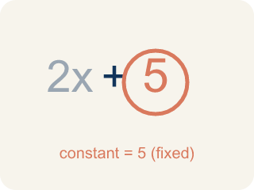
Constant (Constante) — A fixed number in an expression or equation that does not change.

Unknown (Incógnita) — The value you are trying to find, usually shown with a variable.

Practice
Show your work. Use the blank space under each problem.
1. A detective found some fingerprints on Monday and 14 more on Tuesday, for a total of 30. Which equation represents this?
A. f + 14 = 30
B. f − 14 = 30
C. 14f = 30
D. f / 14 = 30
______________________________________________________________________
2. Crack the Equation Error
Step 1 (Clue): A number of case files divided by 3 equals 6.
Step 2 (Choose a variable): Let n be the number of case files.
Step 3 (Write the equation): 3n = 6
Which step has the mistake? Explain and fix it:
______________________________________________________________________
______________________________________________________________________
______________________________________________________________________
3. Find the Equation Error
Step 1 (Situation): Twice a number is 16
Step 2 (Identify operation): Twice means addition
Step 3 (Write equation): n + 2 = 16
Which step has the mistake? Explain and fix it:
______________________________________________________________________
______________________________________________________________________
______________________________________________________________________
4. Write a real-world situation that can be modeled by the equation n / 5 = 9. Explain what n represents and verify your equation makes sense.
Sentence starter: Situation: ___. In this problem, n represents ___. Check: n = ___ because ___ ÷ 5 = 9.
______________________________________________________________________
______________________________________________________________________
______________________________________________________________________
______________________________________________________________________

Answer Key (Teacher)
1. A. f + 14 = 30
The detective's Monday fingerprints (f) plus 14 more equals 30: f + 14 = 30.
Watch for: A common mistake in Write Equations is writing subtraction and division clues in the wrong order — putting the number from the clue first instead of the variable first. For 'a number decreased by 8 equals 5,' students often write 8 − n = 5 instead of the correct n − 8 = 5; for 'a number divided by 4 equals 6,' they write 4 ÷ n (or 4n) instead of n / 4 = 6. Always start with the variable, then attach the operation in the order the words describe it, and check by substituting your answer back in.
2. Crack the Equation Error
The mistake is in Step 3.
Correct work: 'Divided by 3' means division, not multiplication. The correct equation is n / 3 = 6, not 3n = 6. Check: 18 / 3 = 6.
Watch for: The clue says the case files are divided by 3, but the equation 3n = 6 multiplies instead. Dividing means splitting n into 3 equal groups, so the equation is n / 3 = 6, and 18 / 3 = 6 confirms it.
3. Find the Equation Error
The mistake is in Step 2.
Correct work: 'Twice' means multiply by 2, not add 2. The correct equation is 2n = 16.
Watch for: The operation was named wrong at the start: 'twice' was called addition, which led to n + 2 = 16. Twice a number means two of that number, which is multiplication, so the equation is 2n = 16.
4. Open response — answers will vary.
Look for key words: equation, variable, represents, divided, equal, 45.

